Table of Contents

Download Jmeter 3

Thread group 12

Using jmeter now first attempt was with blazemeter 13

Next listeners to listen to your work and show report 16

Additional plugging for real time load simulation 25

Concurrency thread group 30

Ultimate thread group 32

If you use blazemeter u dnt need http recording 34

http cookies and using blazemeter vs setting mozilla port. 35

We have to add http cookie manager 39

How to validate jmeter test -pass /failed assertion 41

WEBTOUR APPLICATION is shit ignore it 47

Controller- its like a folder 47

Regular expression extractor 53

Data driven 54

correlations 59

Extra note 62

**Most Important JMeter Interview Questions** 63

**Conclusion** 68

**Most Important JMeter Interview Questions** 69

**Conclusion** 74

Top 23 JMeter Interview Questions & Answers 74

Running validation with non gui mode 79

Report Creation with blazemeter 81

Distribution mode in running test 83

Bean script basics java 84

More testing 84

JMeter Interview – Read Top Interview Questions. 85

Q-1. What is JMeter? What are the other applications that can be tested using JMeter? 85

Q-2. Explain the basic workflow of JMeter? 85

Q-3. Name the protocols supported by JMeter? 85

Q-4. List the important features that JMeter supports? 86

Q-5. What is seen on the screen when you open a JMeter? 86

Q-6. What is a Test Plan in JMeter? List some of the test plan elements available in JMeter. 86

Q-7. Explain the role of Workbench? 87

Q-8. What is a Thread Group? List down its main parts? 87

Q-9. What are JMeter controllers? Explain their types? 87

Q-10.What is a Configuration element? List down its elements. 88

Q-11. What are Listeners? List out a few JMeter Listeners. 88

Q-12. Explain what is Pre-processor Element? Name a few of them. 89

Q-13. Explain what is Post-processor? 89

Q-14. What is the execution order of Test Elements in Test Plan of JMeter? 89

Q-15. Is it required to prepare separate Test Plan using JMeter for the testing of the same application on different Operating System? 89

Q-16. How do you ensure re-usability in your JMeter scripts? 90

Q-17. How can you reduce resource requirements in JMeter? 90

Q-18. List the benefits that JMeter offers for performance testing? 90

Q-19. Explain what is Assertion in JMeter? List its types. 90

Q-20. What is Spike testing and how can we perform it in JMeter? 91

Link to know more about Jmeter 91

Getting Started with JMeter - A Basic Tutorial 92

What is Performance Testing? 92

An Introduction to JMeter 92

Your First JMeter Script 92

Thread Groups 93

Samplers 95

Timers 96

Listeners 97

Your Second JMeter Script 99

Recording Scripts - Your Third JMeter Script 102

Assertions 104

Dynamic Data 105

Scalability 108

Analyzing Results 108

Bean shell scripting 109

# Download Jmeter

Jmeter is built on java so can be used across platforms and its free

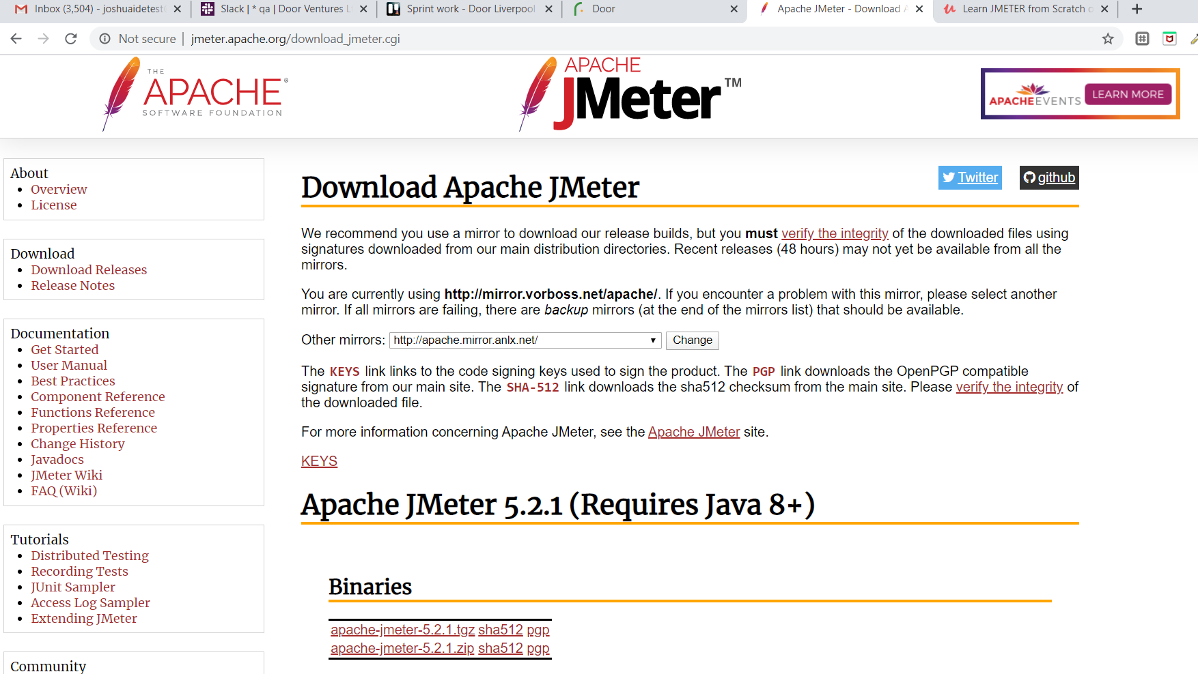

Type jmeter download and download binary zip

You must have java same version

Click it click bin click apachejmeter jar executable file to start or am sure open from desktop like normal

Test plan is all action or script to run

Now note there is no workbench in jmeter anymore do what is the alternative?

First thing we have to do is create a thread group which means how many users want to perform the test.

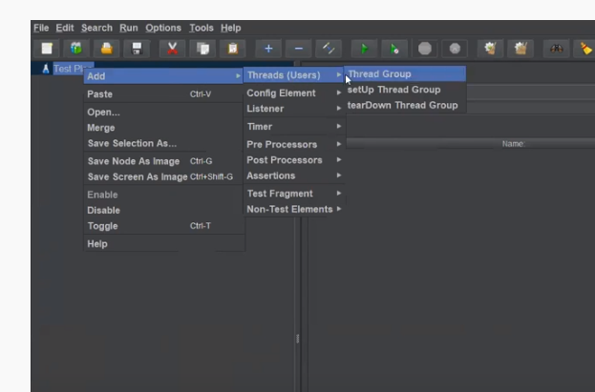

Number of thread means number of users. You can change the name to users

Next what kind of request we need to specify

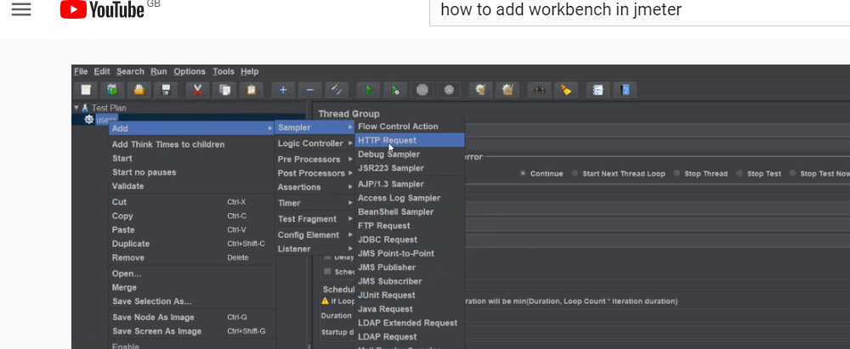

In the request just put the root address [www.googlge.com](http://www.googlge.com) no need to put htttp and in the path…add where in the google you go www,google.com/bala

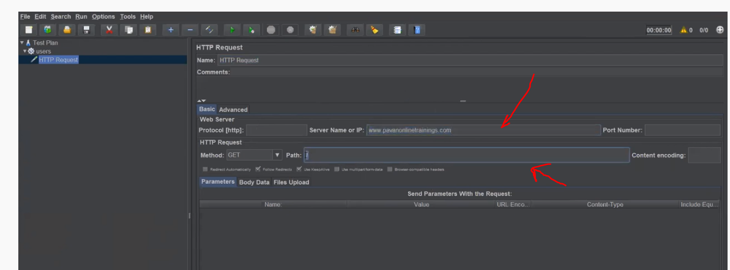

Next we need to see the report, how much time it is taking to hit the website

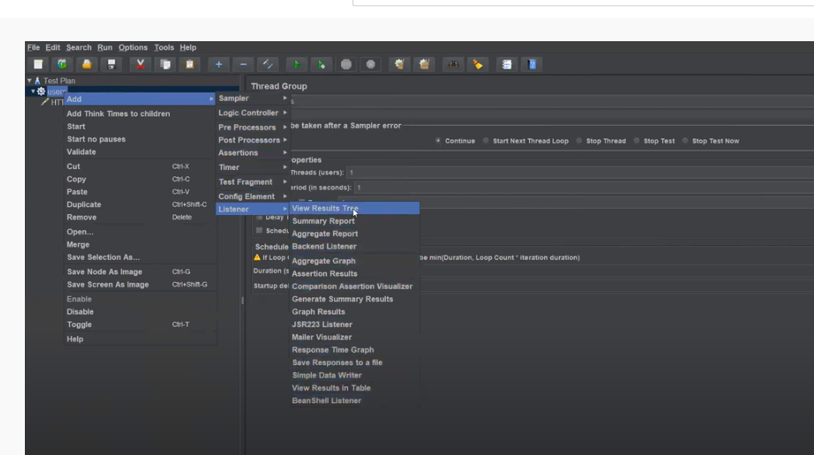

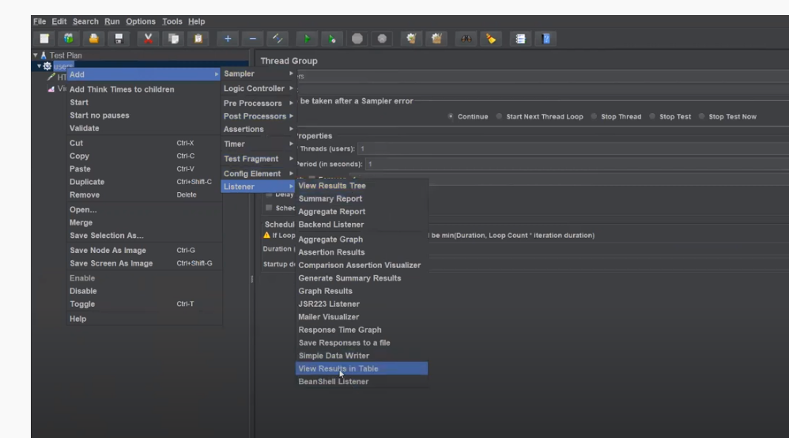

He has view resukt tree and table

To runtest plan first click save and it will give you option to save it with a name

After doing that click on the test plan and then go and click start. Then check the tree and tale for report.

You can highlight report and click clear all

Also go to testplan…add….htp script recorder

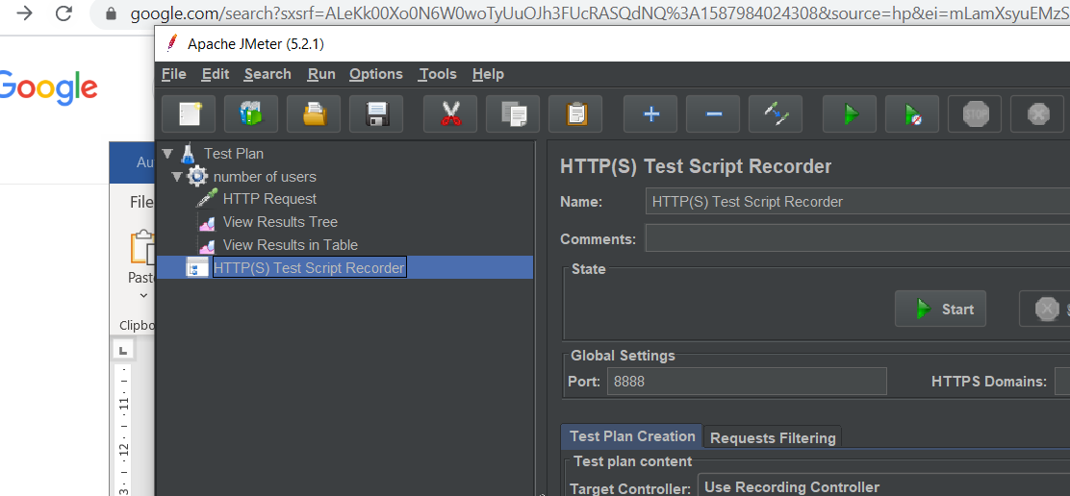

Jmeter is about testing how that test case is behaving for a number of users

Now port 8888 is the port where jmeter listens if you do it on a different port it will not work. So depends on what port you give.

This is necessary to exclude pop ups and crap

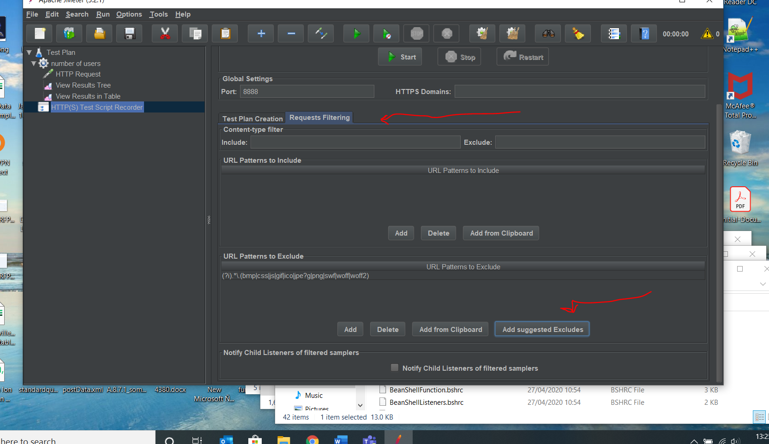

Now note blaze meter is a tool for chrome for load testing like jmeter

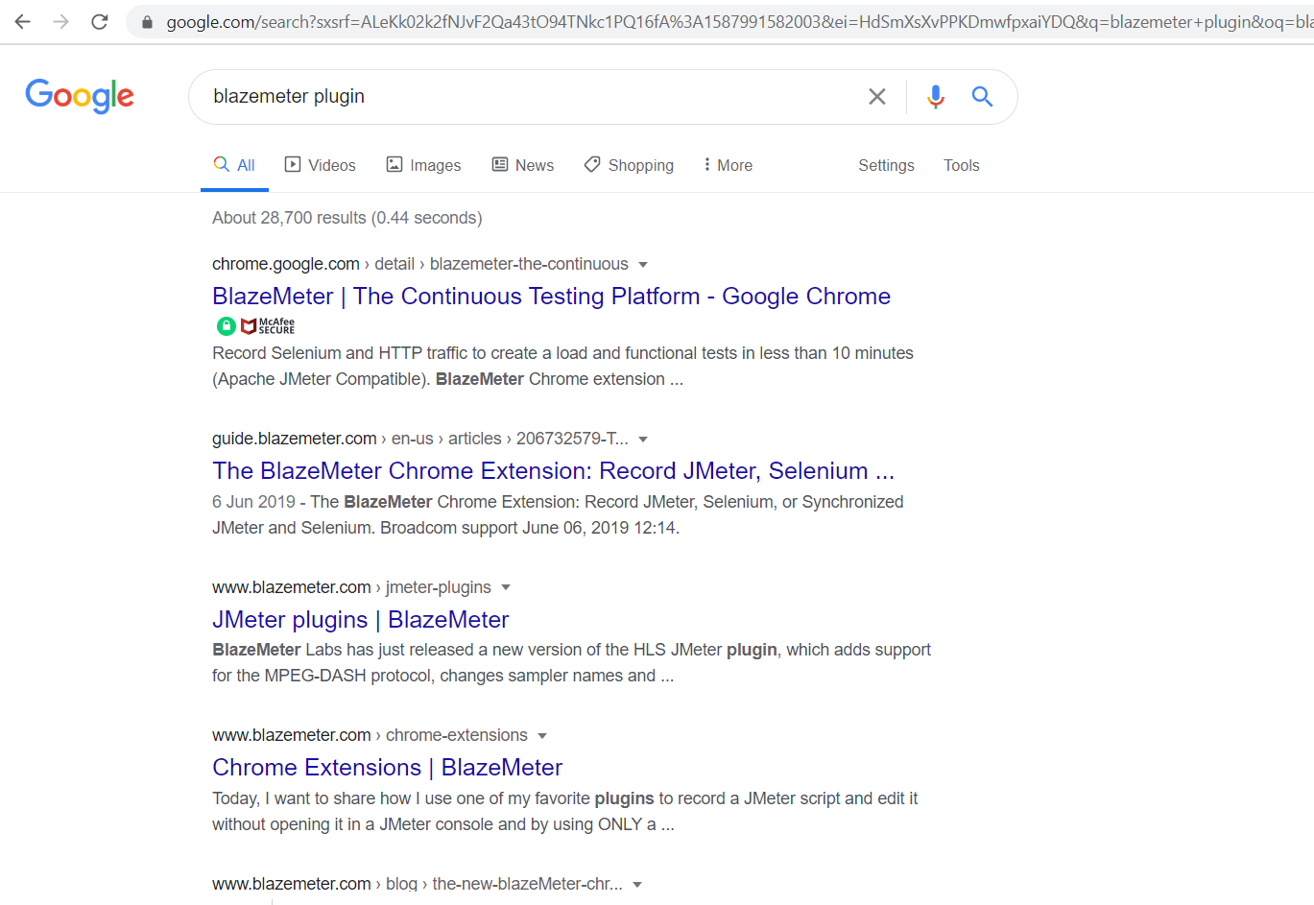

<https://chrome.google.com/webstore/search/blazemeter?hl=en-GB>

just go to more tools extension…. At the bottom go to chromw store house then find blazemeter and add extension to chrome or you can waste your time googling it

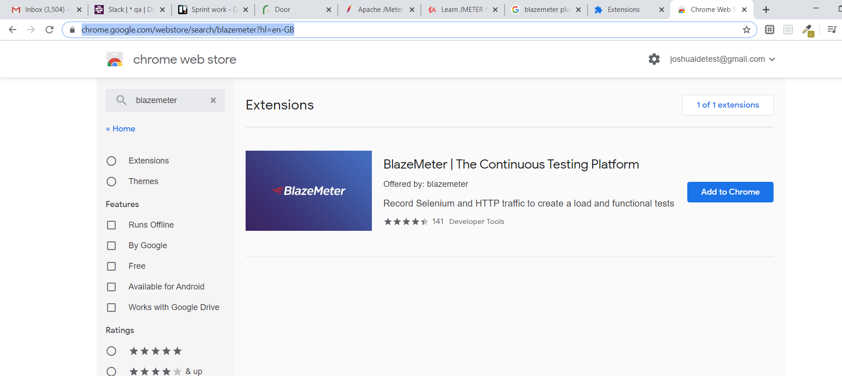

You need to sign up to use it

First name Steel

L name Blast

Email :steelblst@

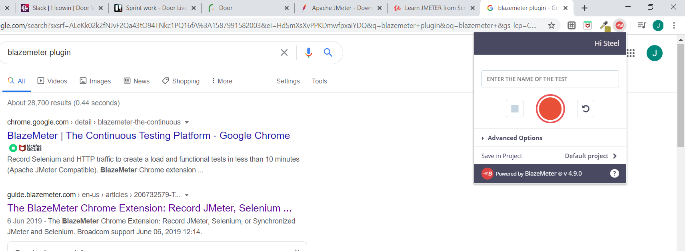

So just type a name for the program and then press record

Jmeter accepts only jmx extensions . there is a way to export blazemeter to jmeter.

Press record…. After stop and download it as jmx

Dnt select selenium or yaml just select all that has to do with the video

Click download and select them from jmeter(jmx) only

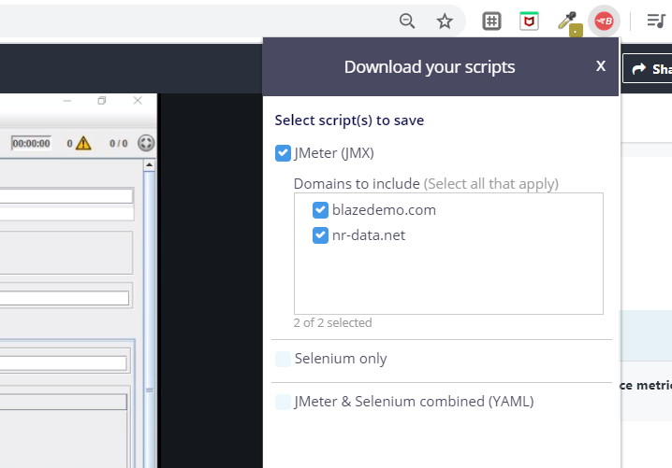

Select only blazedemo ignore the rubbush below and use demo1 not demo when uploading

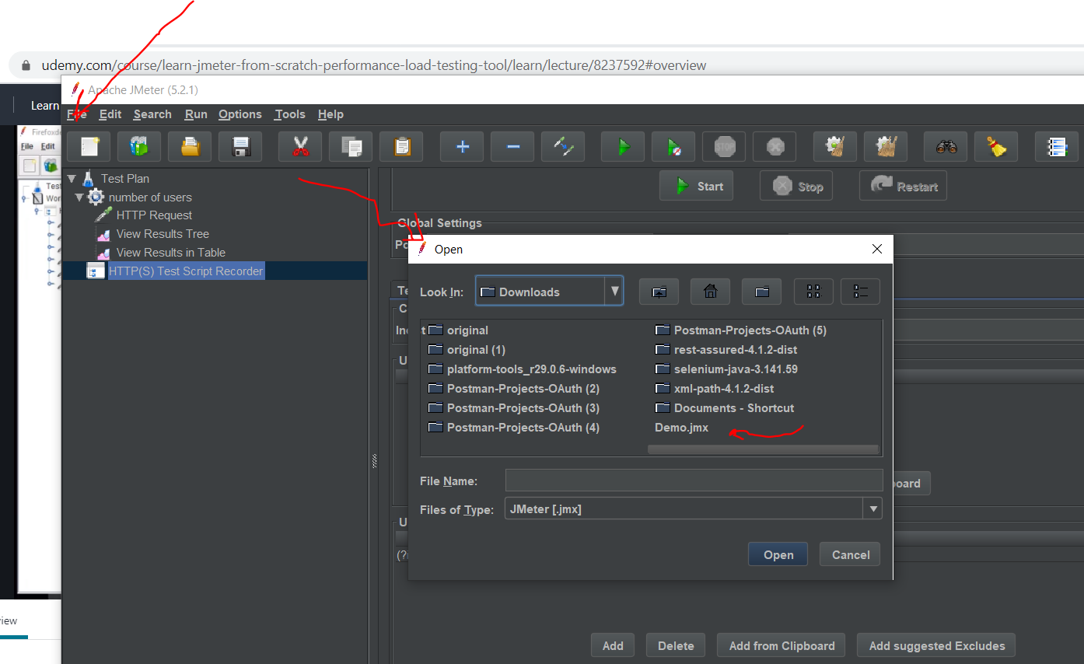

Now we upload it to jmeter

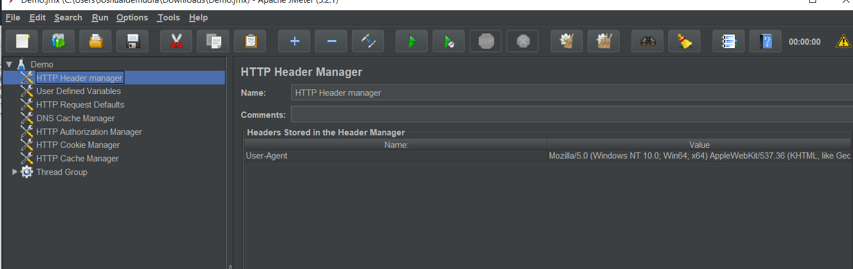

Now look at the thread….

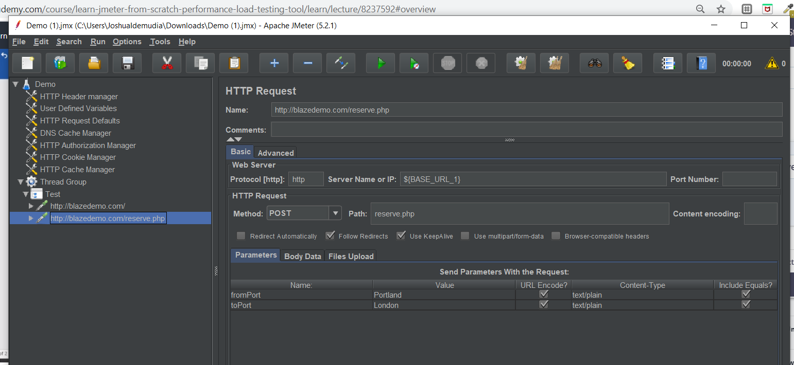

So that is used to show user flow…after u get user flow then u can then add or multiply users

# Thread group

This is the heart of jmeter

Thread is the users

Location of jmeter

C:\Users\JoshuaIdemudia\Downloads\apache-jmeter-5.2.1\apache-jmeter-5.2.1\bin then \jmeter

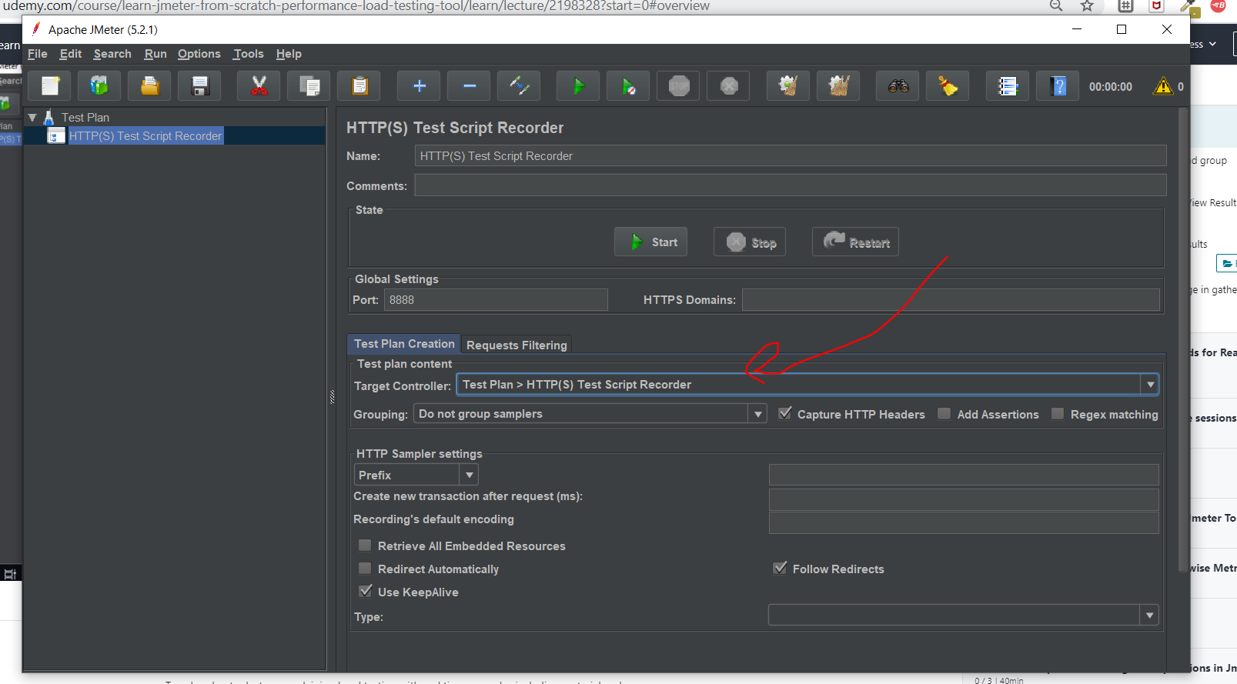

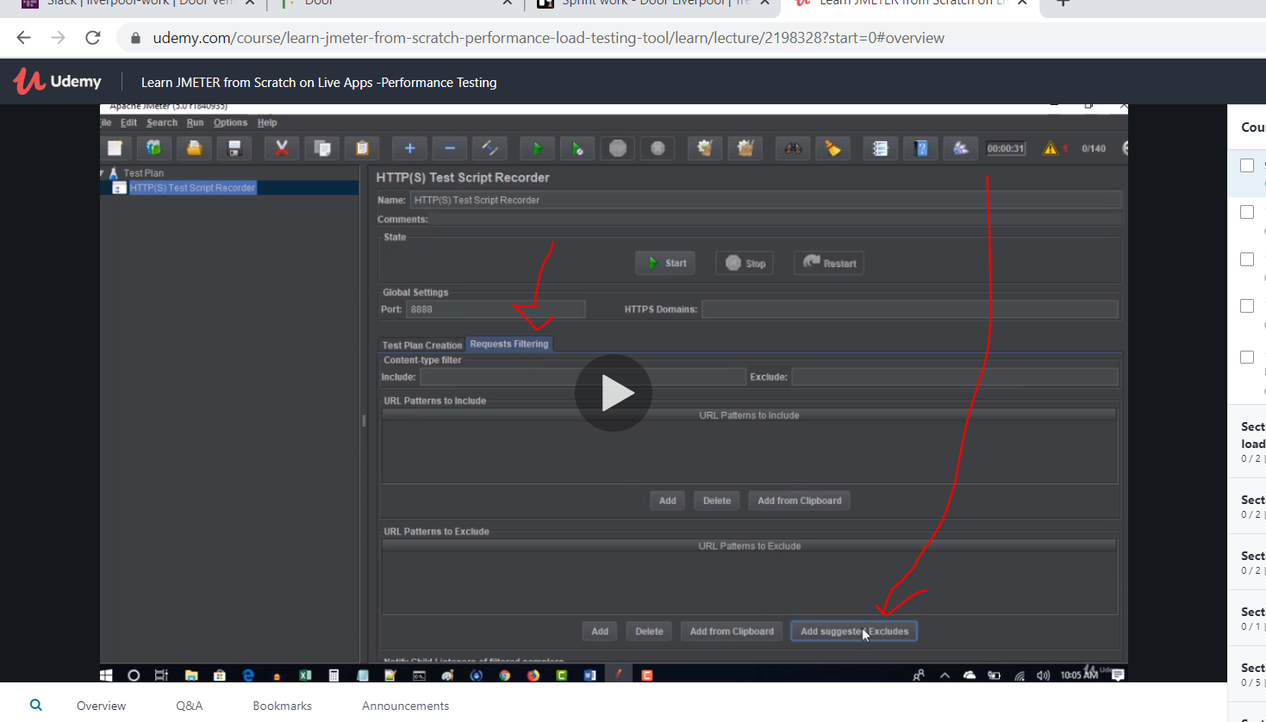

# Using jmeter now first attempt was with blazemeter

After that start the recording now note this is doing it without blazemeter

Now lets go back to <http://blazedemo.com/> and make a video

Just record but do it with mozilla

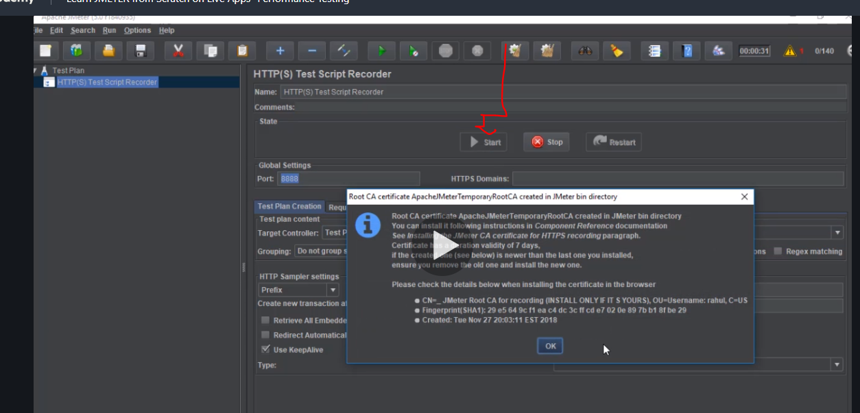

This means in 1 second 10 users use the platform and in5 sec 50 users use the platform.

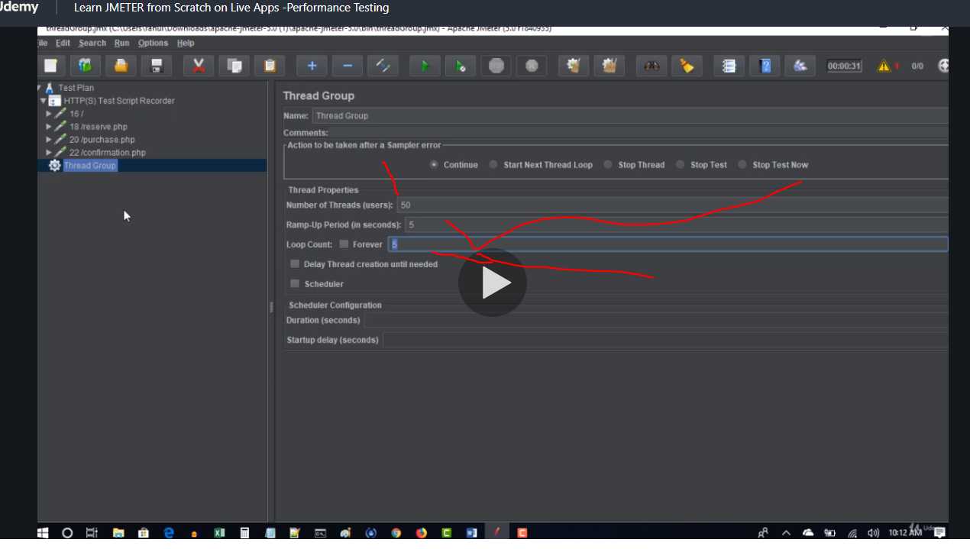

If you loop 5 times mmeans user repeat it and loop will mean it happens 250 times or 250 users generated that way in 25 seconds

Or u can use forever with a duration

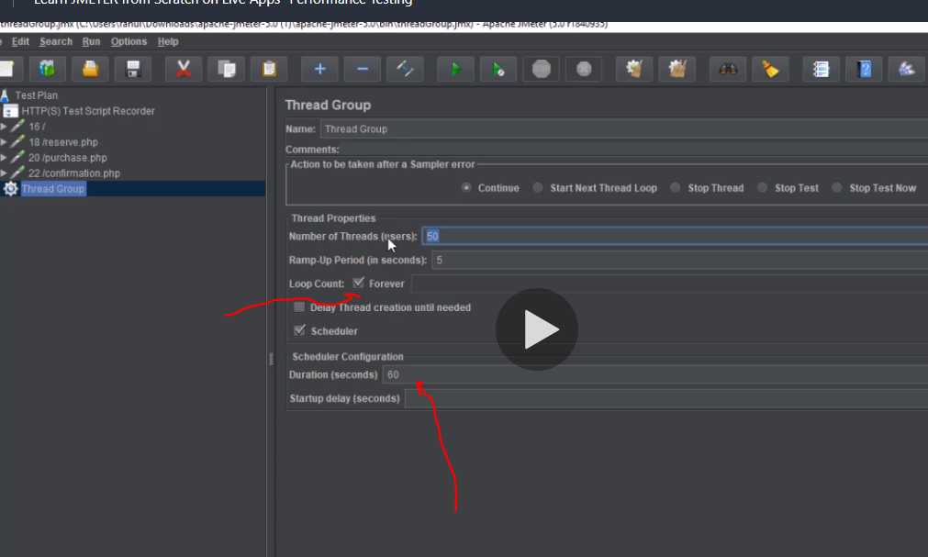

Whether to continue or stop

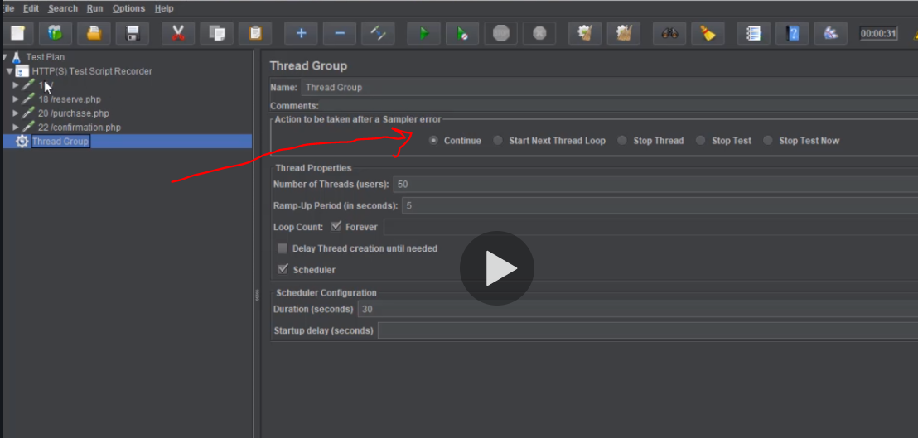

Next cut all inhttp recorder and paste in thread group

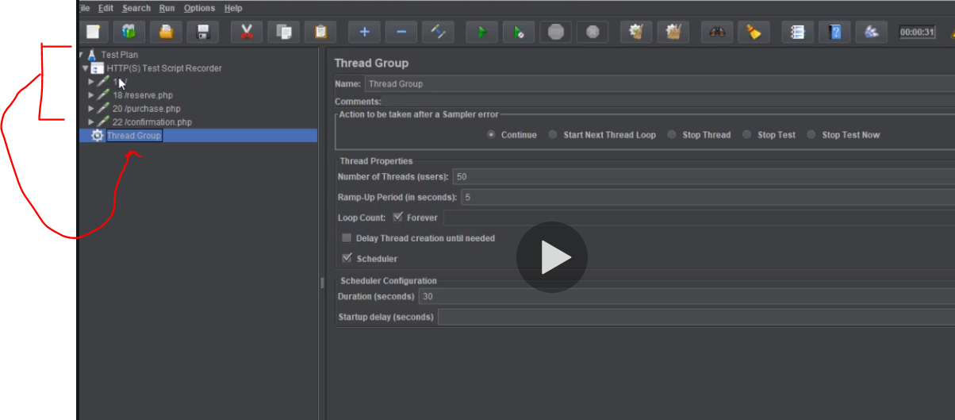

With blazemeter it create the thread for u …u dnt need to cut and paste from http

# Next listeners to listen to your work and show report

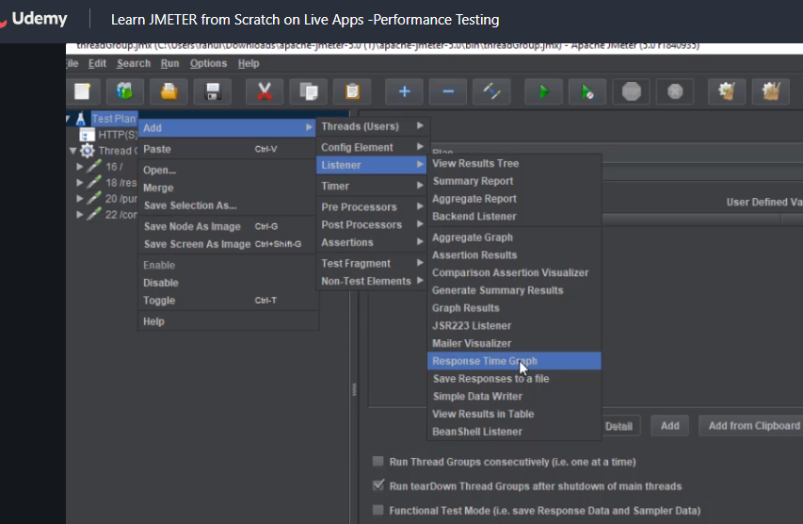

View result tree… aggregate report and graph result. The 3 are very important listners

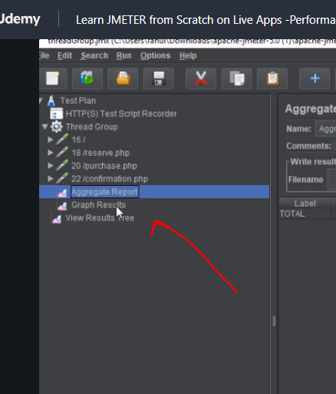

Now this means report got success

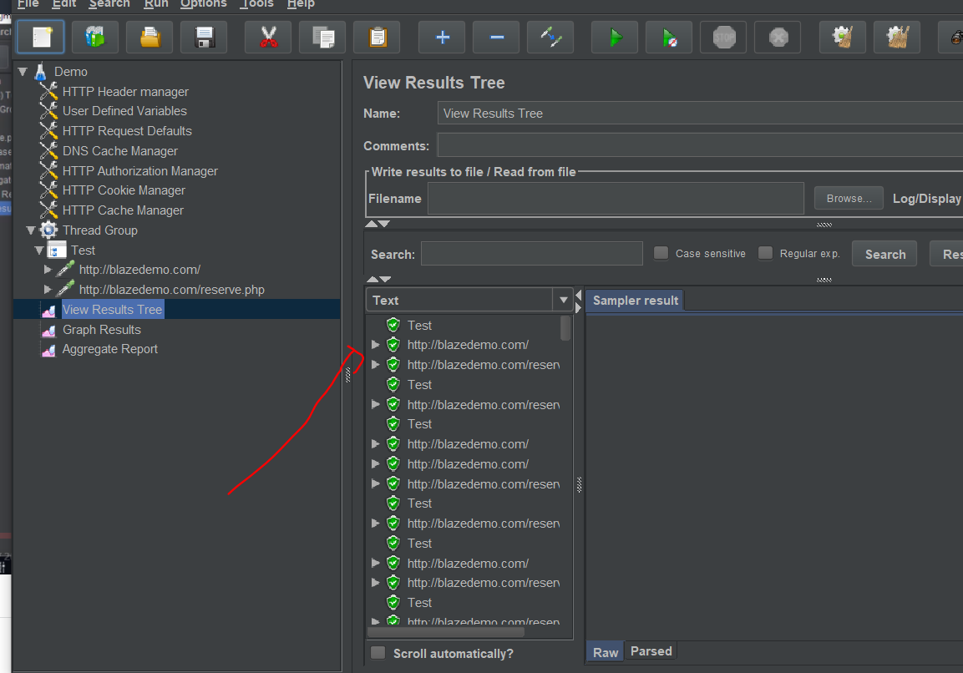

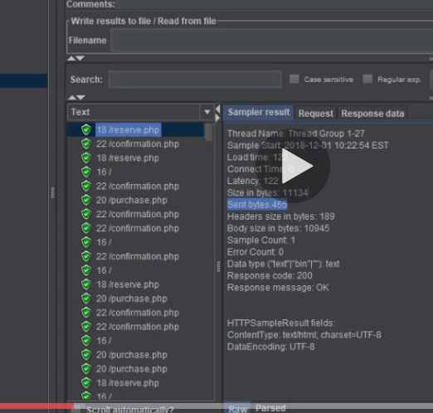

If you see red means something failed. Response code 200 is very good though its what you want to see I think it can also be seen as status code

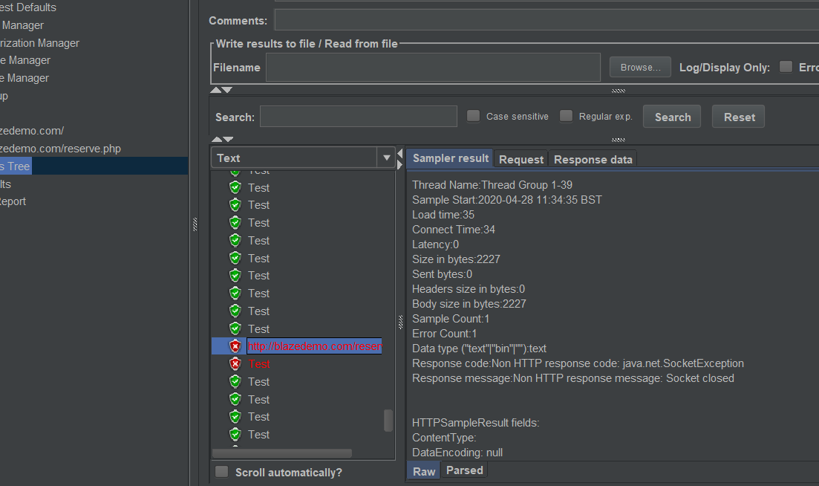

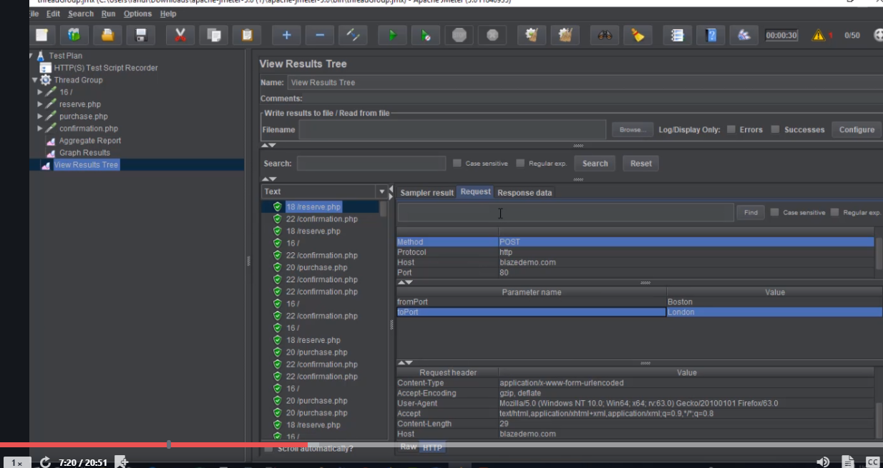

U can view more of the response click request or bottom raw.

View result tree is the best

Advice run with one user first before you add load

You can validate it by

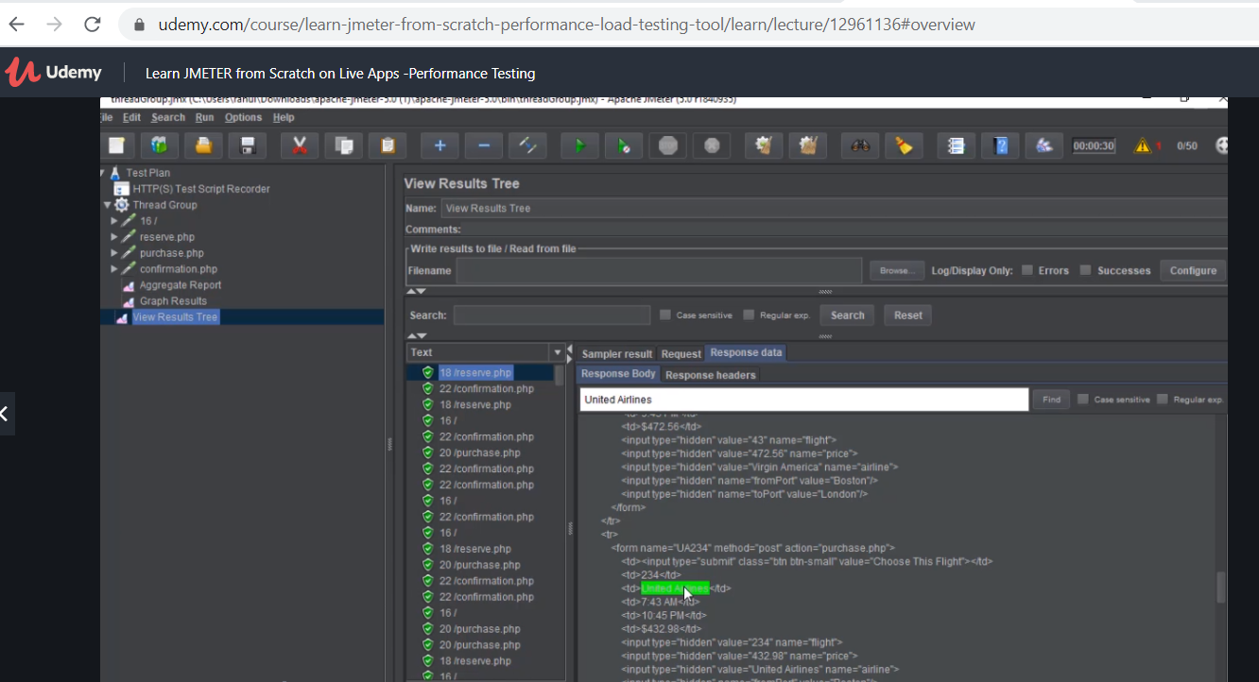

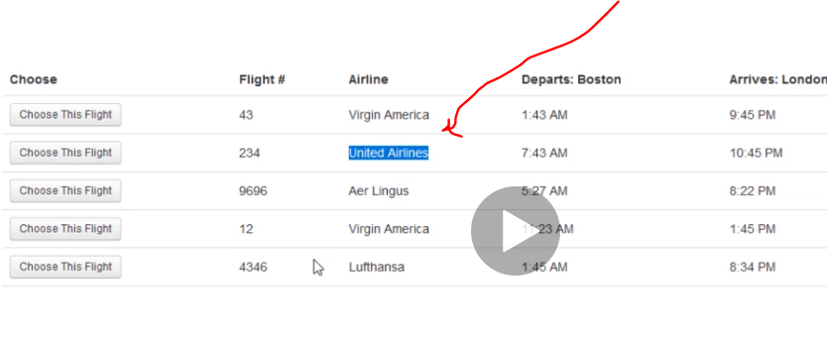

Jmeter records the request in headless mode so all you see are requests

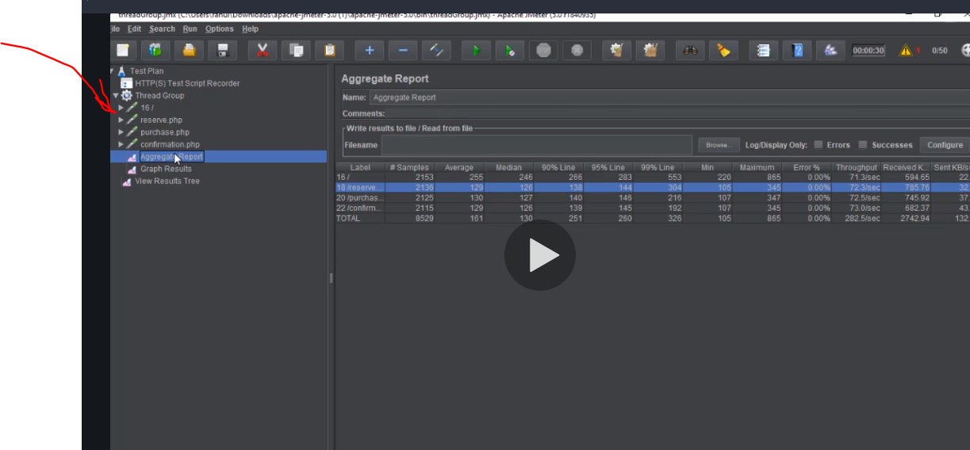

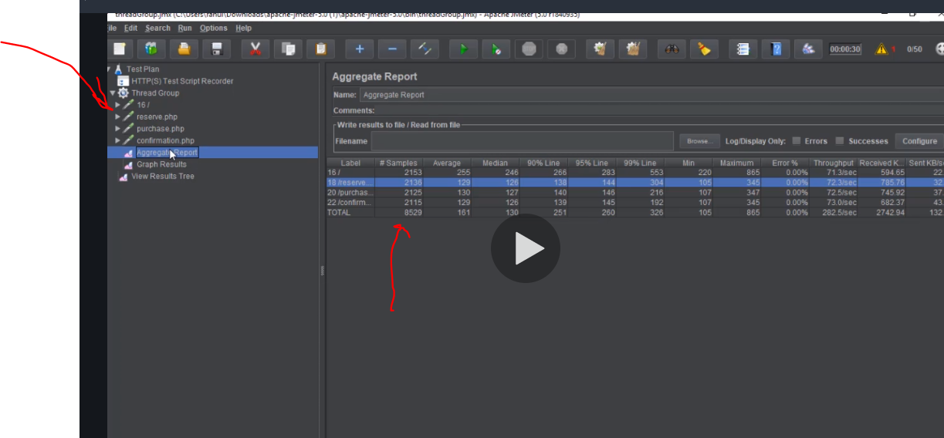

Sample means the amount of users tha hit the request 2153

Average is time taken in total from all the users to get the page 129 sec

Minimum time is the quickest time to get a response-130

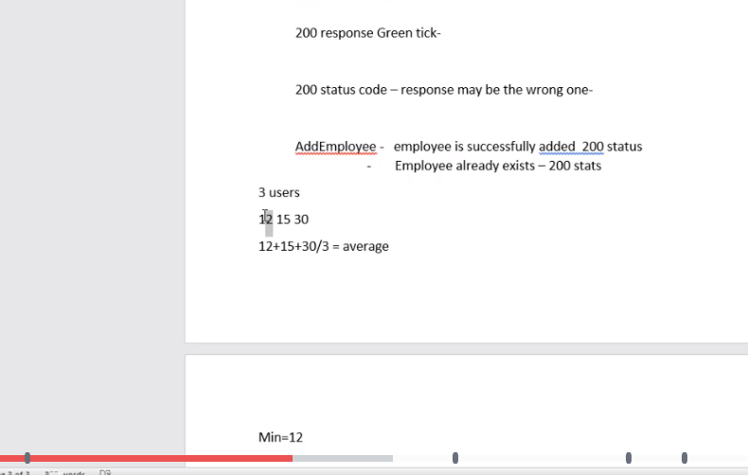

Max same idea longest to get result

Check the error as well 3 ok 10 problem

but through put important to check its says server can handle 72 people per second for the total amount 2513

but at some point as you increase user the server capability stops at that point tht is the maximum it can handle

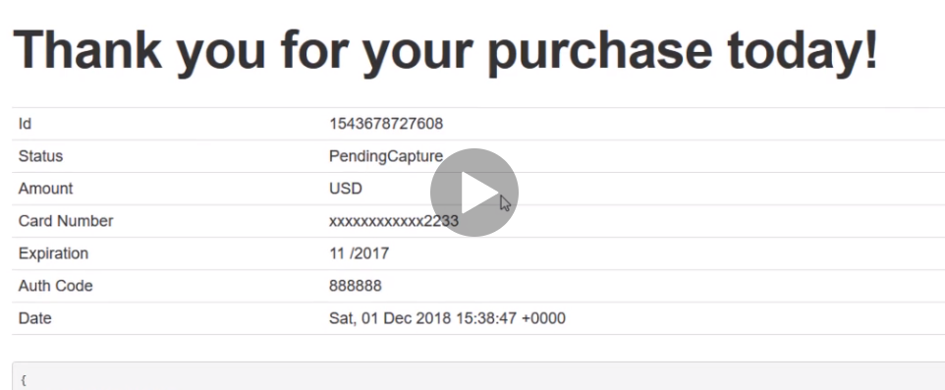

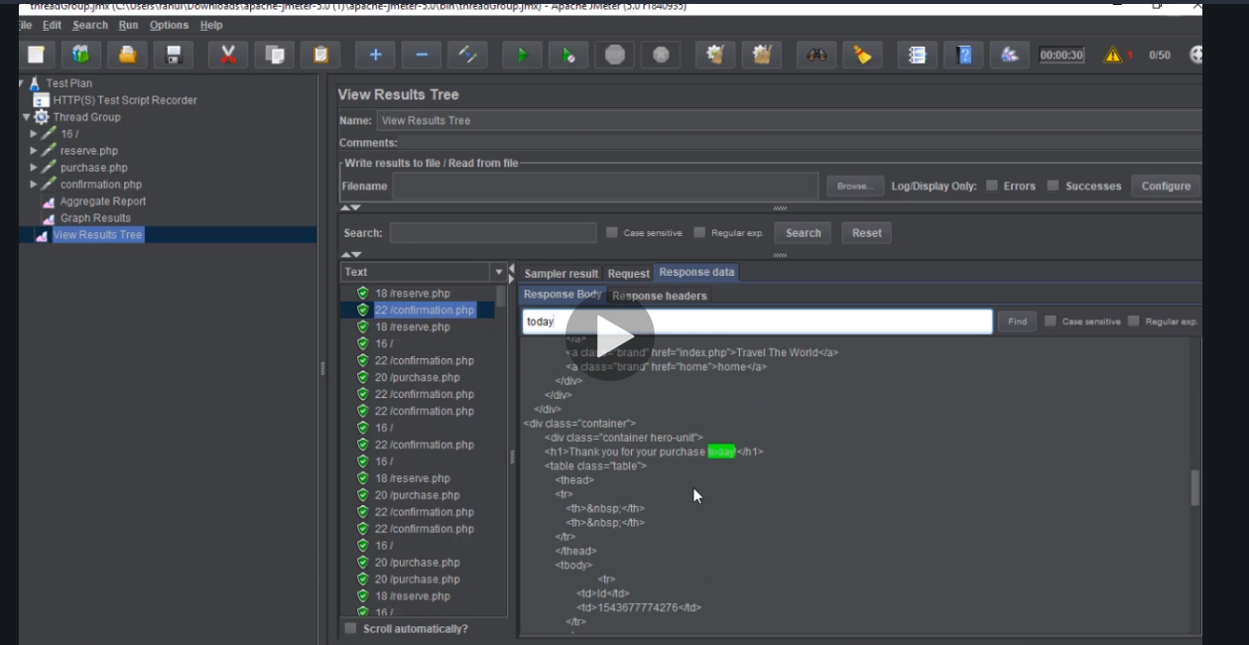

Problem with jmeter…result says pass but actual result is wrong

Take note when deviation is straight all good but if one graph is deviating from the normal grph range kpalava

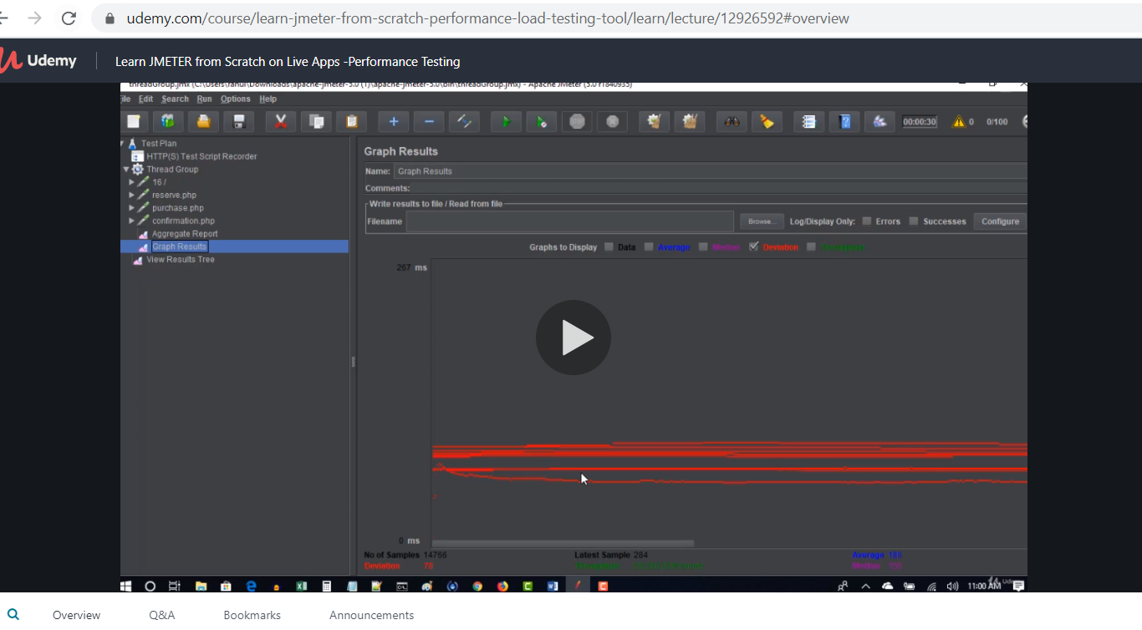

Throughput below should not ddecrease and deviation sholg not increase

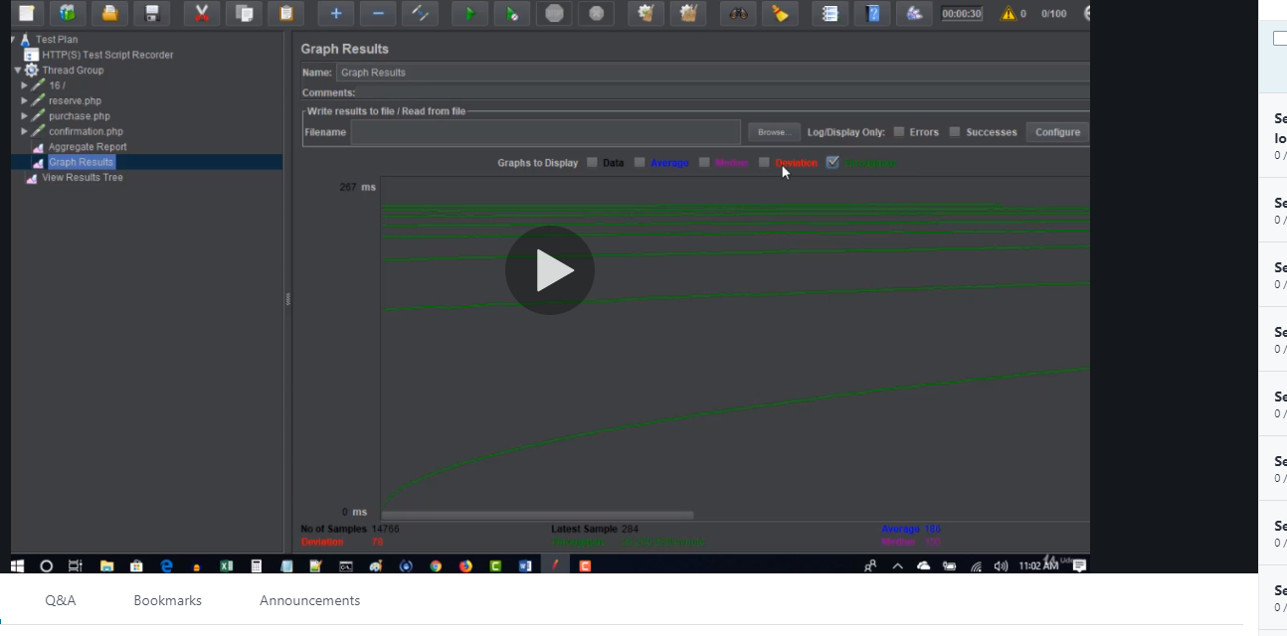

Deviation should always be less than average time graph

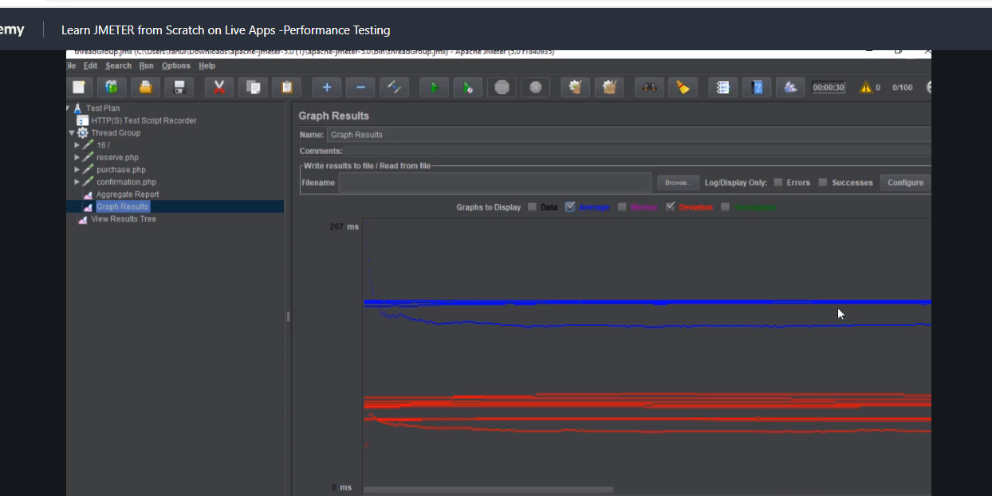

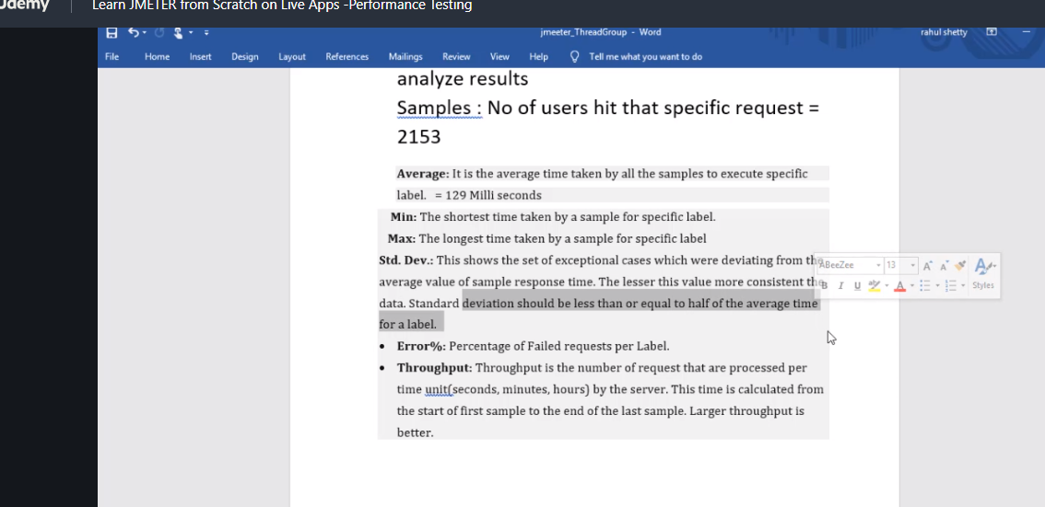

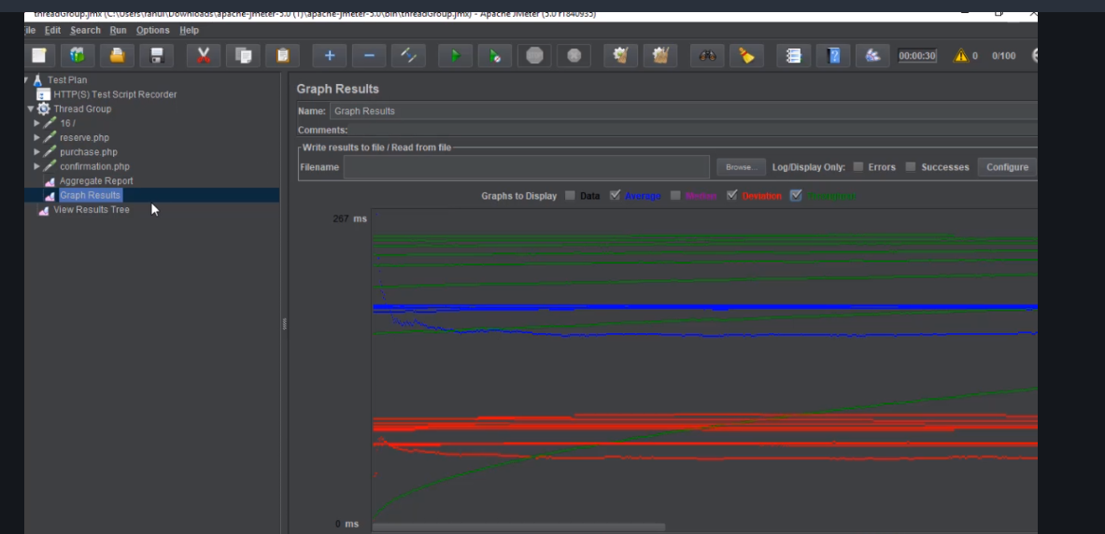

# Additional plugging for real time load simulation

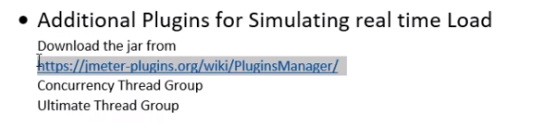

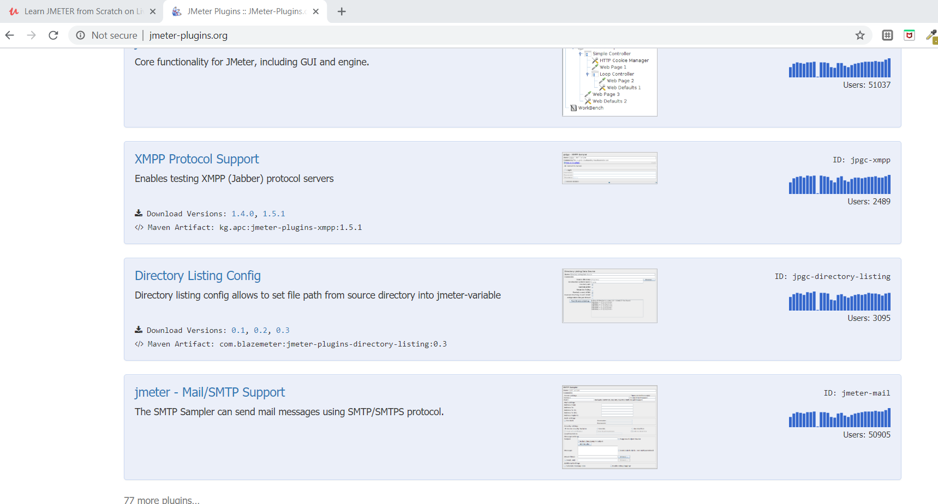

But we want the pluggin that gives us the ability to do all at once without downloading individual pluggings hence we will download pluggin manager

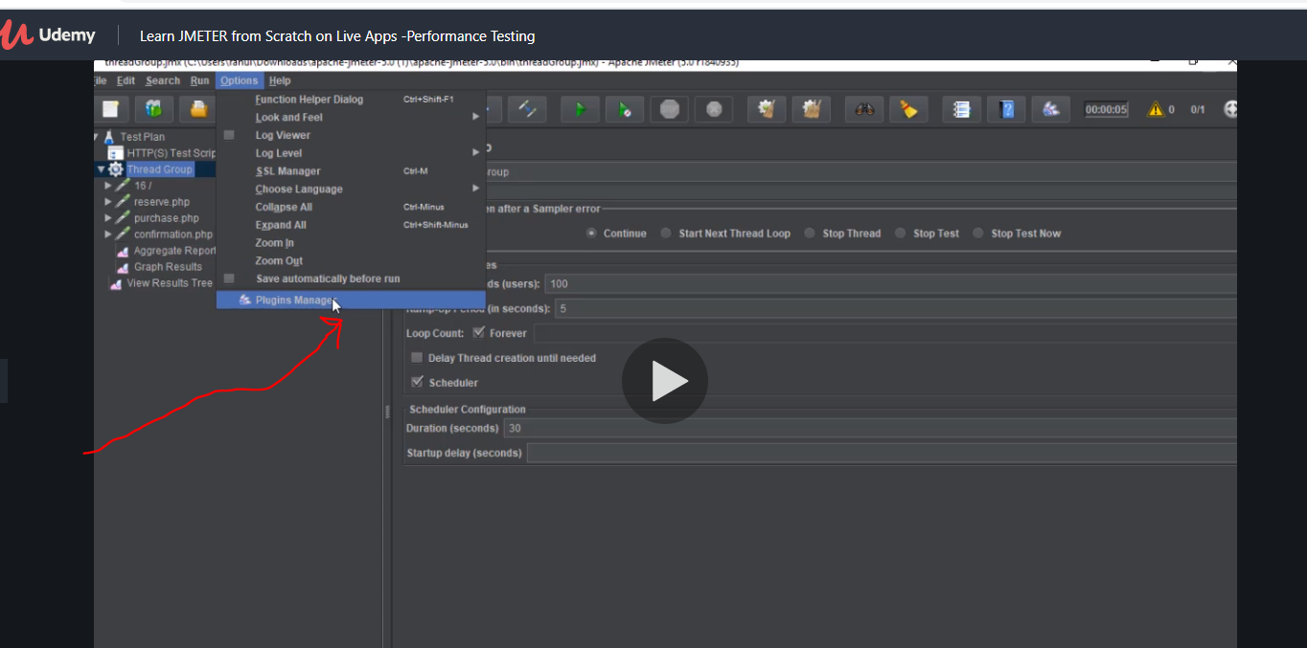

It navigates you into the page after clicking the link then down load the jar

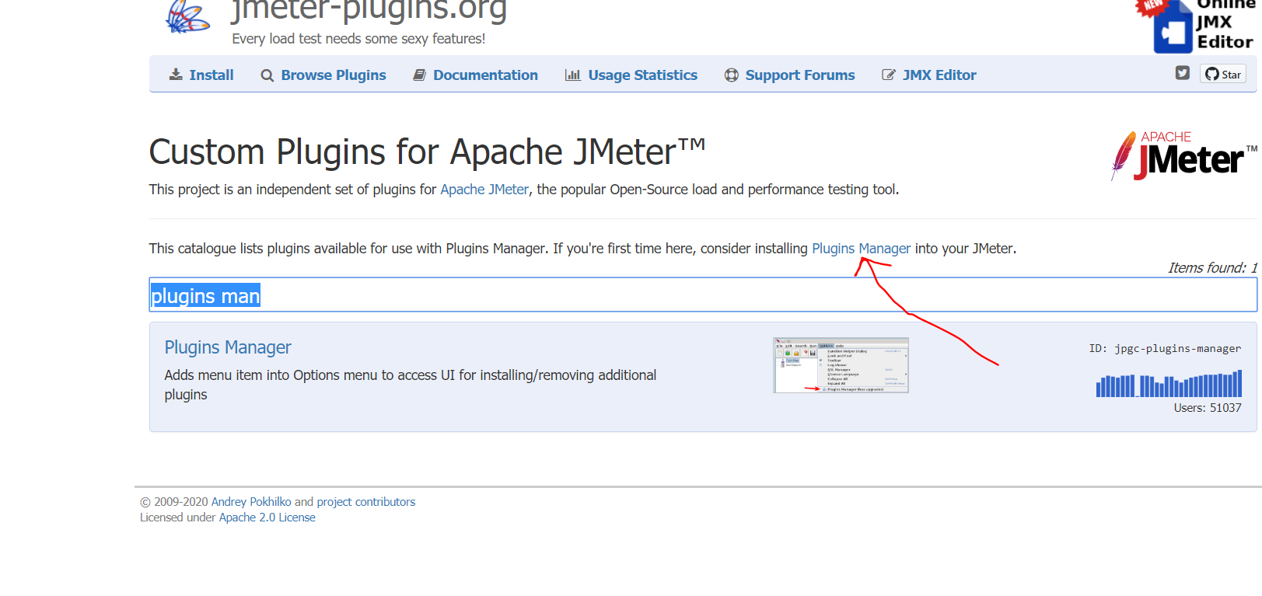

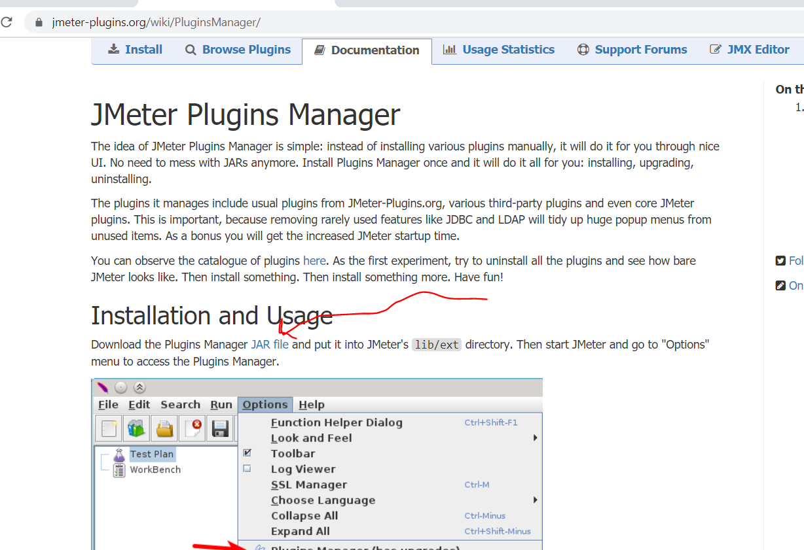

Now lets put the jar in a folder and restart jmeter so go into your jmeter find lib folder and then go to ext and inside it place the jar

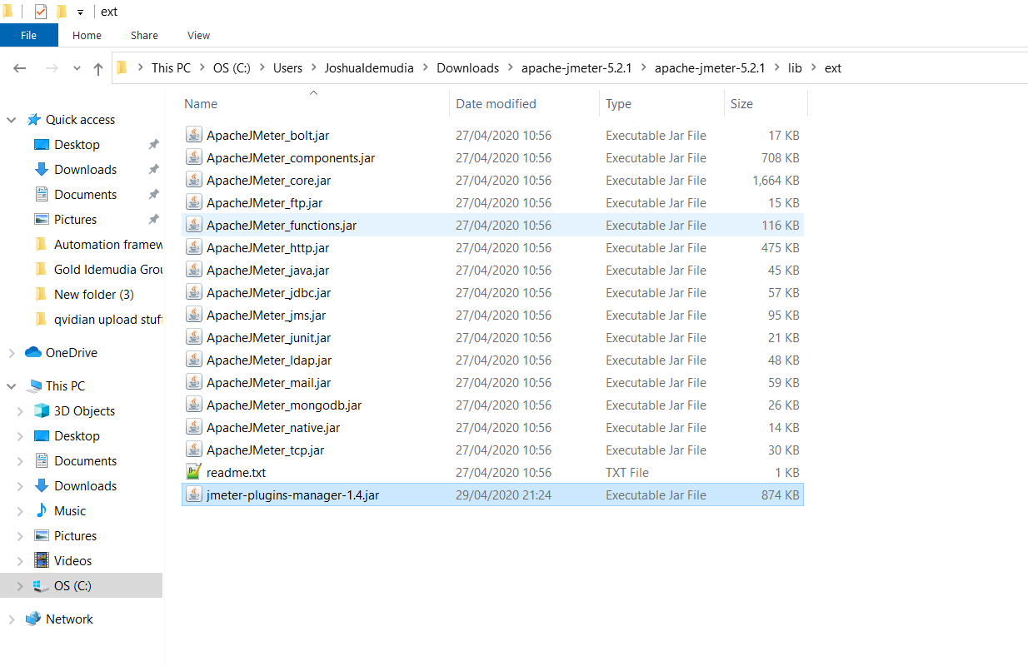

C:\Users\JoshuaIdemudia\Downloads\apache-jmeter-5.2.1\apache-jmeter-5.2.1\lib\ext

After which restart your jmeter just close it and start it again

Now go back to it and click it and from there add all necessary plugins

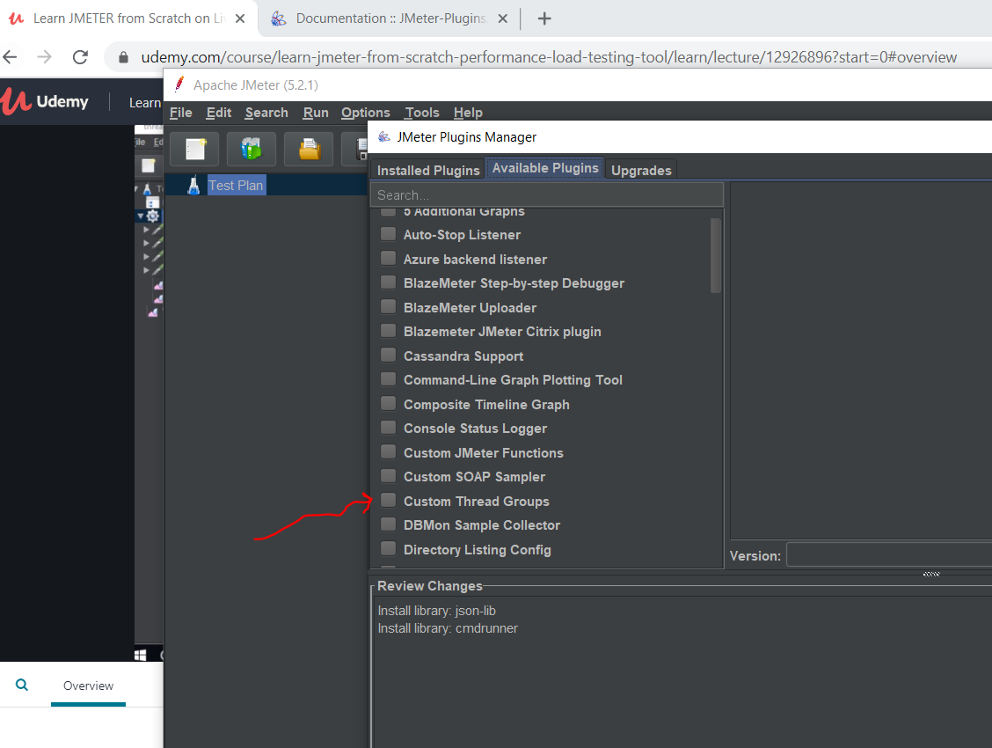

Download custom thread group

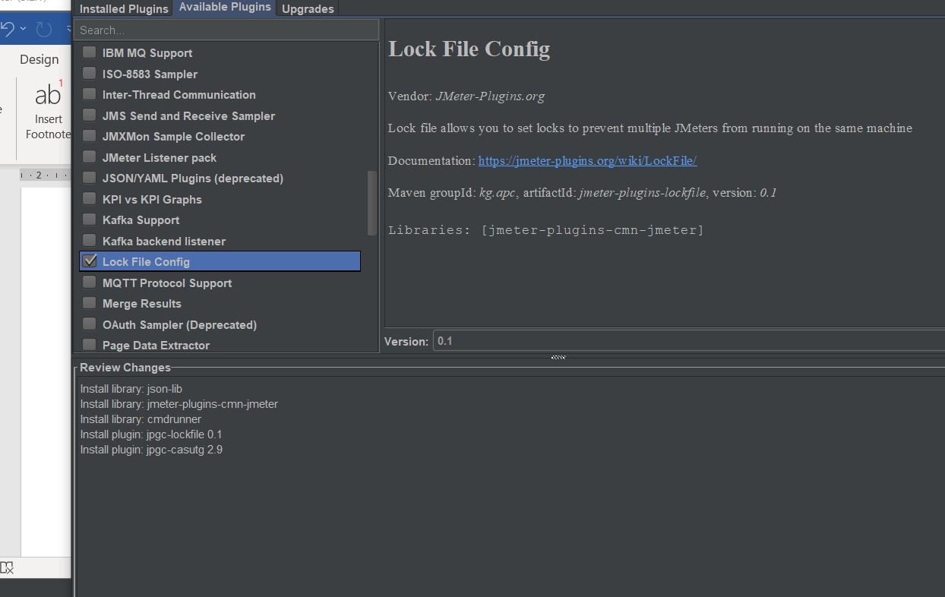

After that click this and then click apply change and reset jmeter at the bottom

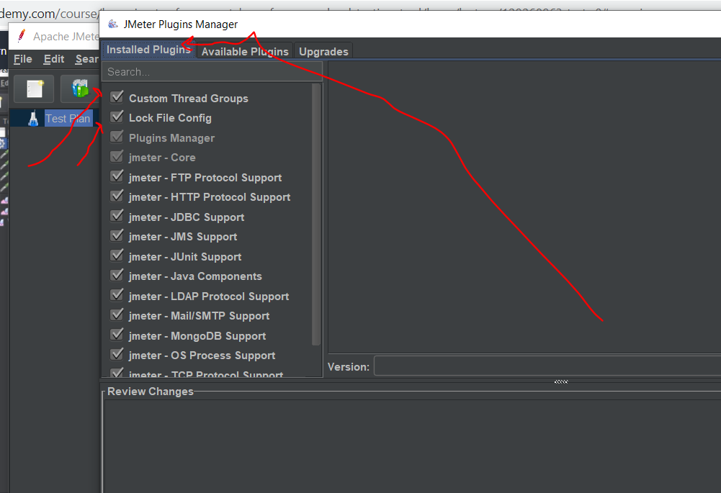

U can now see that

Now before we did add thread group now instead of that we will click two new ones

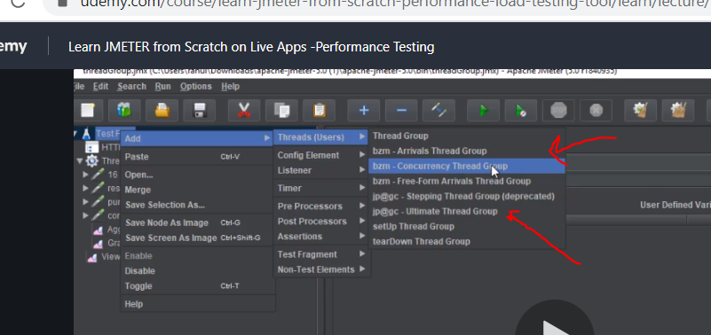

# Concurrency thread group

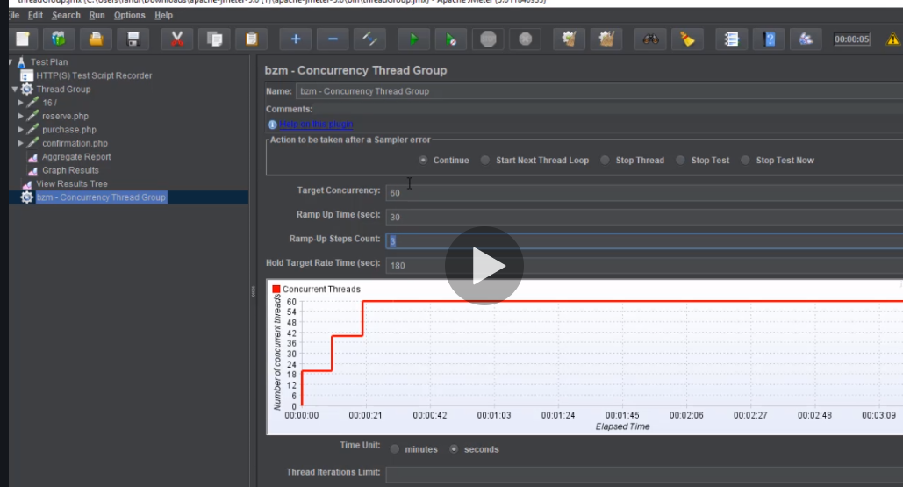

What this means is 60/3=20 users will be ramped up 3 times in 30 seconds. And the graph is shown above.

So I take it every 10 seconds 20 users use it then another 10 sec 40 user and another 10 gives 60 users

Now lets explain what ramp up time is….now say there is a sale and its for 12 oclock now usually people start joing between 11.50 12 12.15 12.30 this is why we need to ramp time. So at 10 mins 20 users are simulated at another we simulated more 40 users.

Note in the real world u will probably use 30 mins not 30 sec but for thr presentation we used 30 sec.

Now hold target rate time means once the 60 users have been simulated hold it for 180 seconds…this then is like a stress test to see how long the server would stay up holing its maximum user of 60 people

So you can use thread group or concurrency thread group

So as you did before u can copy everything from thread into concurrent thread group and disable thread group so it doesn’t run

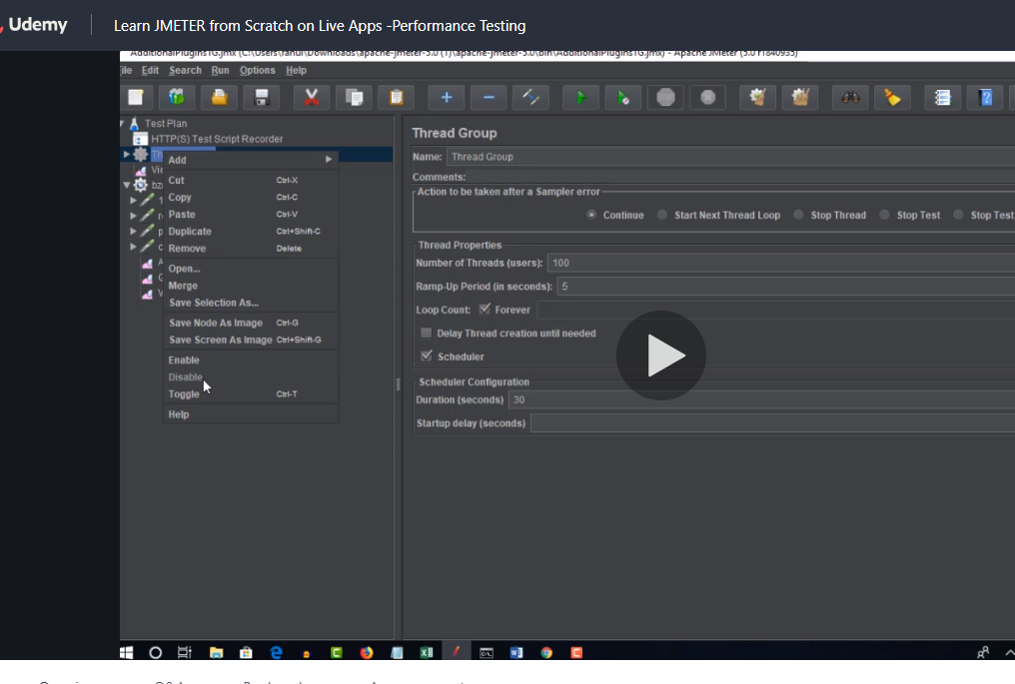

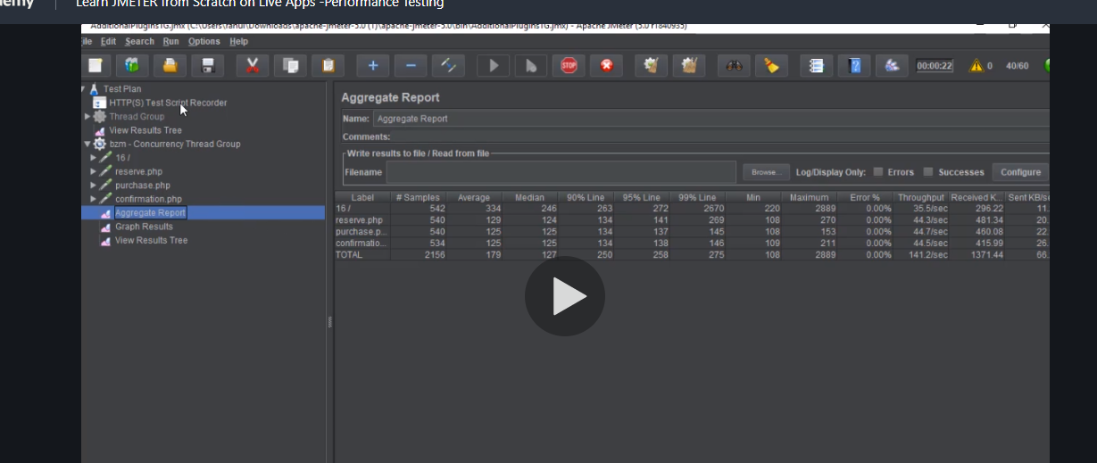

# Ultimate thread group

First you have to click the add row

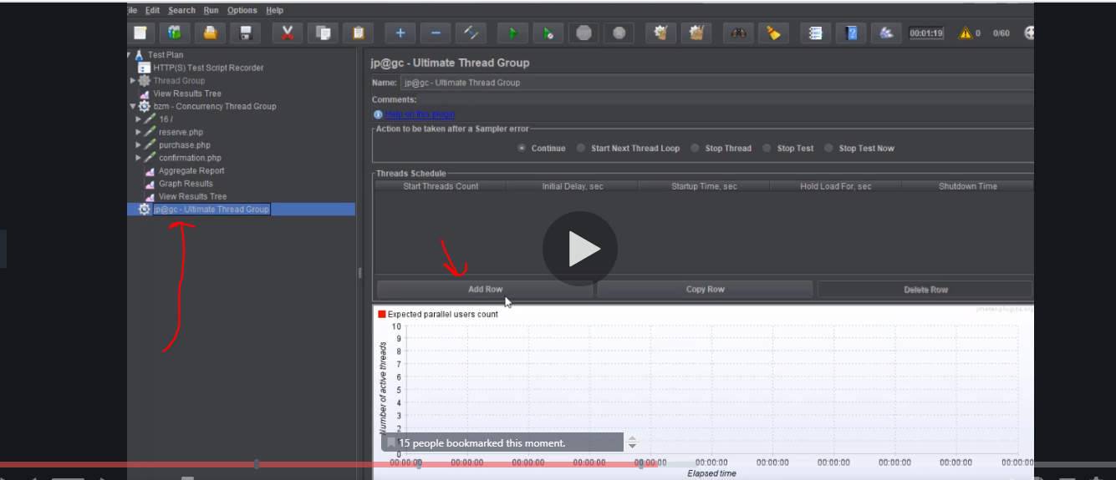

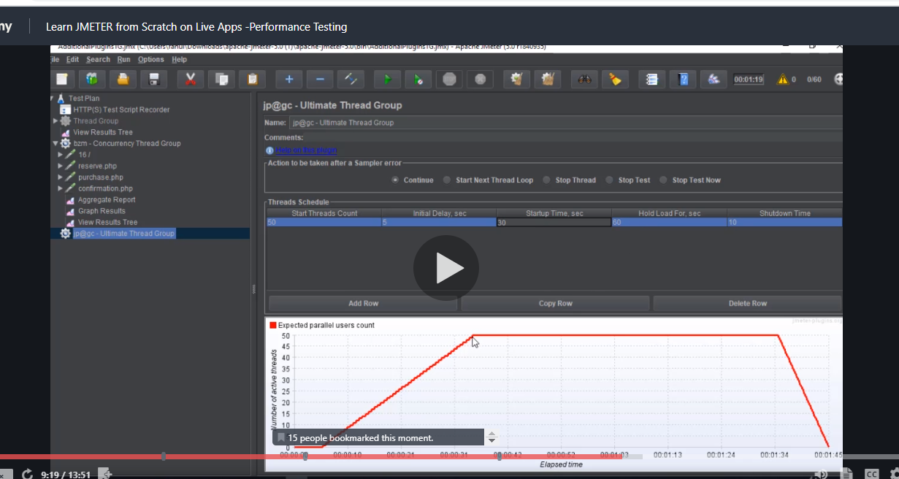

Start with 50 users and for the first 5 seconds no user and then hit 50 users at 30 seconds niceeeee…. And hold it for another 180 seconds as seen above… and shut down means gradually drop the the users for 10 seconds. How cool it is

So remember not everyone leaves your server at same time so we ramp time so we know when reeal time users leave

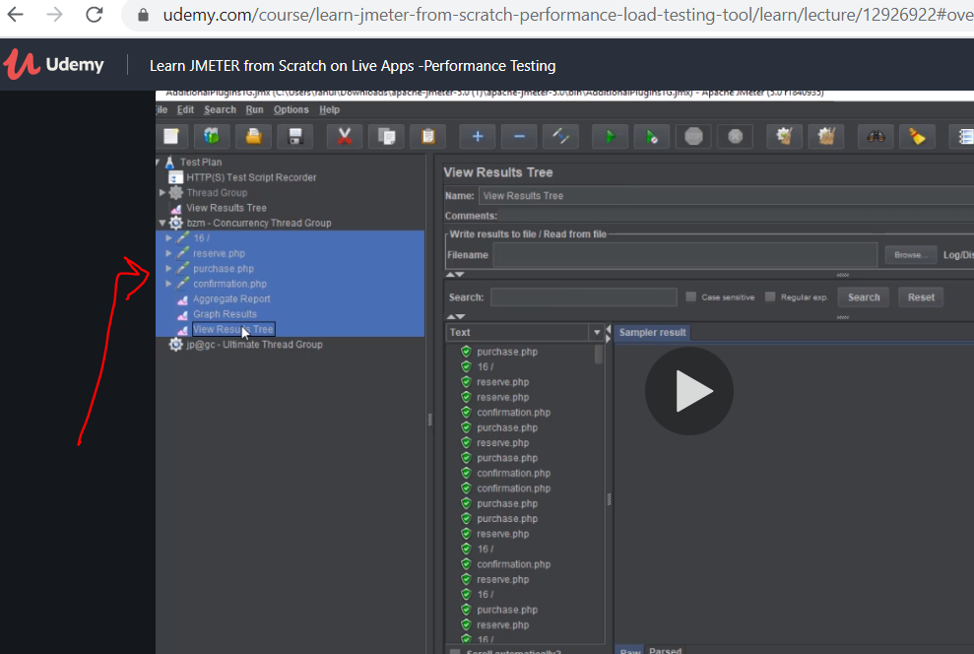

Again run all the users by copying it and disable concurrent and run your test plan, which will now only run ultimate thread. Remember the http test script is what generates all this things I am copying and pasting so when you run it the ultimate thread is only used to put load on it and the graphs are used to see the behaviour.

# If you use blazemeter u dnt need http recording

Just so u dnt confuse yourself blazemetr was used to create thread for chrome while he used http firefox to generate thread simple

# http cookies and using blazemeter vs setting mozilla port.

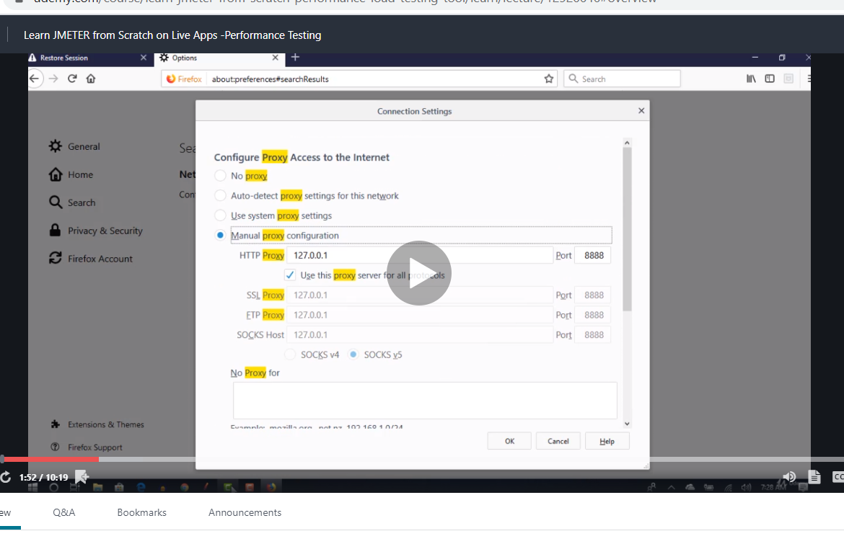

Remember to set the port first otherwise it will not record but lets use blaze meter and later we will have to download firefox

Now first click blaze meter record then put the url

<https://the-internet.herokuapp.com/login>

log in with the user name given on the page and then log out and stop recording.

Now click save it give you jmeter options just select the site you want but I select both this time just to try it.

This will download your jmx file now go back to apache and click file-open and select it

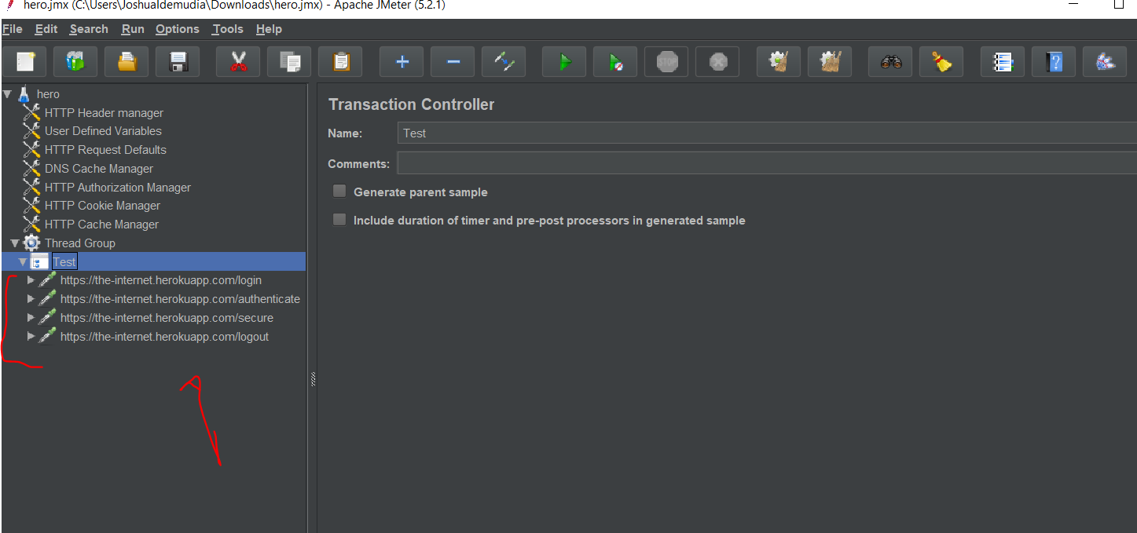

Now this is what I have only hero website any other link I removed. Note blazemeter doesn’t need you to set the port to 8888 but mozilla does otherwise it will not record.

Also remember with mozilla u use hhtp record after that u have to create thread group and copy the result into thread but blazemeter does it for us hence we dnt need http record shit .

So this are the operations needed. Next we will put load on them

As you can see he steps log in authenticate log out….. basically if u click the authenticate you can even see the password and username used.

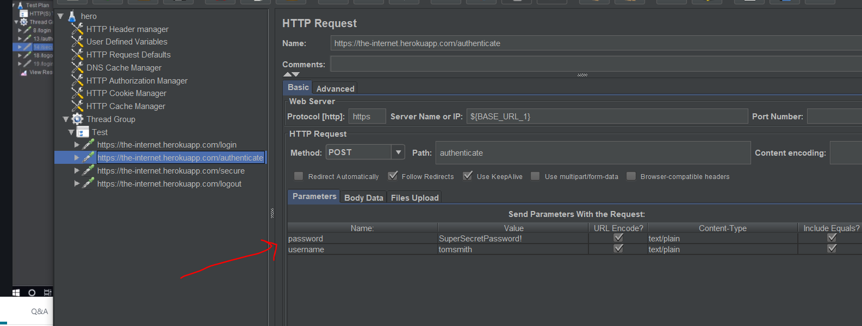

Now lets run this test with 1 user 1ram 1 loop just a normal scenario to make sure no problem at all… no point if you dnt test for 1 first before testing for many or applying load.

Remember next we have to add listeners to check whats happening to see the results… use view tree here or graph report and the last one cant remember

When you log in this is what you see

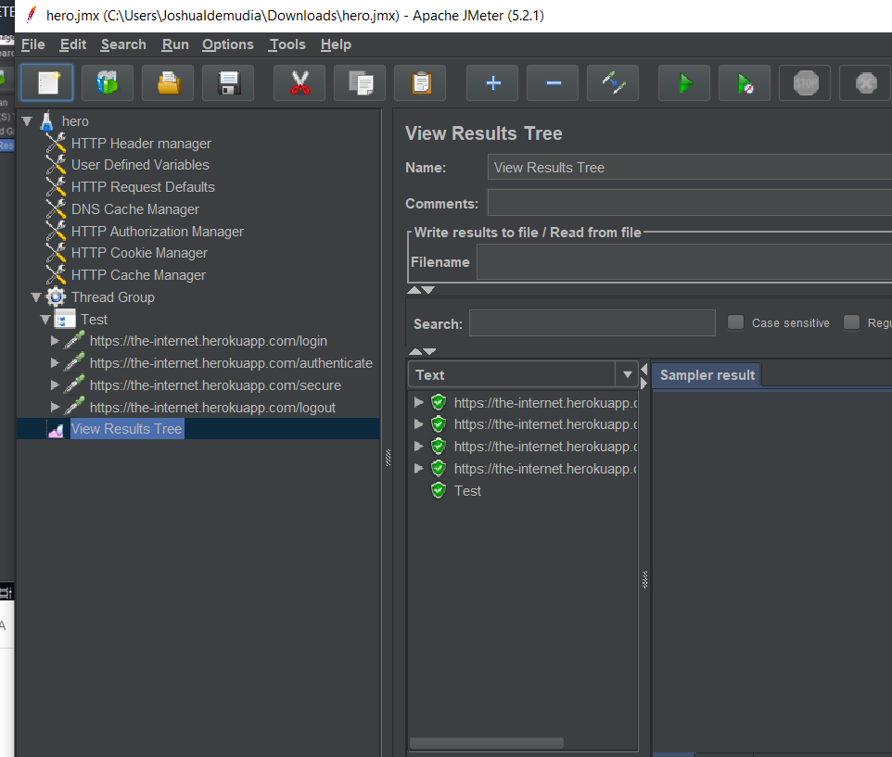

Goooooood all passed….. now we can add load

But first notice something when checking authentication

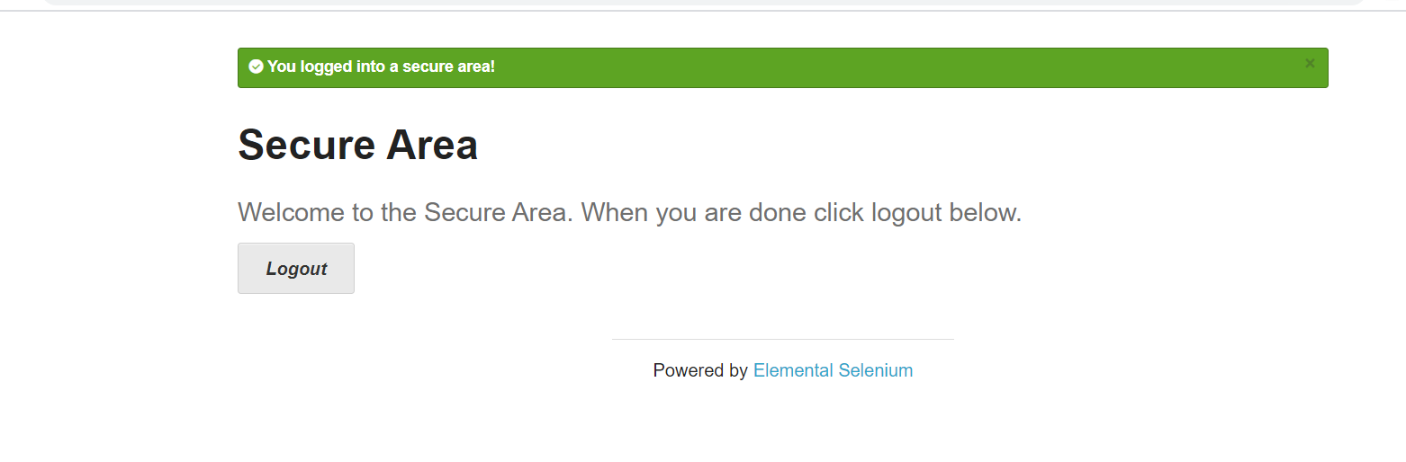

You see welcome to the secure area but the response body still shows the wrong or previous header

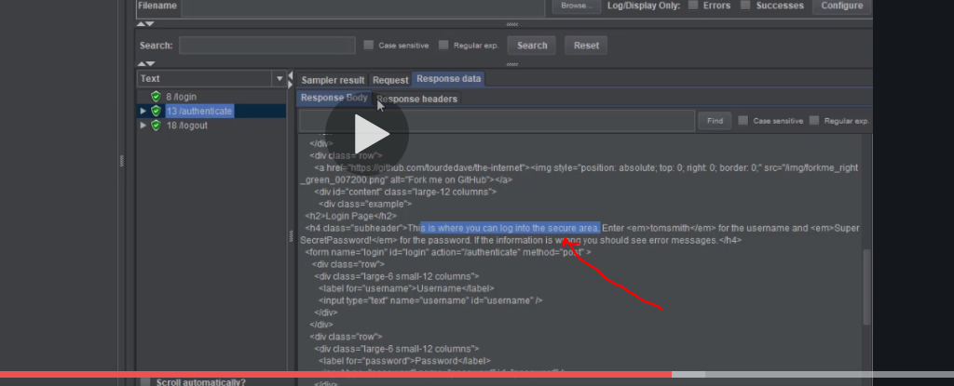

The test shows all green but really it faled so you have to go through the response for sub and main authentication to check properly.

Cookies saves request but http does not save any request . for facebook everything you do facebook cookies saves everything so once you log in close the browser and open the cookie stores so u dnt need to login everytime…so if the cookie expire or if you delete the cookie then it will ask for your details cos cookie relates you to your faceboook account . otherwise cookies stays on for as long till it expires.

So browser also stores cookies so as soon as youtype something it identifies it

But Jmeter aint no browser so doesn’t get it

Also pay attention, the request code is not 200 its 303 means something is wrong

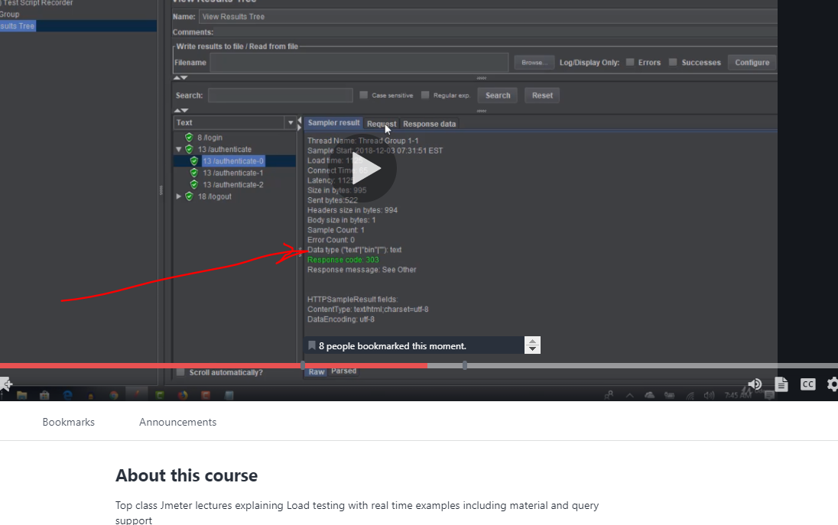

# We have to add http cookie manager

Next we then have to add http cookies manager

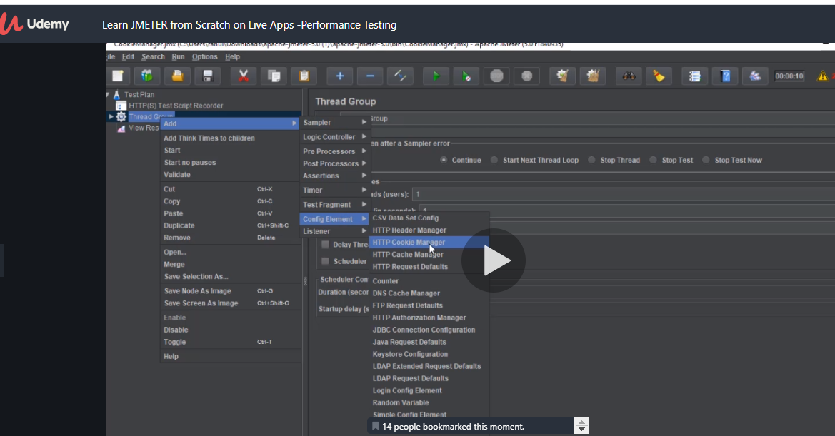

Observe now it now has cookie

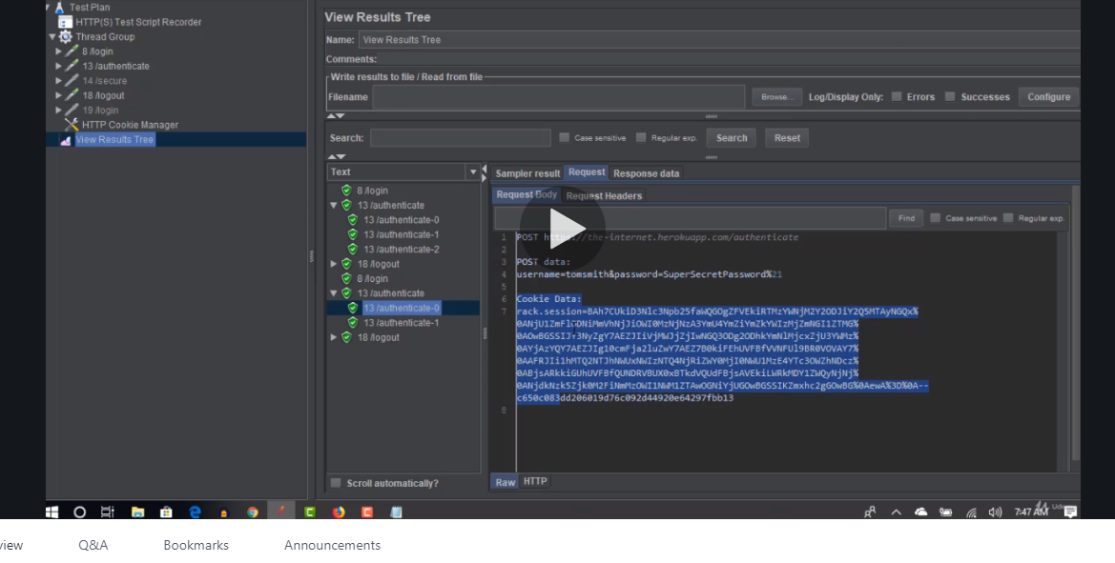

Take note the cookie was got from when you logged in

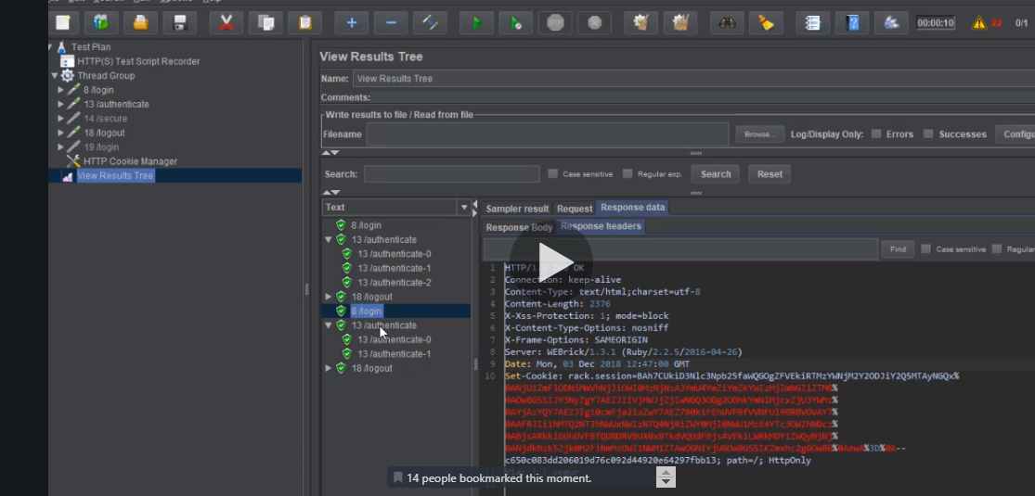

You can also notice the welcome to secure area

So as test when u start your test check request response

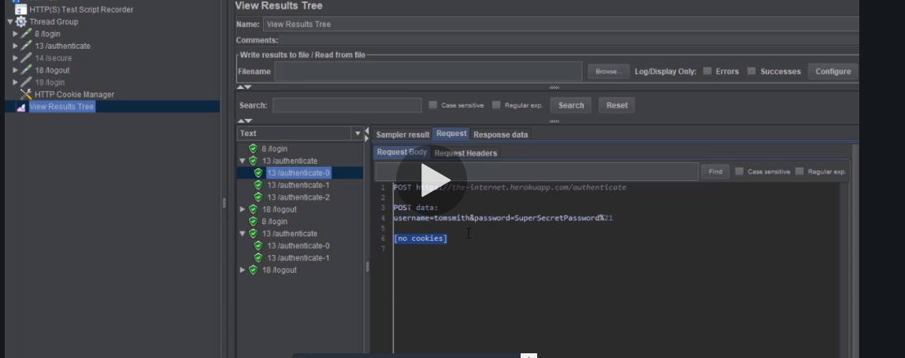

If it say no coolies it means it need cookies so give it some biscuit

# How to validate jmeter test -pass /failed assertion

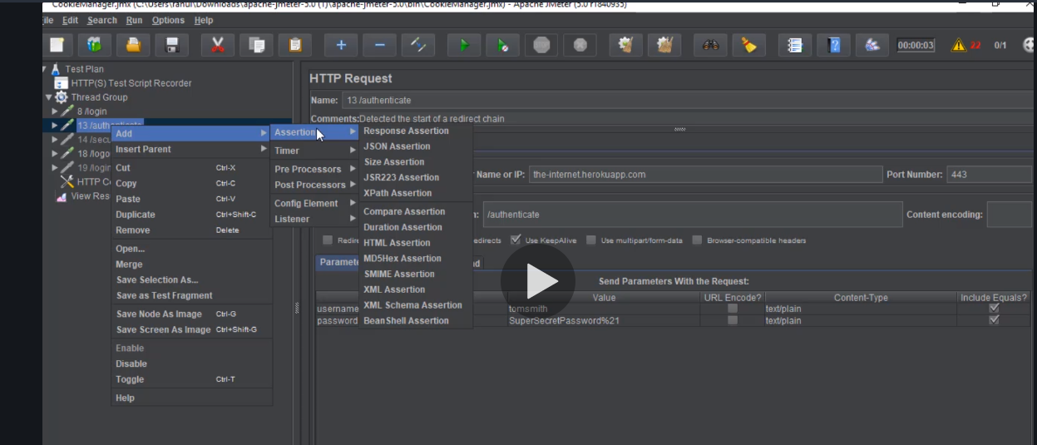

If your report is in xml then we will use xpath assertion and if it is in html use response assertion or html response and if with ap and json response then use json assertion.

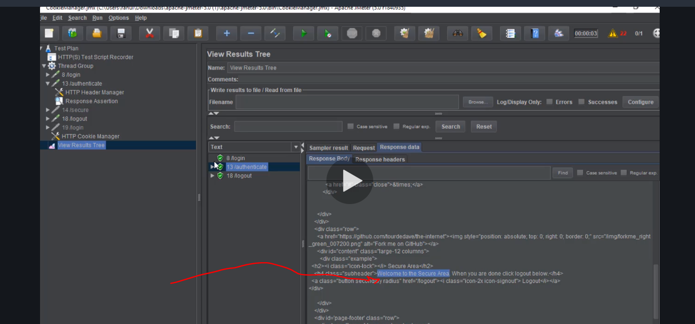

Copy this then go to response assertion select the radio button for text and the click add from click board this will paste what you copied

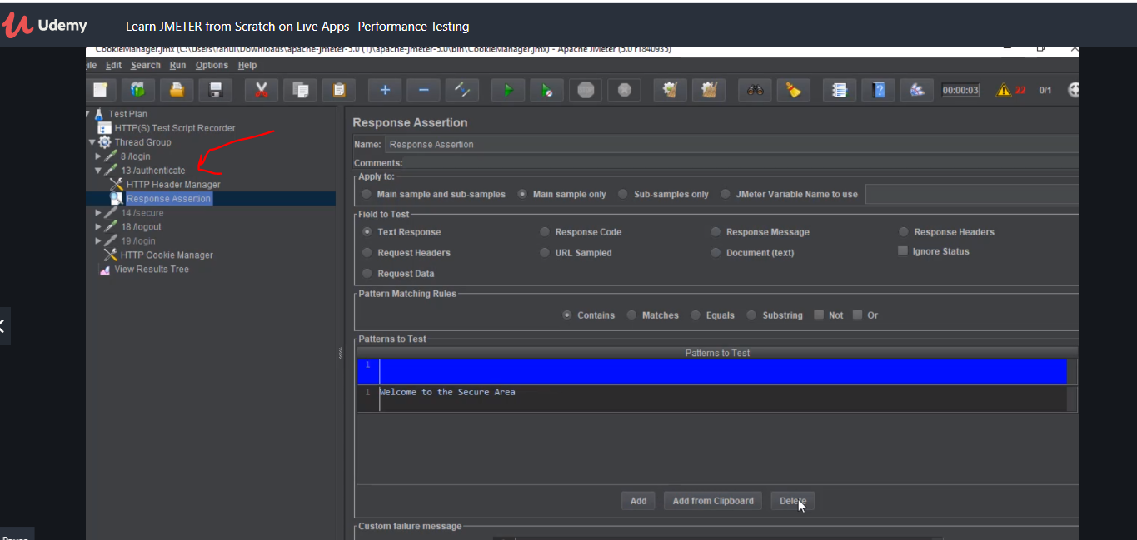

Notice this authentication is in the authentication area

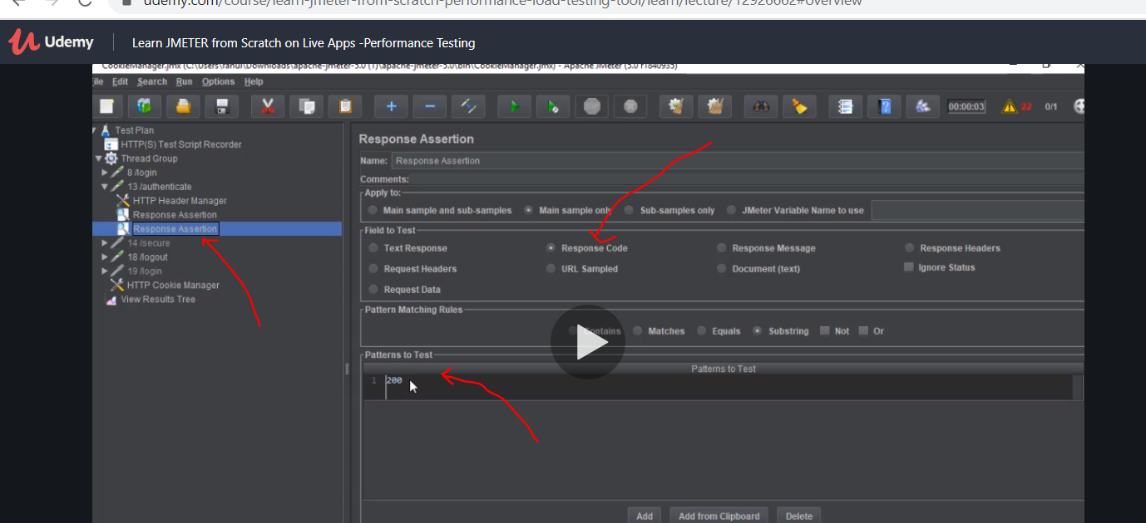

Do another response assertion here click add and put 200 directly for text you have to add from clipboard.

Now you can also add assertion listener

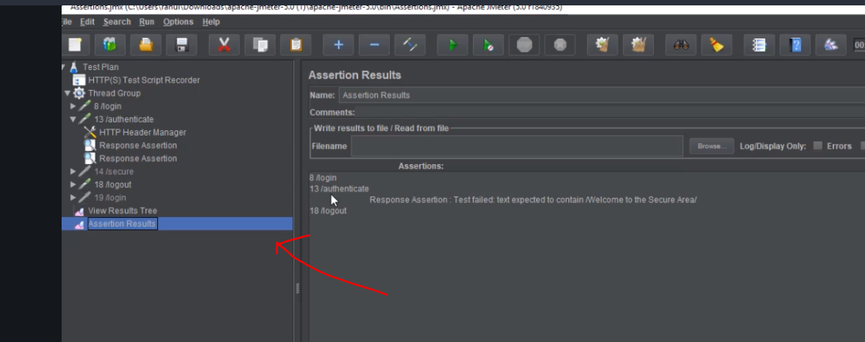

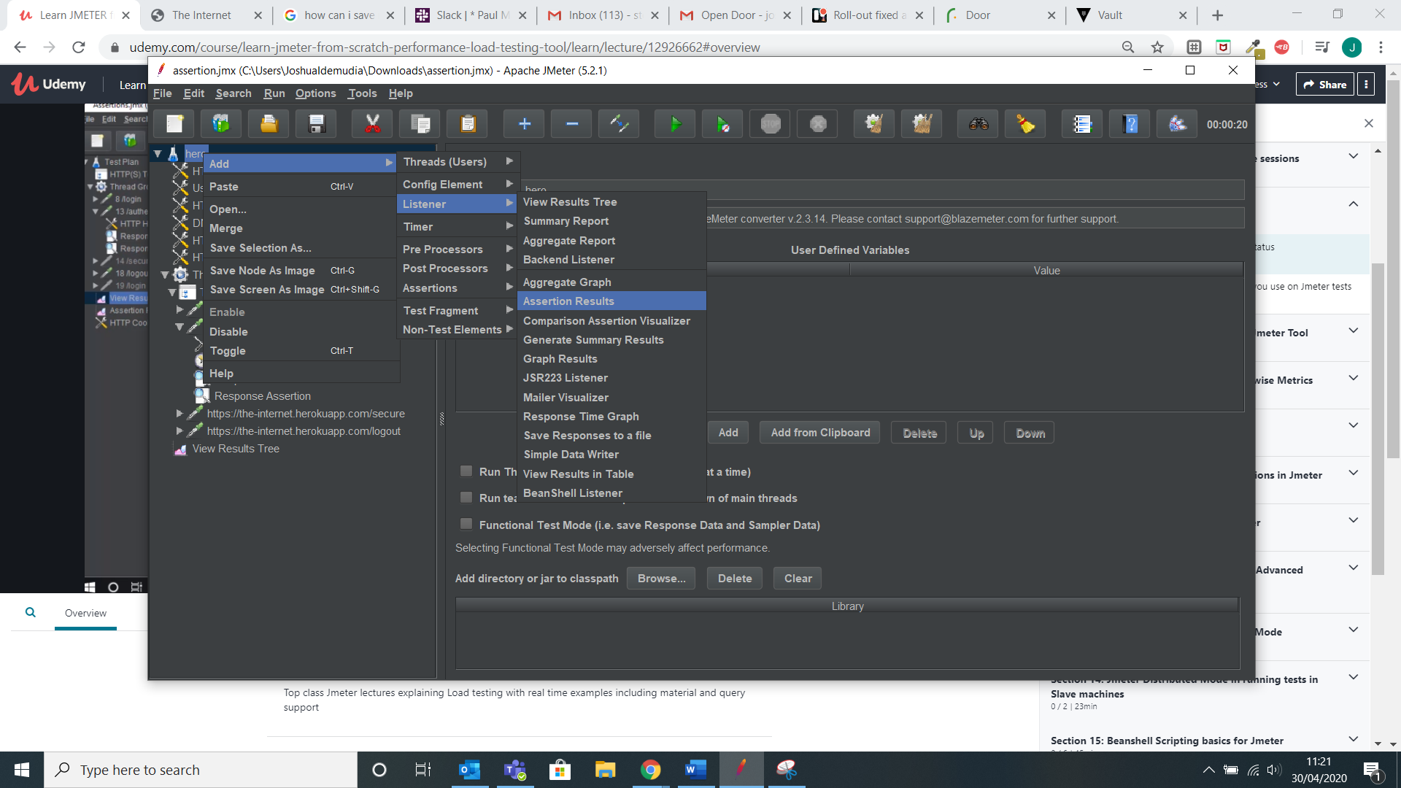

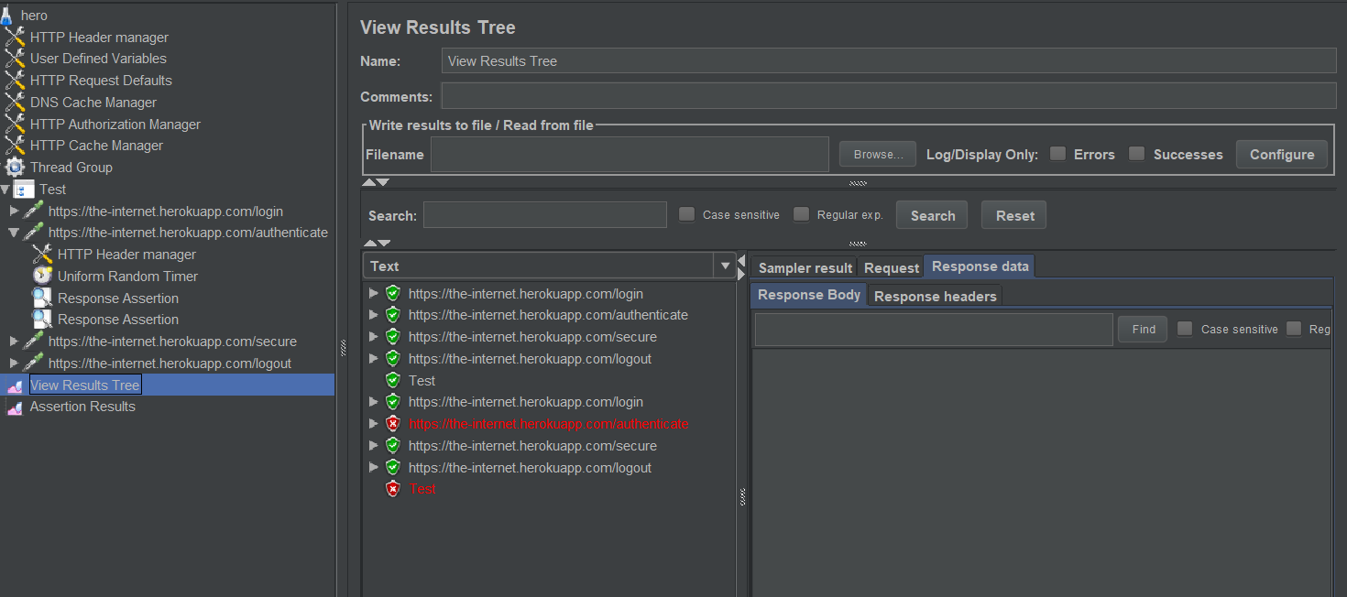

Now without cookie manager we can see how the assertion helps us. Once we put the cookie manager back it will work well.

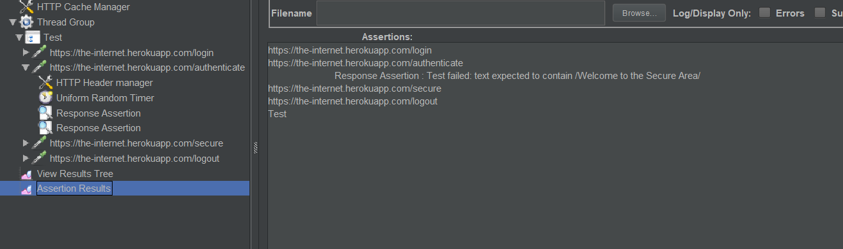

Another assertion size assertion

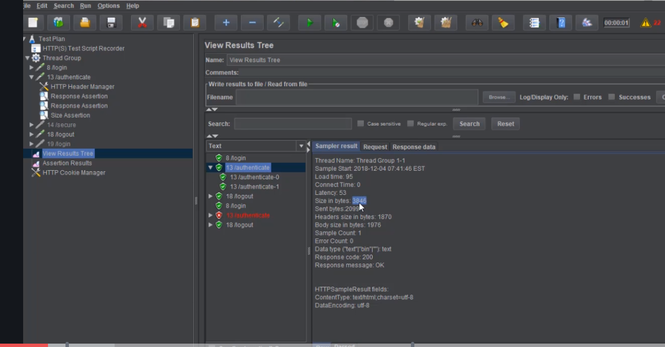

This is very important and should not be less otherwise it will load partially so it is important to validate

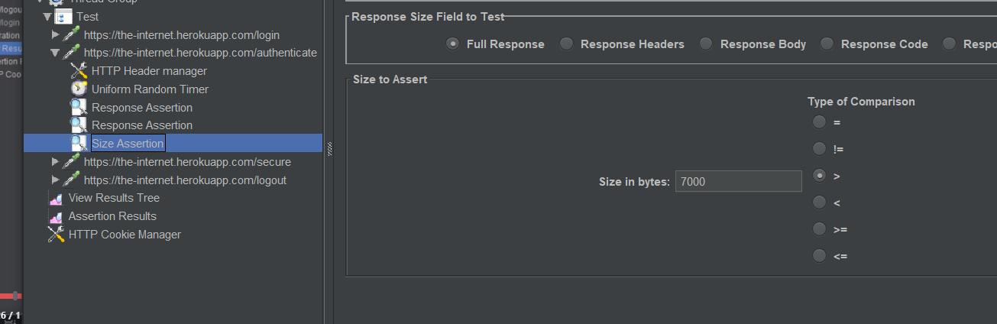

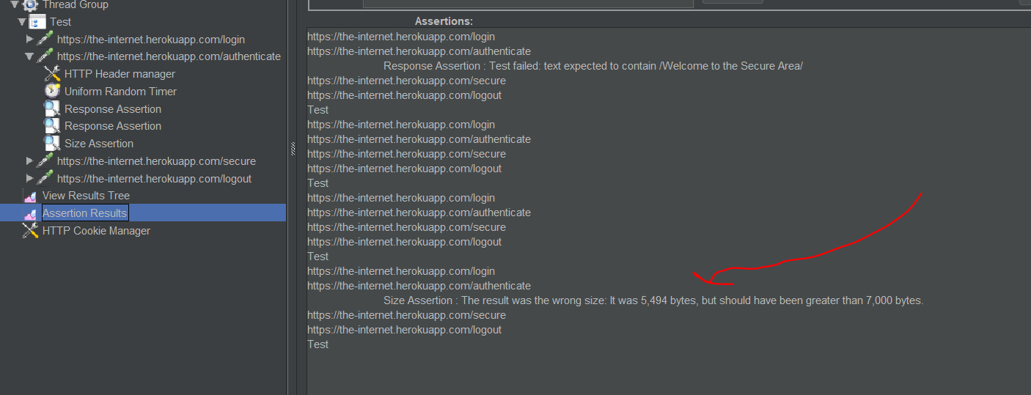

Next is duration assertion

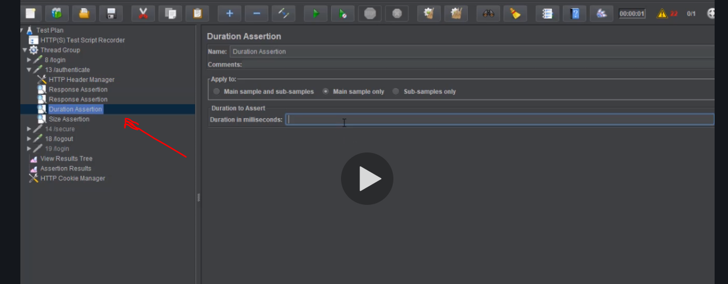

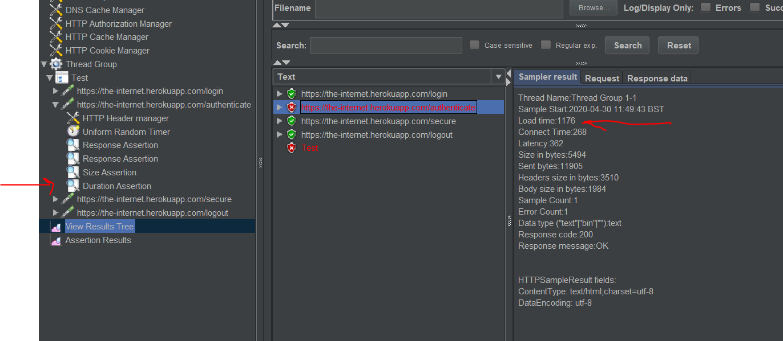

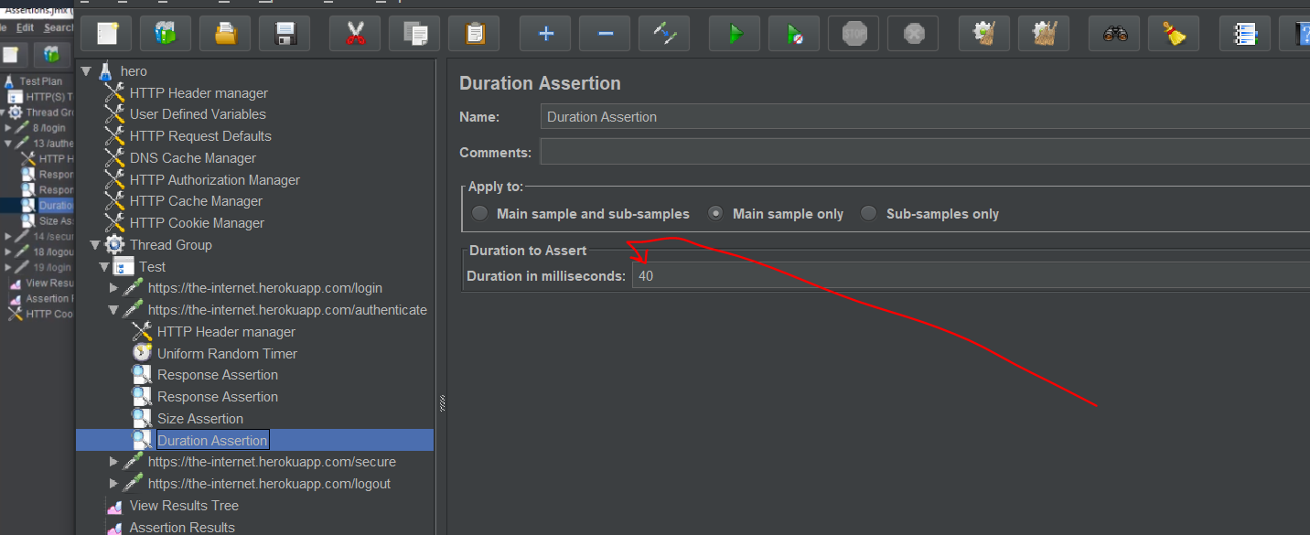

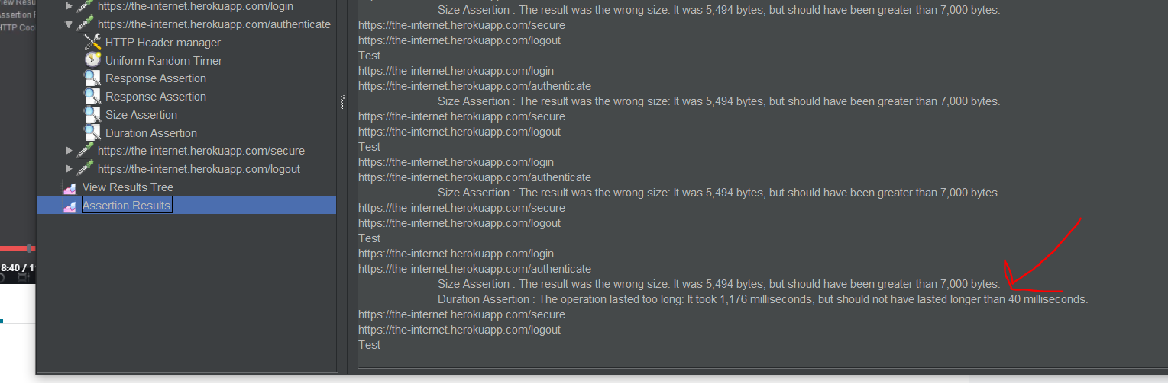

So you can put these assertions and as long as all the conditions are met say your company wants all that condition and you test and any is below then that is a red flag

Now once you have stable results then next step is to put load

# WEBTOUR APPLICATION is shit ignore it

I think this is a simulation environment because if you use it in the real world to load a site u will bring it down so I think this is to simulate the environment

Google webtour application

Password was Fir22* Enreidem then I downloaded the crap fucking validationcode **1590255602648**

# Controller- its like a folder

Container where all request are stored.

Note samplers or request is same kind of means number of times something is done.

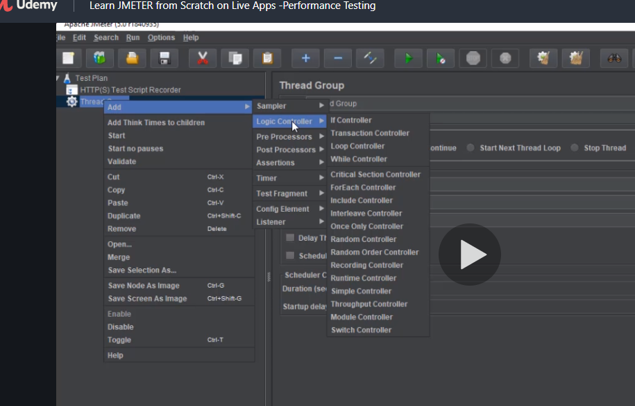

Usinghttp recorder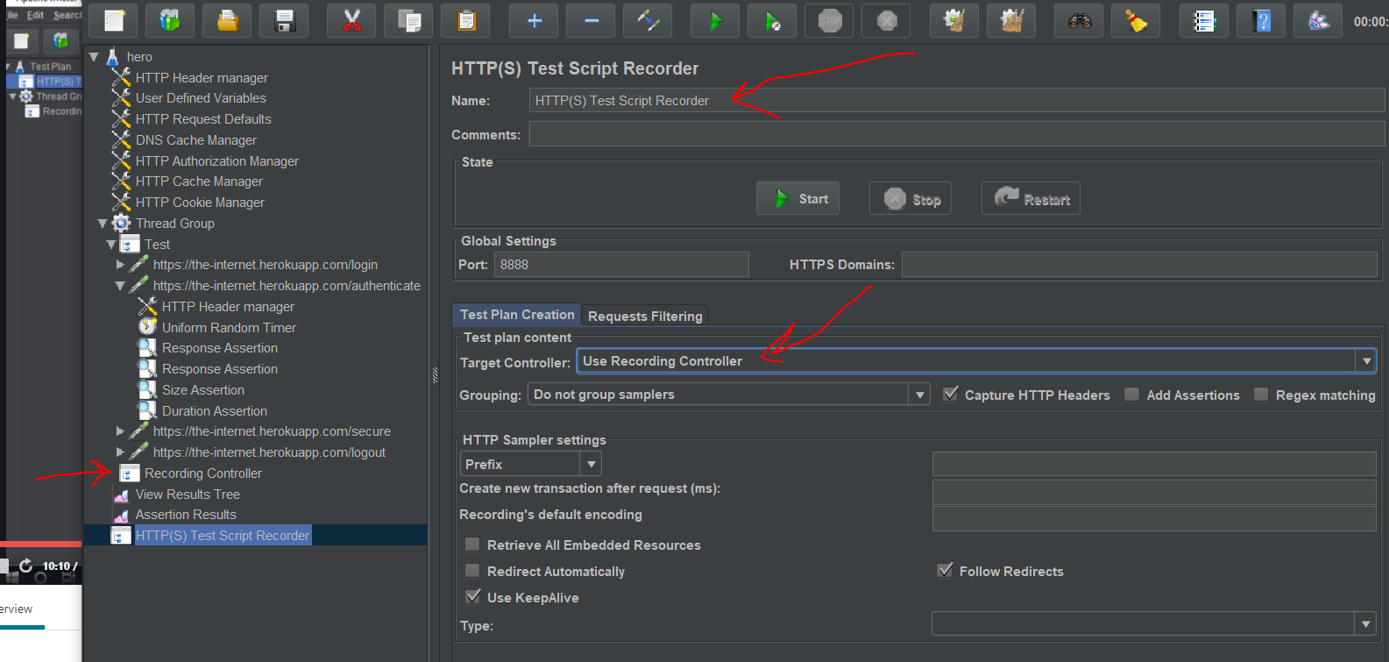

Now create a second controller and copy and paste the test into it

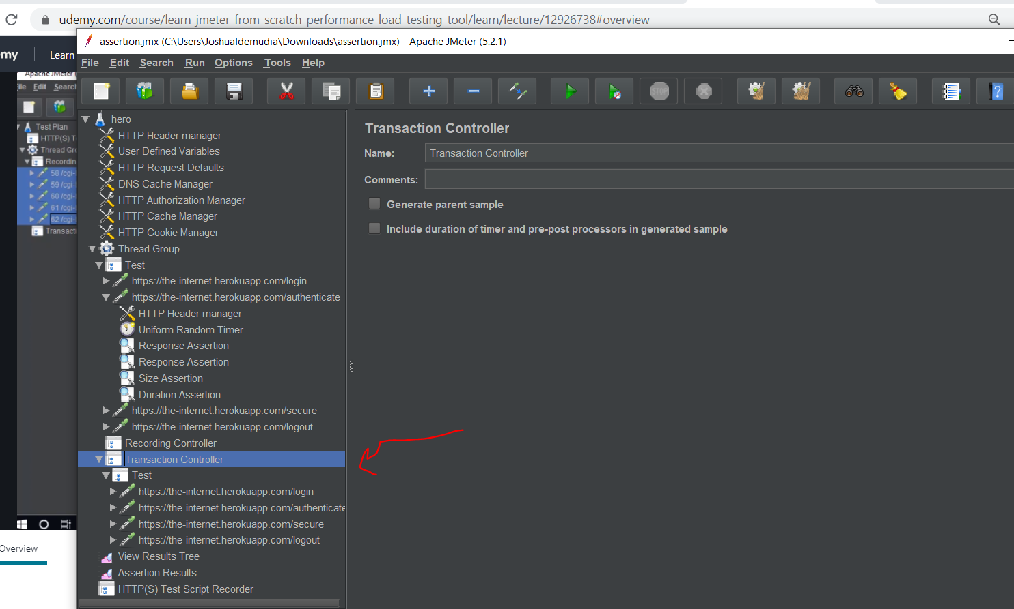

Now you can change it to login the name

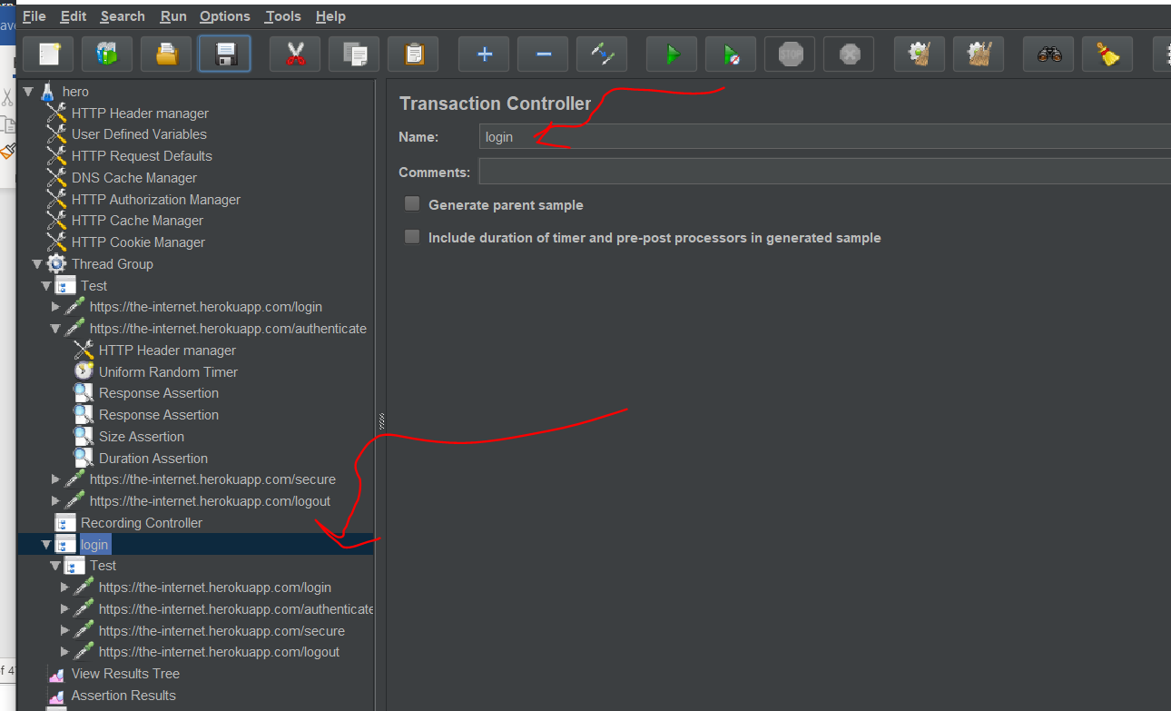

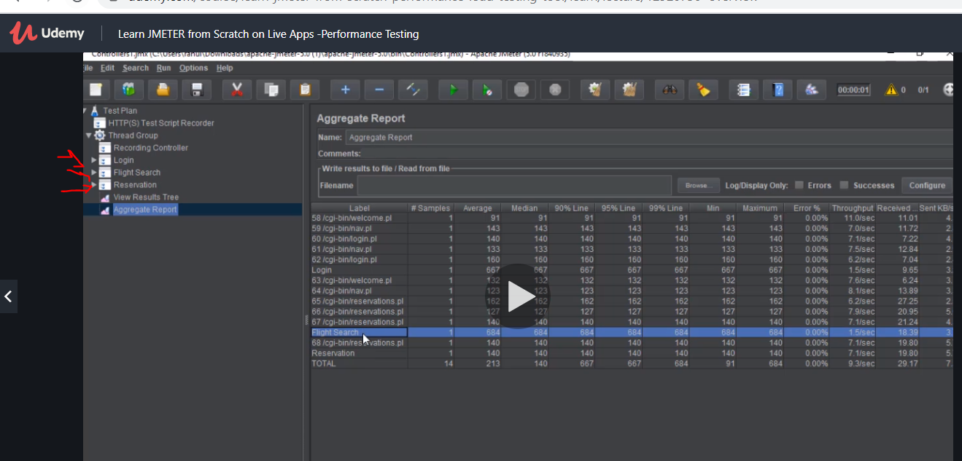

So create 3 transaction and the recoring is going on keep copy the results into thee controller like folder that way each topic contains every transaction type

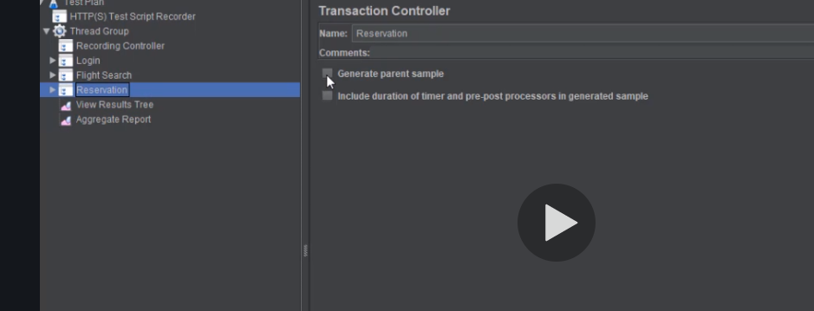

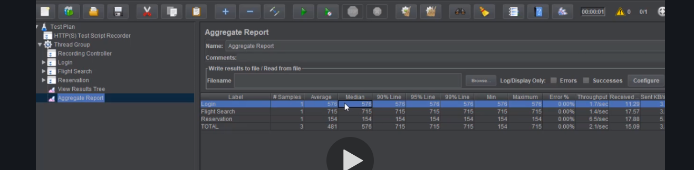

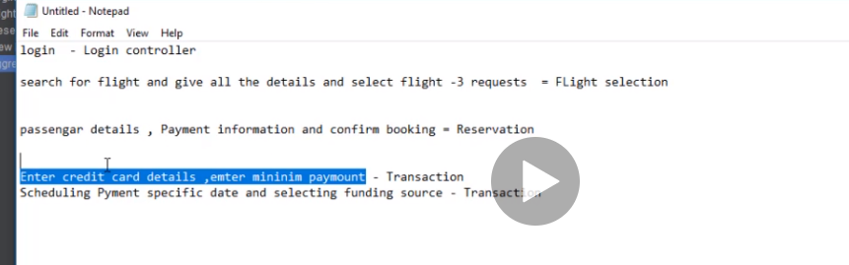

So if you have details like this you have to wrap them up in transaction controllers

Take note you are collectingthe recording from the recording control maybe or not the thread controller for blazemeter.

Now add module controller to avoid repeating your work

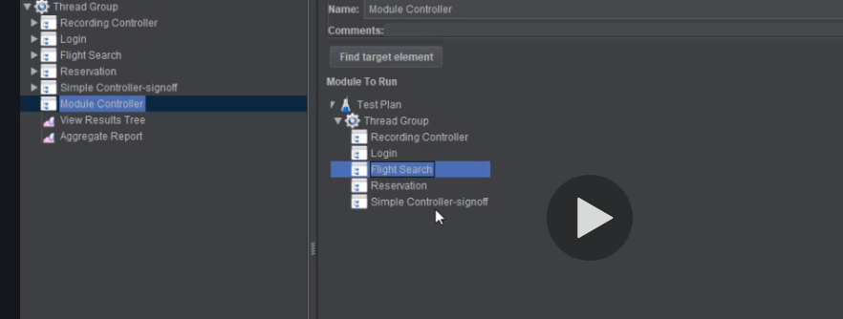

Just select the one u want and it will run the selected one twice

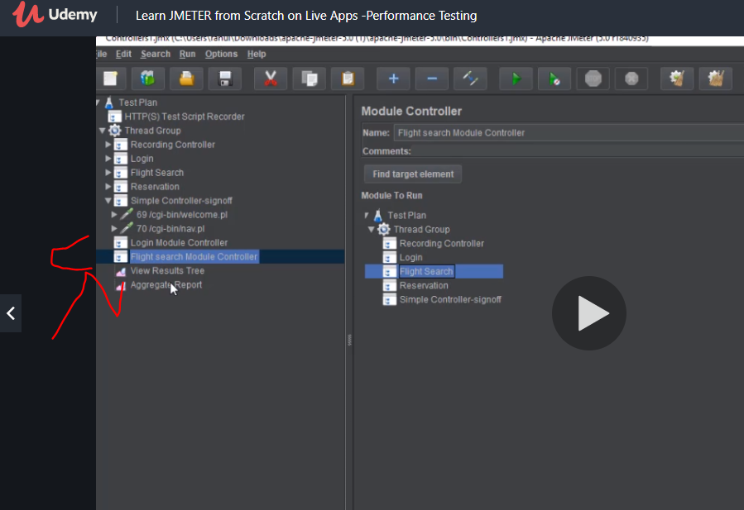

# Regular expression extractor

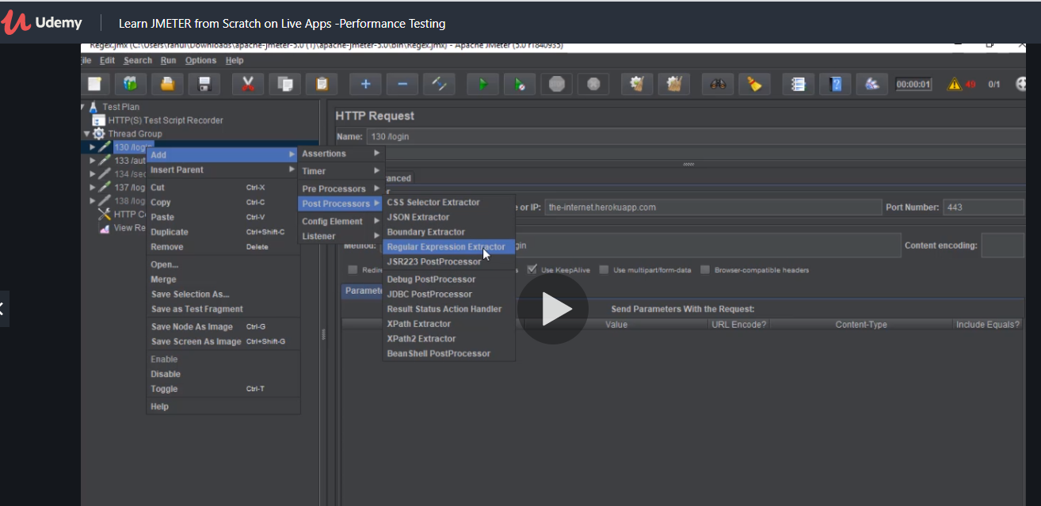

Notice it is placed under the login

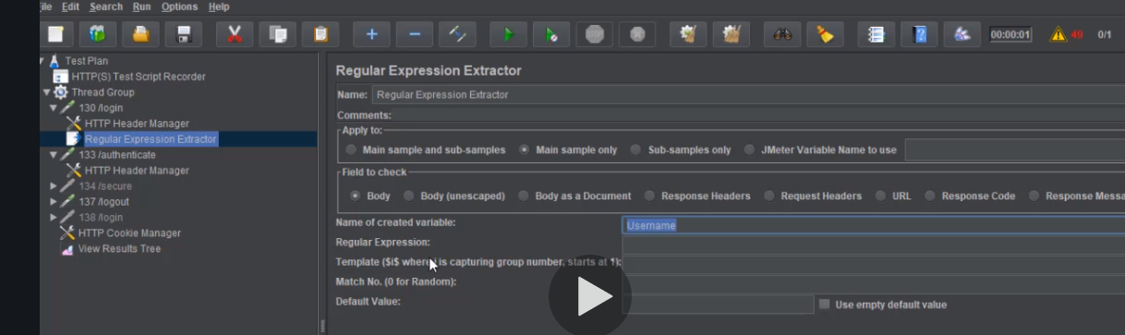

We use dollar sign

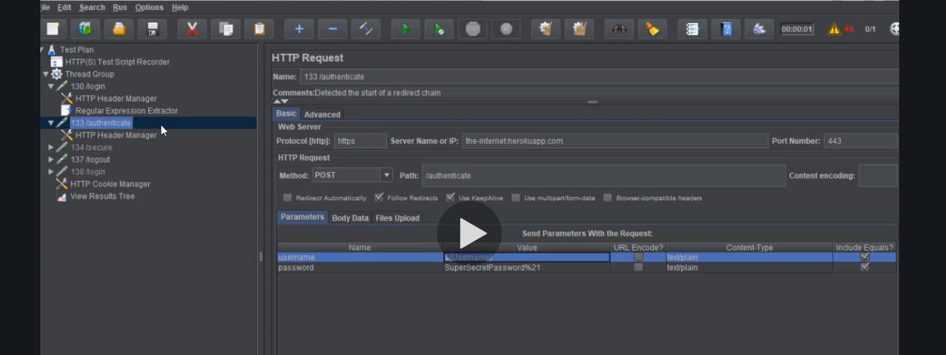

So basically they want to avoid the username and password hardwire

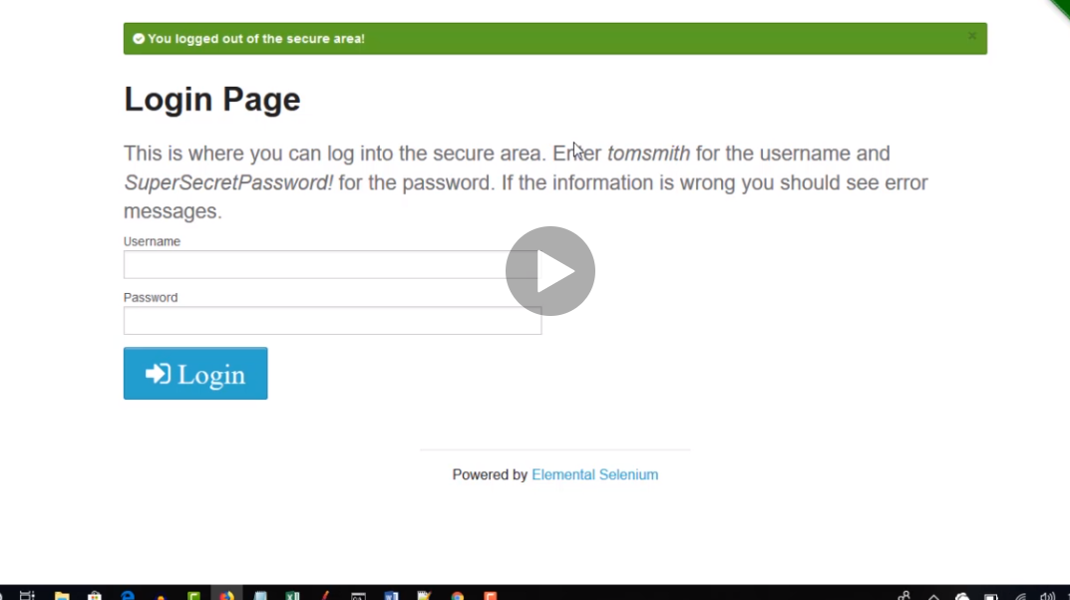

# Data driven

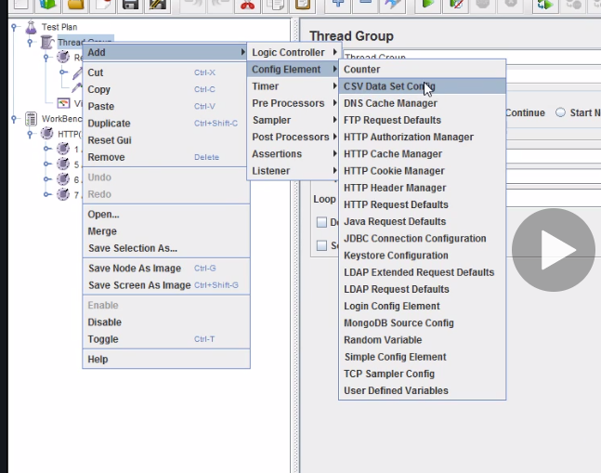

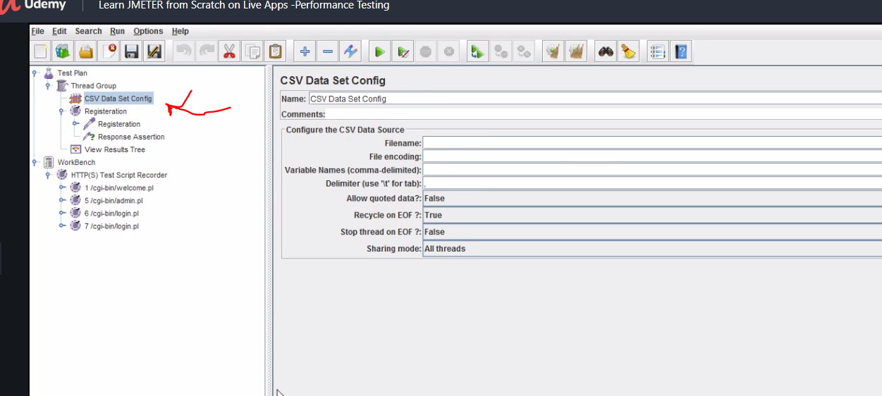

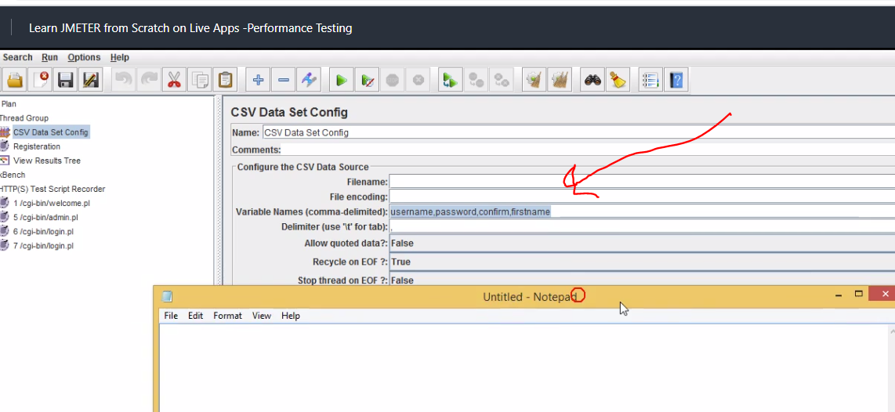

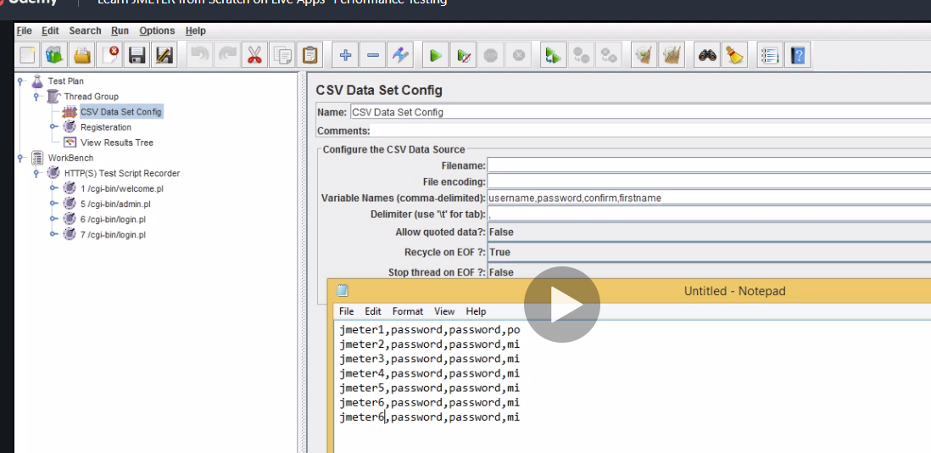

Save it as csv extension or it wnt workas just note pad

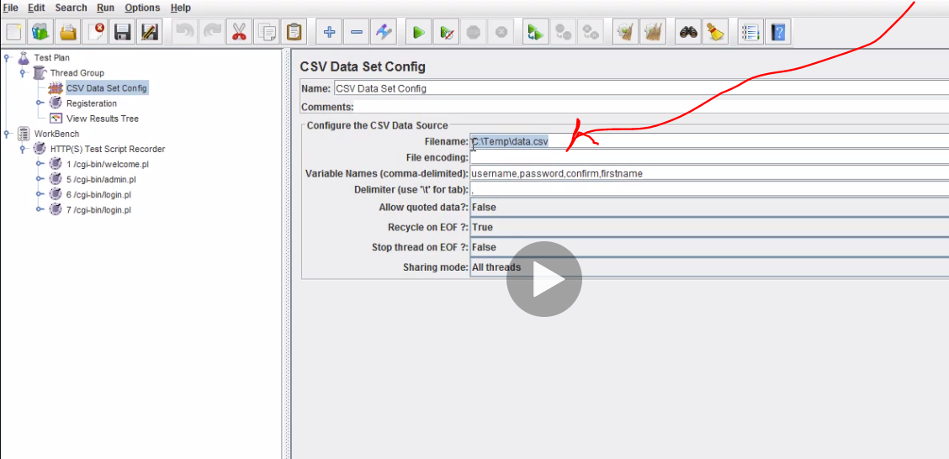

Add the directory of the location of the saved file.

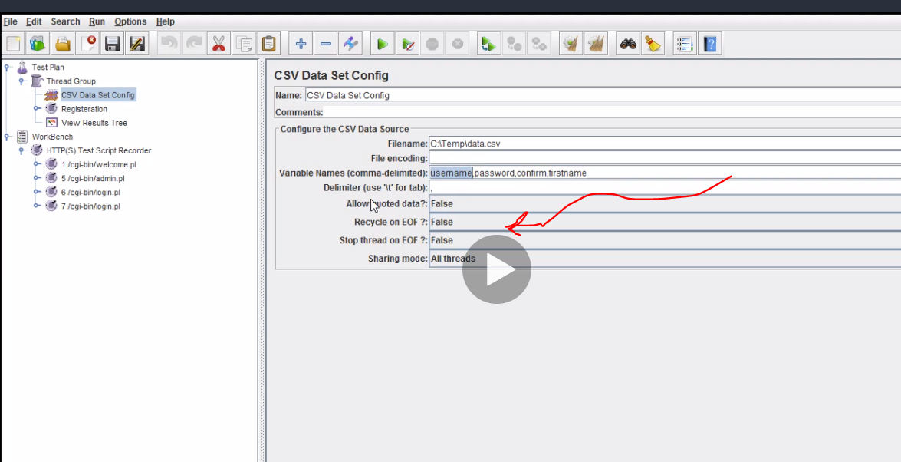

Now use dollar sign to call them here

Remember tou first record and get the request. Now use a registration request go and change the name and use dollar sign for the for variables, the others invluding fistname stay the same

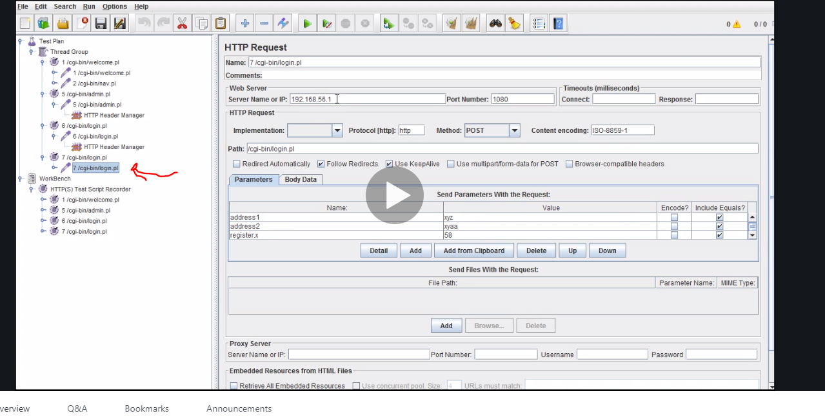

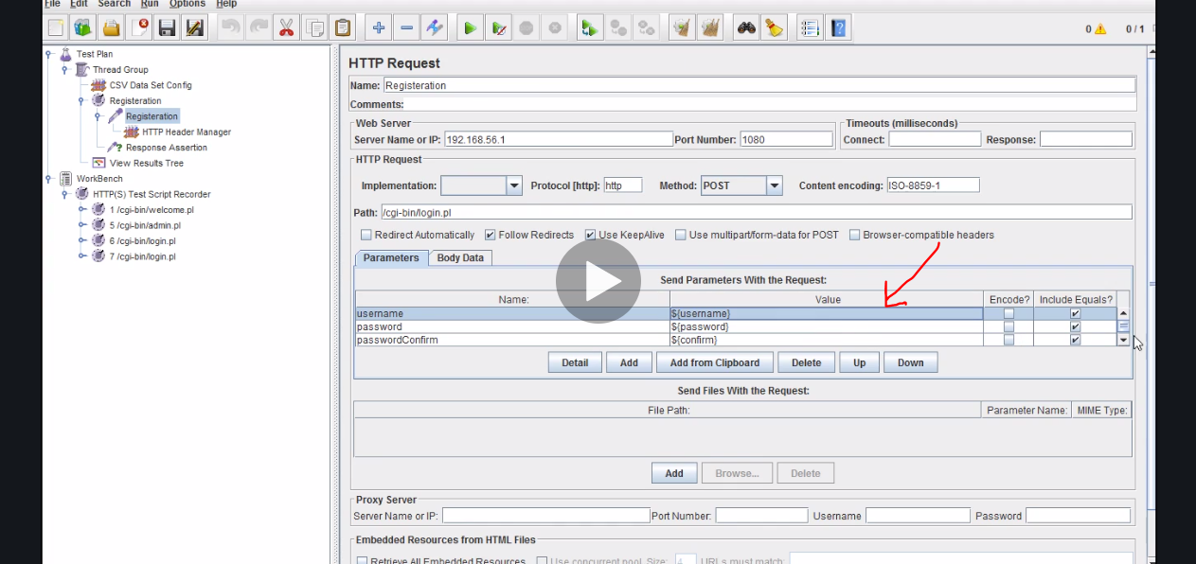

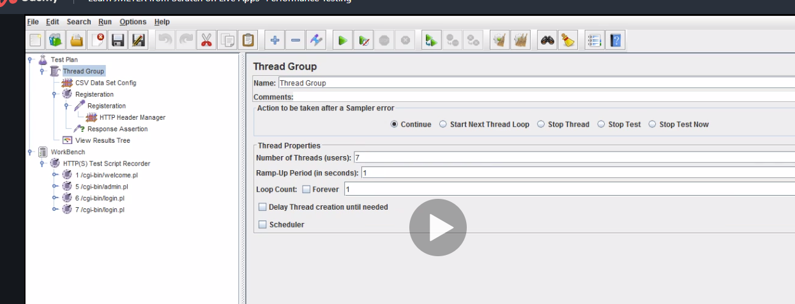

Change number of thread to seven because we have seven users from the csv file

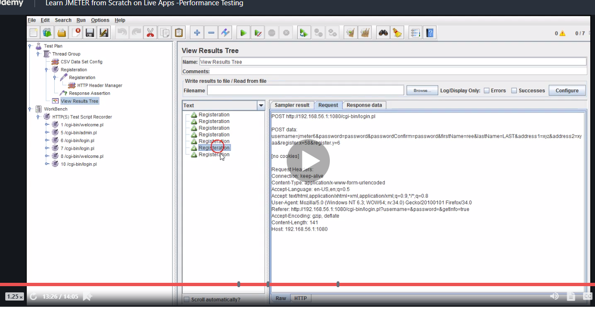

rememner

# correlations

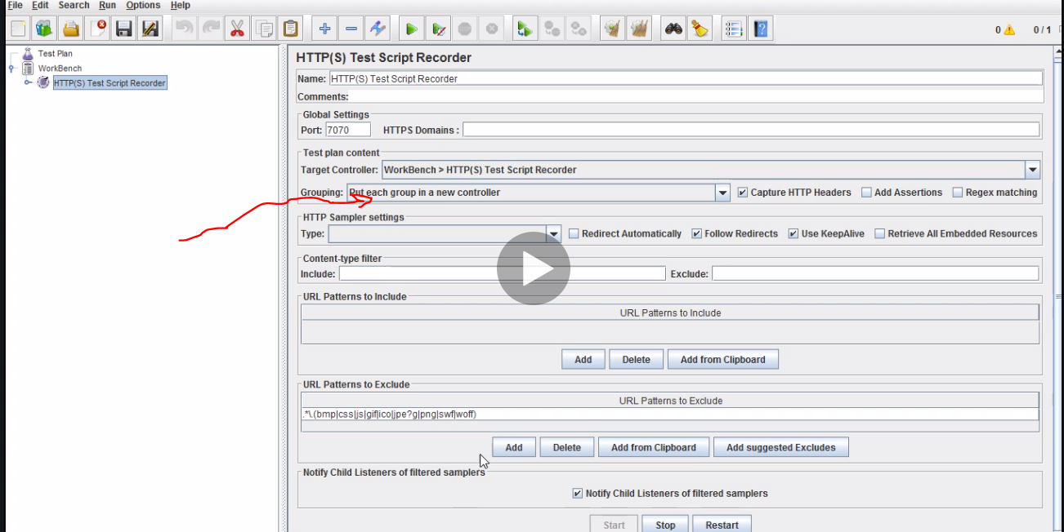

Recorded parameters

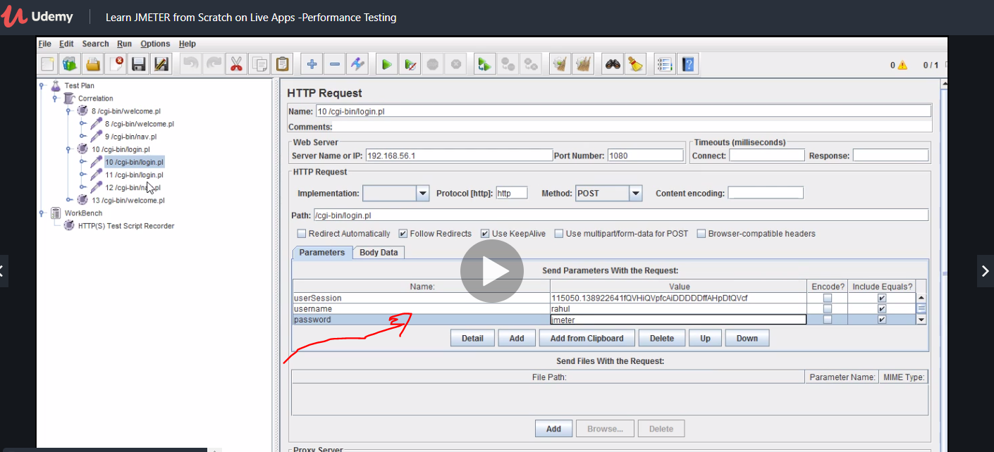

Correlation is getting unique values evertime and we corolate them

Now because we are not handling session dynamically we get this problem

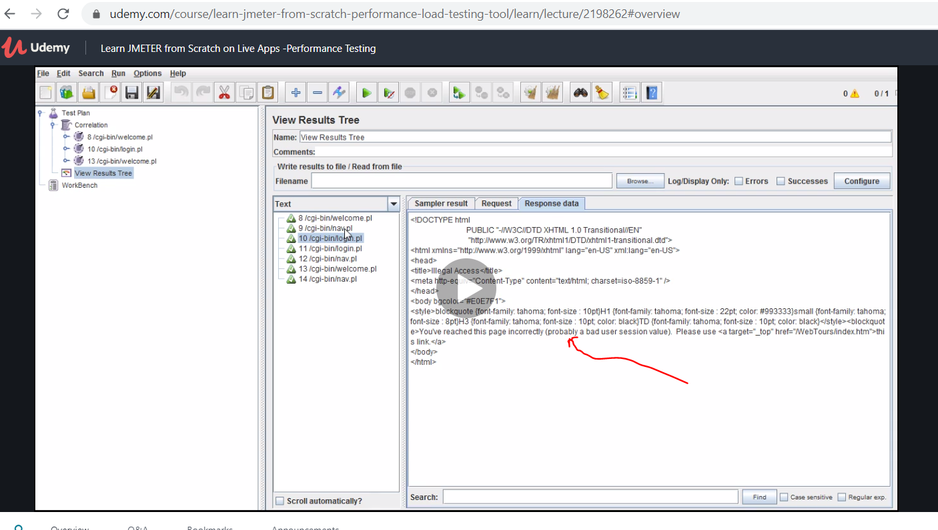

Now search

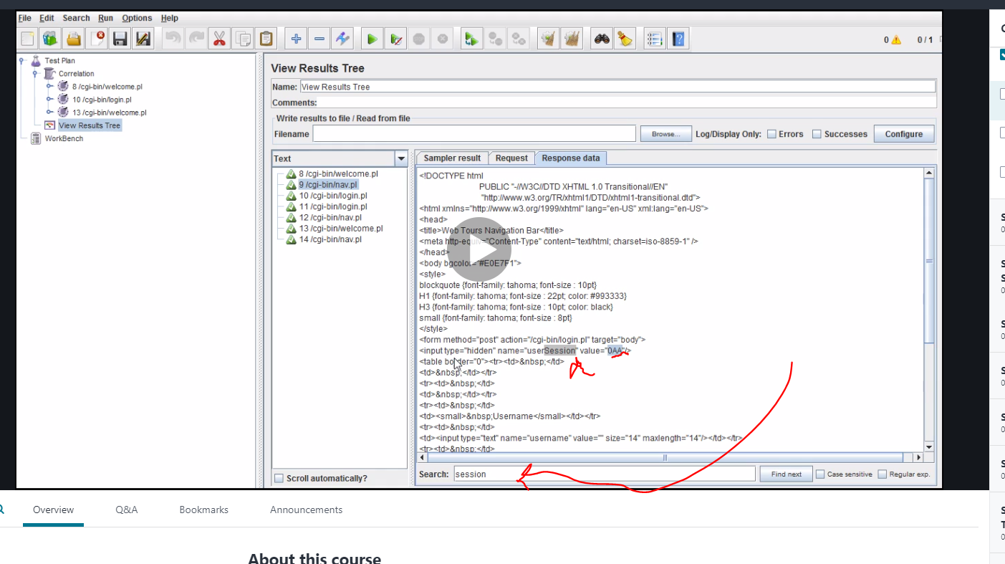

Back to the page

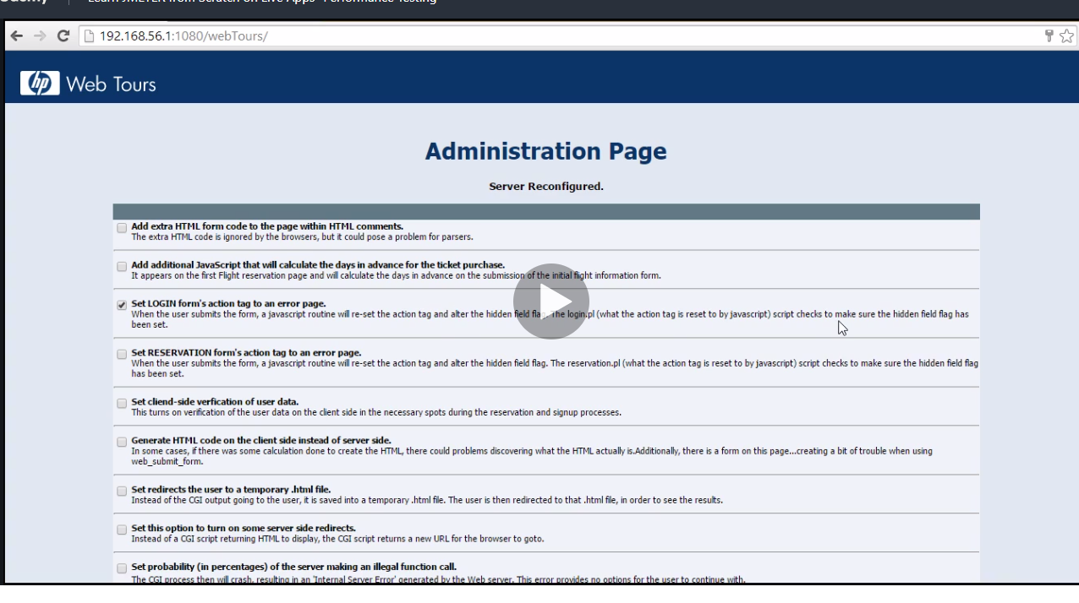

Note dynamic means something is changing

Now using regular expression

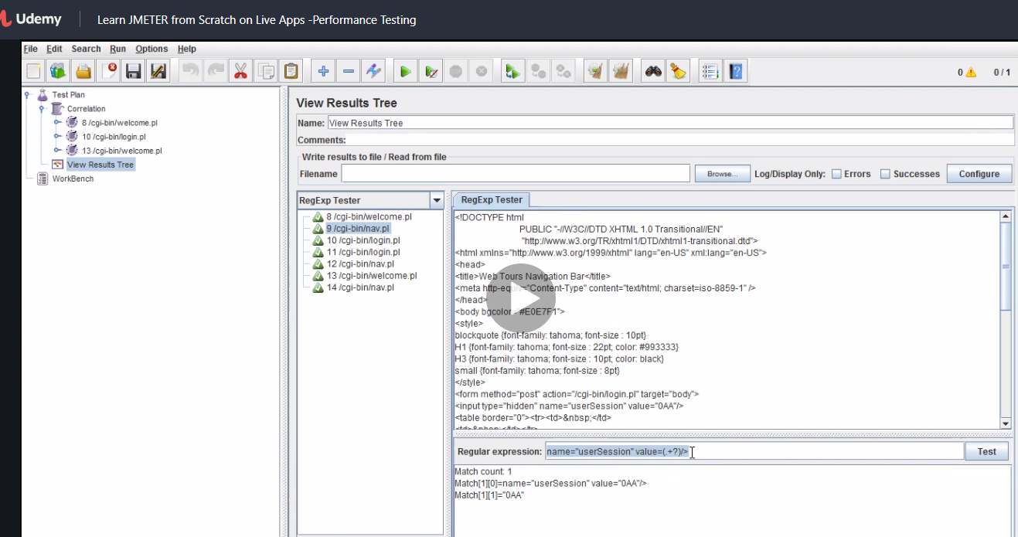

# Extra note

**List of Most Frequently Asked JMeter Interview Questions And Answers to Help You Prepare For The Upcoming Interview:**

JMeter has become quite popular in the Software Testing industry within a very short span of time. Jmeter is a java application that is built by Apache.

Experts consider Jmeter to be the best open source load testing tool that can be used to measure the performance of an application. This article concentrates more on all the prime concepts of JMeter which you need to be aware of.

***This article includes a set of most popular JMeter interview questions and answers along with examples in simple terms, which in turn will enable you to understand the concept better and thereby help you to clear any interview successfully.***

[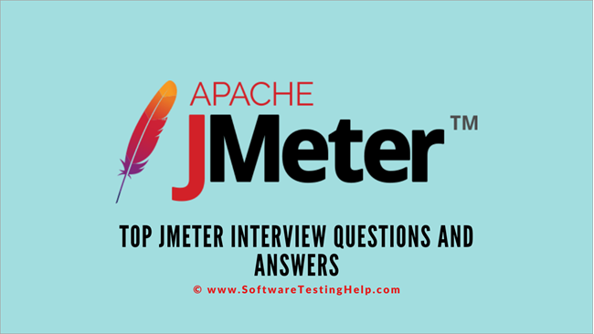](https://cdn.softwaretestinghelp.com/wp-content/qa/uploads/2020/03/Top-JMeter-Interview-Questions-and-Answers.png)



### **Most Important JMeter Interview Questions**

**=> Further reading: Read our Complete Free**[**JMeter Tutorial series here**](https://www.softwaretestinghelp.com/jmeter-tutorials/)**.**

**Q #1) Explain the architecture of JMeter.**

**Answer:** Jmeter is a Java-based open-source application that is basically designed for the purpose of Load Testing. It supports all major protocols that are supported in Load Runner. Unlike any browser, JMeter works on levels of protocols and does not execute JavaScript present in HTML web pages.

**Q #2) Does JMeter simulate actual browser behavior?**

**Answer:**No, JMeter does not support the actual browser behavior. It does not render the HTML webpages as the normal browser does. The response can be viewed in HTML format but the actual timings are not present in the generated samples.

**Q #3) What is Distributed testing?**

**Answer:** Distributed Testing means using multiple machines for load testing in which one of the machines can be made master and others can be kept as a slave. It is very important to note that all the machines should be on the  same network and should have the same version of Java and JMeter

**Q #4) What is the use of Regular Expression in JMeter?**

**Answer:** Regular Expression is used for extracting some values dynamically from the responses.These values can be used in the subsequent request or can be saved for reporting purposes. Regular Expression is used in both Pre-Processors as well as Post Processors.

**Q #5) What are the types of processors in JMeter?**

**Answer:** Basically there are two types of processors in JMeter namely Pre-Processor and Post Processor.

Pre-Processors execute before the main sampler and can change the scope of the sampler whereas Post Processors execute after the main sampler and are applicable to all samplers in the same scope of Test Plan. They can be used to extract some fields from the server response and store them in variables.

**Q #6) What are the different ways of Data Parameterization in JMeter?**

**Answer:** Data Parametrization makes the scripts reusable where the values is not required to be hardcoded for the same request with different parameters.

**Below is the data parametrization that is supported in JMeter:**

* CSV Data Set Config
* User-Defined Variables.

**Q #7) What are the maximum recommended threads on a single system?**

**Answer:** It depends on the hardware configuration of your system which includes a processor, JVM, allocated memory -Xmx, etc.

Other factors that impact thread count are the number of components in your test plan i.e. the number of config elements or processors and it also depends on whether you are using GUI/Non-GUI Mode.

**Q #8) Explain the difference between Gaussian and Poisson Timers.**

**Answer:** Both Gaussian and Poisson Timers work on a mathematical formula with some constant delay and additional offset. Difference between the two lies in the fact that how the lambda value is calculated in the case of Poisson timer and how deviation is calculated in the case of Gaussian Timer.

**Q #9) What are the major differences between JMeter and Load Runner.**

**Answer:** JMeter is considered as the major competitor of Load Runner in the industry. **Enlisted are some of the major differences:**

| **Load Runner** | **Jmeter** |
| --- | --- |
| Licensed Software | Open Source tool. |
| Developed by Mercury | Developed by Apache. |
| UI is very impressive | It lacks in UI |
| It has more technical capabilities. | Less technically sound as compared to Load Runner. |
| Supports SAP, Siebel and Peoplesoft. | Doesn’t support SAP and Siebel |

**Q #10) What is the use of co-relation in JMeter?**

**Answer:** Co-relation is a process of extracting the values from the server response and storing it in a variable to be used in any other request which is to follow.

**For Example,** for testing any login functionality if you have to use the session ID/cookie ID, you can extract the values from the response of GET Request of the login page and then dynamically use the same while making POST request for a login.

**Q #11) What are the different types of listeners?**

**Answer:**Listeners are used for storing the execution results of load testing in different forms be it in a table, graph, tree or in any other presentable format so that it can be presented to the client. There are different type of inbuild listeners in JMeter and many others can be imported into it by using plugins as per the requirement.

**Some of the inbuild listeners are:**

* View results in Table
* View results in Tree
* Graph results
* Aggregate graph
* Aggregate report
* Assertion results
* Response time graph

**Q #12) Explain the flow of the Test Script Recorder.**

**Answer:** HTTP(s) Test Script Recorder is used to record all the Http(s) requests going to the server from your application. Some configurations require to be done in JMeter in order to make it work.

**Steps followed to record https traffic are:**

* Add HTTP(s) Test script recorder to WorkBench.
* Enter the port number to start your proxy server.
* Choose the target either as “Workbench” or add a Recording Controller in your test plan and select the same target for storing all the recordings under it.
* Start the proxy server.
* Configure your browser with manual proxy settings pointing to the same port number used in the test script recorder.

**Q #13) Can JMeter record actions from mobile? If yes, how?**

**Answer:** Yes, JMeter can record HTTP or Https request going to the server from your mobile application also. It is required that mobile and JMeter are on the same network.

**Below is the configuration required:**

* Configure your proxy server in JMeter to run at a specified port.
* Set up the proxy on your mobile wifi settings and enter the same port number that is used in the recorder.
* Install the Root CA certificate on your mobile.
* Hit server requests from your mobile and observe it getting captured by the specified controller.

**Q #14) How to do master-slave configuration in JMeter?**

**Answer:** Master-slave configuration is a part of distributed testing in which more than one machine is used to perform load testing of the server under test.

It is very important that all machines are on the same network and all have the same version of JMeter. In distributed testing, one machine considered as the master and the others are kept as slaves by doing some configurations.

**The process is specified below:**

* On the master machine, edit the JMeter.properties file and add the IP addresses of slave machines against the remote_host field in the file.
* Save the file and open the JMeter again.
* Now, from the RUN menu in JMeter, select Remote Start and choose the IP of the machine to be invoked.
* Choose RUN menu and select Remote Start all to start all the slave machines for your testing.

**Q #15) What are the JMeter supported protocols?**

**Answer:** JMeter**supports various standard protocols like:**

* HTTP/HTTPs
* SOAP
* LDAP
* FTP
* SMTP
* TCP

**Q #16) Explain the syntax of JMeter variables and functions.**

**Answer:** Just as in any other programming language, variables and functions are used in JMeter also in order to make the scripts reusable.

**Syntax of Variable** – ${var}

There are many inbuilt functions that are available in JMeter to perform various actions. Function string can be generated from the Function Dialogue Box itself.

**For Example,** if you want to get the machine IP stored in a machineIP variable, you can use the string ${__machineIP(machineIP)}.

**Q #17) Why is it recommended to run JMeter in GUI mode?**

**Answer:** JMeter tests can be run both GUI as well as Non-GUI Mode. It is highly recommended to run the load test in Non-GUI mode because the AWT event thread can kill the tests in case of high load scenarios.

**The various Non-GUI mode supported with JMeter are:**

* Command-line
* ANT plugin
* MAVEN plugin
* Jenkins

**Q #18) Is it possible to run selenium scripts in JMeter? If yes, how?**

**Answer:**Yes, it is possible to run selenium scripts in JMeter to get some ideas on their performance.

There are two ways of doing it. Either you can use JUnit libraries to build selenium scripts and save as Jars and copy the same in the JMeter directory. And then add JUnit sampler to your test plan and import the Jar file.

Otherwise, the Webdriver sampler plugin can be added in the JMeter ext folder. Restart the JMeter. Write your selenium code in the Webdriver sampler and then execute it to see the performance.

**Q #19) How do you manage sessions and cookies in JMeter?**

**Answer:** Sessions and cookies can be managed in JMeter by using config elements such as HTTP Cache Manager which provides an option to clear the cookies in every iteration and also allows to add user-defined cookies.

HTTP Cache manager helps you in clearing cache after each iteration as per your requirement in the load tests and also limits the number of elements that can be stored in the cache. Both of these config elements can be attached to the HTTP sampler.

**Q #20) What are the important steps for testing JDBC request?**

**Answer:** JDBC requests are used to establish a connection with the databases and then measure the response time of the queries.

**Important steps for testing JDBC requests are:**

* **Setting up Config Element,** JDBC Connection configuration in which Database URL and JDBC Driver Class needs to be added as per the database which is being used. Also, add the variable name for this connection configuration so as to use it in the sampler.
* Add JDBC Request. Add the same variable name added above and write your queries to the test.

**Q #21) What is BeanShell scripting?**

**Answer:** BeanShell is a lightweight Java scripting that is used in JMeter to perform some complex task. BeanShell sampler can perform various functions with the use of coding. You can print the thread number, get the current sampler executed, fetch the cookies, etc.

**Q #22) Can JMeter measure the performance of a complete application? For Example, you have multiple screens in your mobile app. Can JMeter measure the time taken to flip the screens?**

**Answer:** No, JMeter does not measure the transition time between the screens. It can only measure the server actions not the UI interactions.

**Q #23) What is a Root CA certificate?**

**Answer:** HTTPS connection requires a certificate to authenticate the connections which get established when the browser hits the webserver. JMeter generates it temporarily to intercept the SSL traffic in order to record the actions. For recording actions via mobile, you need to have this certificate on your mobile to record the actions.

**Q #24) Which factors decide the maximum threads that one should generate per system?**

**Answer:** It depends on the hardware of the system.

**For Example,** on a 2-3 GHz CPU, 400-600 threads can be generated. It also depends on the components in your test plan. More the processors and XML parsing elements, the more the CPU load and hence fewer threads. For high load, it is recommended to use multiple machines for load testing.

**Q #25) What is a Workbench and why is it required?**

**Answer:** Workbench is a storage area for adding some components which can be added to the test plan if required.

Components of workbench do not get saved with the test plan automatically. They have to be saved separately as test fragments. A most important part of the Workbench is HTTP(s) Test script recorder which is highly useful in recording the https request and later load can be applied to+9859 them to measure the response time.

**Q #26) What is Tidy Parsing?**

**Answer:**Tidy Parsing is a type of parsing that is used in Xpath extractor. If the response is in pure XML then tidy parsing is not required whereas, in the case of XHTML, it is mandatory to check the tidy parsing option in order to fetch the correct results.

**Q #27) What are the important plugins that are supported in JMeter?**

**Answer:** JMeter supports different types of plugins which are helpful in generating high-quality results.

**Below are the major plugins that are supported:**

* Thread group plugin – Stepping thread group plugin.
* Samplers plugins like Webdriver.
* Listeners plugins.

**Q #28) What are the types of the controller in JMeter?**

**Answer:** Controllers are used in JMeter to control the flow of execution of requests.

**Below are the controllers that are used in JMeter:**

* Recording controller
* IF controller
* While controller
* Transaction controller
* Loop controller
* Simple controller
* Module controller

### **Conclusion**

I'm sure that this article on JMeter interview questions would have helped to enrich your knowledge on JMeter concepts to a great extent.

A thorough understanding of all the questions covered here would help you to crack any interview confidently.

**List of Most Frequently Asked JMeter Interview Questions And Answers to Help You Prepare For The Upcoming Interview:**

JMeter has become quite popular in the Software Testing industry within a very short span of time. Jmeter is a java application that is built by Apache.

Experts consider Jmeter to be the best open source load testing tool that can be used to measure the performance of an application. This article concentrates more on all the prime concepts of JMeter which you need to be aware of.

***This article includes a set of most popular JMeter interview questions and answers along with examples in simple terms, which in turn will enable you to understand the concept better and thereby help you to clear any interview successfully.***

[](https://cdn.softwaretestinghelp.com/wp-content/qa/uploads/2020/03/Top-JMeter-Interview-Questions-and-Answers.png)



### **Most Important JMeter Interview Questions**

**=> Further reading: Read our Complete Free**[**JMeter Tutorial series here**](https://www.softwaretestinghelp.com/jmeter-tutorials/)**.**

**Q #1) Explain the architecture of JMeter.**

**Answer:** Jmeter is a Java-based open-source application that is basically designed for the purpose of Load Testing. It supports all major protocols that are supported in Load Runner. Unlike any browser, JMeter works on levels of protocols and does not execute JavaScript present in HTML web pages.

**Q #2) Does JMeter simulate actual browser behavior?**

**Answer:**No, JMeter does not support the actual browser behavior. It does not render the HTML webpages as the normal browser does. The response can be viewed in HTML format but the actual timings are not present in the generated samples.

**Q #3) What is Distributed testing?**

**Answer:** Distributed Testing means using multiple machines for load testing in which one of the machines can be made master and others can be kept as a slave. It is very important to note that all the machines should be on the  same network and should have the same version of Java and JMeter

**Q #4) What is the use of Regular Expression in JMeter?**

**Answer:** Regular Expression is used for extracting some values dynamically from the responses.These values can be used in the subsequent request or can be saved for reporting purposes. Regular Expression is used in both Pre-Processors as well as Post Processors.

**Q #5) What are the types of processors in JMeter?**

**Answer:** Basically there are two types of processors in JMeter namely Pre-Processor and Post Processor.

Pre-Processors execute before the main sampler and can change the scope of the sampler whereas Post Processors execute after the main sampler and are applicable to all samplers in the same scope of Test Plan. They can be used to extract some fields from the server response and store them in variables.

**Q #6) What are the different ways of Data Parameterization in JMeter?**

**Answer:** Data Parametrization makes the scripts reusable where the values is not required to be hardcoded for the same request with different parameters.

**Below is the data parametrization that is supported in JMeter:**

* CSV Data Set Config
* User-Defined Variables.

**Q #7) What are the maximum recommended threads on a single system?**

**Answer:** It depends on the hardware configuration of your system which includes a processor, JVM, allocated memory -Xmx, etc.

Other factors that impact thread count are the number of components in your test plan i.e. the number of config elements or processors and it also depends on whether you are using GUI/Non-GUI Mode.

**Q #8) Explain the difference between Gaussian and Poisson Timers.**

**Answer:** Both Gaussian and Poisson Timers work on a mathematical formula with some constant delay and additional offset. Difference between the two lies in the fact that how the lambda value is calculated in the case of Poisson timer and how deviation is calculated in the case of Gaussian Timer.

**Q #9) What are the major differences between JMeter and Load Runner.**

**Answer:** JMeter is considered as the major competitor of Load Runner in the industry. **Enlisted are some of the major differences:**

| **Load Runner** | **Jmeter** |
| --- | --- |
| Licensed Software | Open Source tool. |
| Developed by Mercury | Developed by Apache. |
| UI is very impressive | It lacks in UI |
| It has more technical capabilities. | Less technically sound as compared to Load Runner. |
| Supports SAP, Siebel and Peoplesoft. | Doesn’t support SAP and Siebel |

**Q #10) What is the use of co-relation in JMeter?**

**Answer:** Co-relation is a process of extracting the values from the server response and storing it in a variable to be used in any other request which is to follow.

**For Example,** for testing any login functionality if you have to use the session ID/cookie ID, you can extract the values from the response of GET Request of the login page and then dynamically use the same while making POST request for a login.

**Q #11) What are the different types of listeners?**

**Answer:**Listeners are used for storing the execution results of load testing in different forms be it in a table, graph, tree or in any other presentable format so that it can be presented to the client. There are different type of inbuild listeners in JMeter and many others can be imported into it by using plugins as per the requirement.

**Some of the inbuild listeners are:**

* View results in Table
* View results in Tree
* Graph results
* Aggregate graph
* Aggregate report
* Assertion results
* Response time graph

**Q #12) Explain the flow of the Test Script Recorder.**

**Answer:** HTTP(s) Test Script Recorder is used to record all the Http(s) requests going to the server from your application. Some configurations require to be done in JMeter in order to make it work.

**Steps followed to record https traffic are:**

* Add HTTP(s) Test script recorder to WorkBench.
* Enter the port number to start your proxy server.
* Choose the target either as “Workbench” or add a Recording Controller in your test plan and select the same target for storing all the recordings under it.
* Start the proxy server.
* Configure your browser with manual proxy settings pointing to the same port number used in the test script recorder.

**Q #13) Can JMeter record actions from mobile? If yes, how?**

**Answer:** Yes, JMeter can record HTTP or Https request going to the server from your mobile application also. It is required that mobile and JMeter are on the same network.

**Below is the configuration required:**

* Configure your proxy server in JMeter to run at a specified port.
* Set up the proxy on your mobile wifi settings and enter the same port number that is used in the recorder.
* Install the Root CA certificate on your mobile.
* Hit server requests from your mobile and observe it getting captured by the specified controller.

**Q #14) How to do master-slave configuration in JMeter?**

**Answer:** Master-slave configuration is a part of distributed testing in which more than one machine is used to perform load testing of the server under test.

It is very important that all machines are on the same network and all have the same version of JMeter. In distributed testing, one machine considered as the master and the others are kept as slaves by doing some configurations.

**The process is specified below:**

* On the master machine, edit the JMeter.properties file and add the IP addresses of slave machines against the remote_host field in the file.
* Save the file and open the JMeter again.
* Now, from the RUN menu in JMeter, select Remote Start and choose the IP of the machine to be invoked.
* Choose RUN menu and select Remote Start all to start all the slave machines for your testing.

**Q #15) What are the JMeter supported protocols?**

**Answer:** JMeter**supports various standard protocols like:**

* HTTP/HTTPs
* SOAP
* LDAP
* FTP
* SMTP
* TCP

**Q #16) Explain the syntax of JMeter variables and functions.**

**Answer:** Just as in any other programming language, variables and functions are used in JMeter also in order to make the scripts reusable.

**Syntax of Variable** – ${var}

There are many inbuilt functions that are available in JMeter to perform various actions. Function string can be generated from the Function Dialogue Box itself.

**For Example,** if you want to get the machine IP stored in a machineIP variable, you can use the string ${__machineIP(machineIP)}.

**Q #17) Why is it recommended to run JMeter in GUI mode?**

**Answer:** JMeter tests can be run both GUI as well as Non-GUI Mode. It is highly recommended to run the load test in Non-GUI mode because the AWT event thread can kill the tests in case of high load scenarios.

**The various Non-GUI mode supported with JMeter are:**

* Command-line
* ANT plugin
* MAVEN plugin
* Jenkins

**Q #18) Is it possible to run selenium scripts in JMeter? If yes, how?**

**Answer:**Yes, it is possible to run selenium scripts in JMeter to get some ideas on their performance.

There are two ways of doing it. Either you can use JUnit libraries to build selenium scripts and save as Jars and copy the same in the JMeter directory. And then add JUnit sampler to your test plan and import the Jar file.

Otherwise, the Webdriver sampler plugin can be added in the JMeter ext folder. Restart the JMeter. Write your selenium code in the Webdriver sampler and then execute it to see the performance.

**Q #19) How do you manage sessions and cookies in JMeter?**

**Answer:** Sessions and cookies can be managed in JMeter by using config elements such as HTTP Cache Manager which provides an option to clear the cookies in every iteration and also allows to add user-defined cookies.

HTTP Cache manager helps you in clearing cache after each iteration as per your requirement in the load tests and also limits the number of elements that can be stored in the cache. Both of these config elements can be attached to the HTTP sampler.

**Q #20) What are the important steps for testing JDBC request?**

**Answer:** JDBC requests are used to establish a connection with the databases and then measure the response time of the queries.

**Important steps for testing JDBC requests are:**

* **Setting up Config Element,** JDBC Connection configuration in which Database URL and JDBC Driver Class needs to be added as per the database which is being used. Also, add the variable name for this connection configuration so as to use it in the sampler.
* Add JDBC Request. Add the same variable name added above and write your queries to the test.

**Q #21) What is BeanShell scripting?**

**Answer:** BeanShell is a lightweight Java scripting that is used in JMeter to perform some complex task. BeanShell sampler can perform various functions with the use of coding. You can print the thread number, get the current sampler executed, fetch the cookies, etc.

**Q #22) Can JMeter measure the performance of a complete application? For Example, you have multiple screens in your mobile app. Can JMeter measure the time taken to flip the screens?**

**Answer:** No, JMeter does not measure the transition time between the screens. It can only measure the server actions not the UI interactions.

**Q #23) What is a Root CA certificate?**

**Answer:** HTTPS connection requires a certificate to authenticate the connections which get established when the browser hits the webserver. JMeter generates it temporarily to intercept the SSL traffic in order to record the actions. For recording actions via mobile, you need to have this certificate on your mobile to record the actions.

**Q #24) Which factors decide the maximum threads that one should generate per system?**

**Answer:** It depends on the hardware of the system.

**For Example,** on a 2-3 GHz CPU, 400-600 threads can be generated. It also depends on the components in your test plan. More the processors and XML parsing elements, the more the CPU load and hence fewer threads. For high load, it is recommended to use multiple machines for load testing.

**Q #25) What is a Workbench and why is it required?**

**Answer:** Workbench is a storage area for adding some components which can be added to the test plan if required.

Components of workbench do not get saved with the test plan automatically. They have to be saved separately as test fragments. A most important part of the Workbench is HTTP(s) Test script recorder which is highly useful in recording the https request and later load can be applied to+9859 them to measure the response time.

**Q #26) What is Tidy Parsing?**

**Answer:**Tidy Parsing is a type of parsing that is used in Xpath extractor. If the response is in pure XML then tidy parsing is not required whereas, in the case of XHTML, it is mandatory to check the tidy parsing option in order to fetch the correct results.

**Q #27) What are the important plugins that are supported in JMeter?**

**Answer:** JMeter supports different types of plugins which are helpful in generating high-quality results.

**Below are the major plugins that are supported:**

* Thread group plugin – Stepping thread group plugin.
* Samplers plugins like Webdriver.
* Listeners plugins.

**Q #28) What are the types of the controller in JMeter?**

**Answer:** Controllers are used in JMeter to control the flow of execution of requests.

**Below are the controllers that are used in JMeter:**

* Recording controller
* IF controller
* While controller
* Transaction controller
* Loop controller
* Simple controller
* Module controller

### **Conclusion**

I'm sure that this article on JMeter interview questions would have helped to enrich your knowledge on JMeter concepts to a great extent.

A thorough understanding of all the questions covered here would help you to crack any interview confidently.

# Top 23 JMeter Interview Questions & Answers

**1) Explain what is JMeter?**

JMeter is a[Java](https://www.guru99.com/java-tutorial.html)tool, which is used for performance [Load Testing](https://www.guru99.com/load-testing-tutorial.html).

**2) Explain how JMeter works?**

JMeter acts like a group of users sending requests to a target server. It collects response from the target server and other statistics which show the performance of the application or server via graphs or tables.

**3) Explain where you can use functions and variables?**

Variables and functions can be written into any field of any test component

**4) Mention what are regular expressions in JMeter?**

Based on the pattern, a regular expression is used to search and manipulate text. JMeter is useful in interpreting forms of regular expression or patterns being used throughout a JMeter test plan.

**5) Explain what is Samplers and Thread groups?**

* Thread group: For any test plan, JMeter is the beginning part of thread group elements. It is an important element of JMeter, where you can set a number of users and time to load all the users given in the thread group
* Samplers: Sampler generates one or more sample results; these sample results have many attributes like elapsed time, data size, etc. Samplers allow JMeter to send specific types of requests to the server, through samplers, thread group decides which type of request it needs to make. Some of the useful samplers are HTTP request, FTP request, JDBC request and so on.

**6) Whether the test plans built using JMeter are OS dependent?**

Usually,[Test Plan](https://www.guru99.com/what-everybody-ought-to-know-about-test-planing.html)are saved in their XML format, so there is nothing to do with any particular O.S. It can be run on any OS where JMeter can run.

**7) Mention what are the types of a processor in JMeter?**

The types of a processor in JMeter are

* Pre-processor
* Post processor

**8) Explain what are Pre-processor Elements? List some of the pre-processor elements?**

A pre-processor is something that will happen before the sampler executes. To configure the sample request prior to its execution or to update variables that are not extracted from response text pre-processor elements are used.



Some of the pre-processor elements are

* HTTP URL re-writing modifier
* HTTP user parameter modifier
* HTML link parser
* BeanShell PreProcessor

**9) Mention the execution order of Test Elements?**

The test plans elements execution order is

* Configuration elements
* Pre-processors
* Timers
* Samplers
* Post-processors
* Assertions
* Listeners

**10) What does “contain” and “matches” indicates in the regular expression?**

In the regular expression, contains indicates that the regular expression matched at least some part of the target. While matches mean the regular expression matched the whole target. So, ‘alphabet’ is “matched” by ‘al.*t.’

**11) Explain what is the configuration elements?**

A configuration element works parallel with a Sampler. To set up defaults and variables for later use by samplers configuration elements can be used. At the start of the scope, these elements are processed before any samplers in the same scope.

**12) Explain what is a timer in JMeter and what are the types of it?**

A JMeter thread by default will send requests continuously without any pause. To get a pause between the request, Timers are used. Some of the Timers used are Constant Timer, Gaussian Random Timer, Synchronizing Timer, Uniform Random Timer and so on.

**13) Explain what is Test Fragment?**

Test fragment is also a type of element like Thread Group element. The only difference is test fragment is not implemented unless it is referenced by either a Module controller or an Include controller.

**14) Explain what is Assertion in JMeter? What are the types of assertion?**

Assertion helps to verify that your server under test returns the expected results

Some commonly used Assertion in JMeter are

* Response Assertion
* Duration Assertion
* Size Assertion
* XML Assertion
* HTML Assertion

**15) Explain how you can reduce the resource requirement in JMeter?**

To reduce the resource requirements in JMeter

* Use non-GUI mode: jmeter –n –t test.jmx –l test.jtl
* During the load, a test doesn’t use “view results tree” or “view results in table” listeners, use them only during the scripting phase
* Don’t use functional mode
* Instead of using lots of similar samplers, use the same sampler in a loop and use the variable to vary the sample

**16) Explain how you can perform spike testing in JMeter?**

By synchronizing, timer JMeter spike[Testing](https://www.guru99.com/software-testing.html)can be achieved. Synchronizing timer blocks thread until a specific amount of threads has been blocked and then release them all together thus creating large instantaneous load.

**17) Explain how you can capture the script of the authentication window in JMeter?**

Normally, you can capture script by recording.

* First, you have to Threadgroup in Testplan and then make HTTPProxyServer in Workbench
* After that, set port number in the Global Setting box (e.g., 8911) and modify your connection setting in IE as localhost in address 8911 as in port Then you can start http proxy server in JMeter and run your application for login

**18) List out few JMeter Listeners?**

Some of the JMeter Listeners are

* Spline Visualizer
* Aggregate Report
* View Result Tree
* View Result in Table
* Monitor Results
* Distribution Graph
* BeanShell Listener
* Summary Report and so on

**19) What is distributed load testing? How can it be achieved?**

Distributed load testing is the process through which numerous systems can be used for simulating a load of a large number of users. By using the master-slave configuration, JMeter can do distribute load testing.

**20) In JMeter is it necessary to call embedded resources explicitly?**

You can eliminate all embedded resources from being explicitly called. Requests have a checkbox at the bottom that says “retrieve embedded resources.” It would grab all CSS, JPG, etc. It is a brilliant way to find resources and broken link in a web App.

**21) Explain what is the role of Timer in JMeter?**

With the help of a timer, JMeter can delay the time between each request, which a thread makes. It can solve the overload problem of the server.

**22) Explain what is Post-processor?**

To perform any action after making a request, Post-processor is used. For example, if JMeter sends an HTTP request to the web server, and if you want JMeter to stop sending the request if the web server shows an error, then you will use post-processor to perform this action.

**23) What are the benefits that JMeter offers for performance testing?**

JMeter offers benefits on [Performance Testing](https://www.guru99.com/performance-testing.html) like

* It can be used to test performance for both, static resources as well as dynamic resources
* It can handle a maximum number of concurrent users then your website can handle
* It provides the graphical analyses of performance reports

Regular expression parsing response

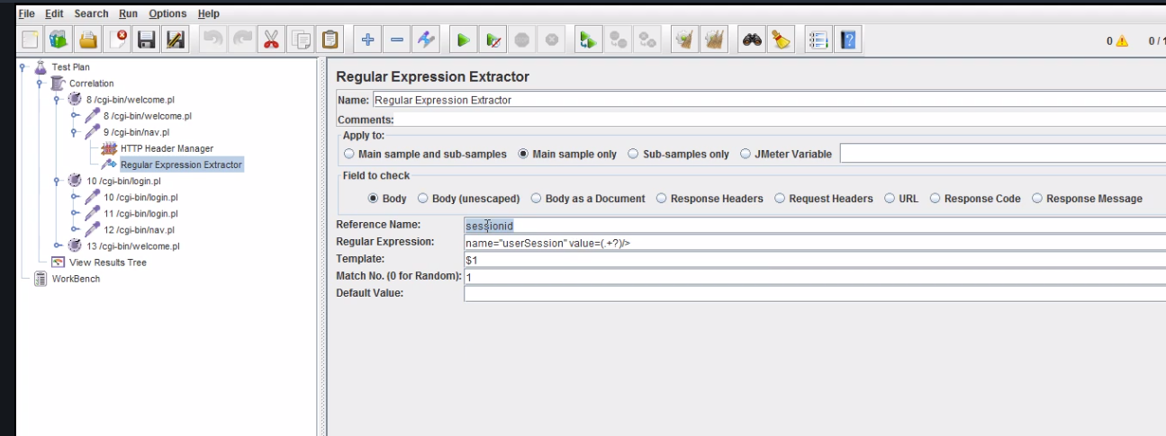

# Running validation with non gui mode

Say run from command or Jenkins



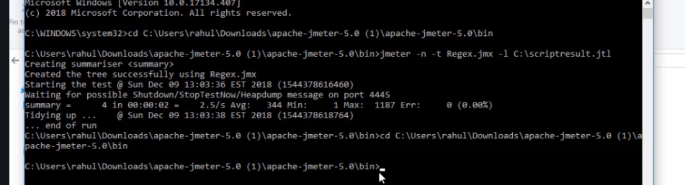

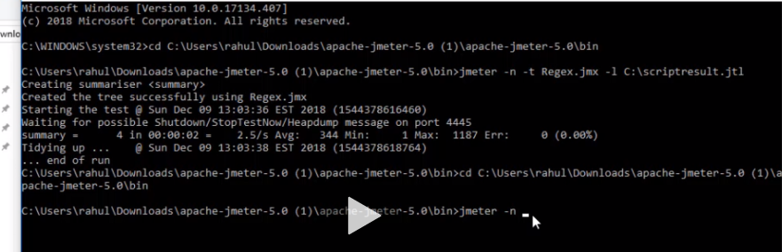

Next give the path of where your test case is….if its in your bin you can just type the name since its in the bin

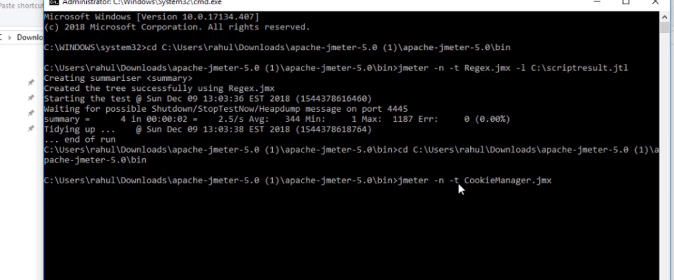

This runs it.

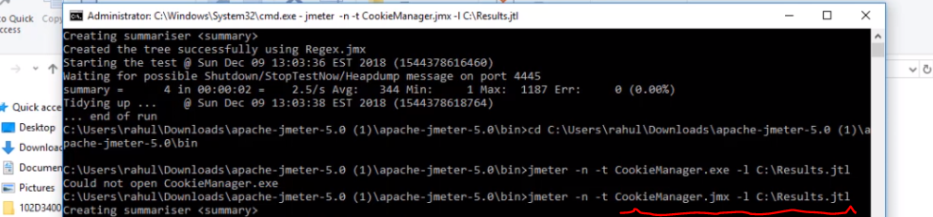

Also this runs it, L means generate result and save it it c/result…it ceates a folder called results and saves it there.

# Report Creation with blazemeter

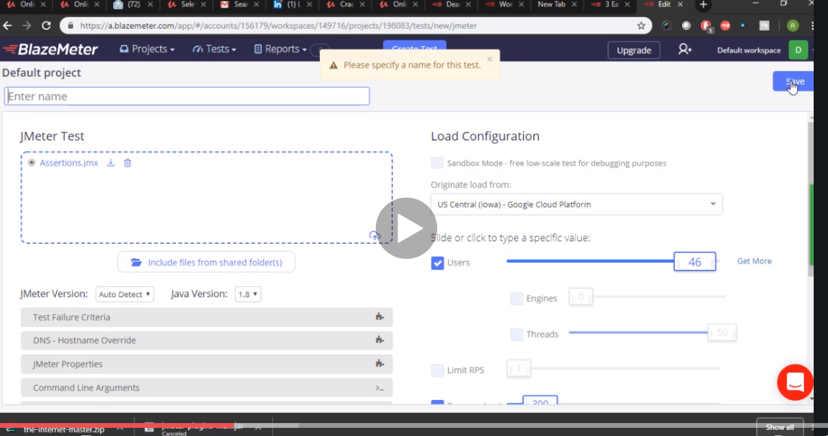

Just upload your jmeter project there and add load or ramp as you can see from the side.

Also name the project

Next press play

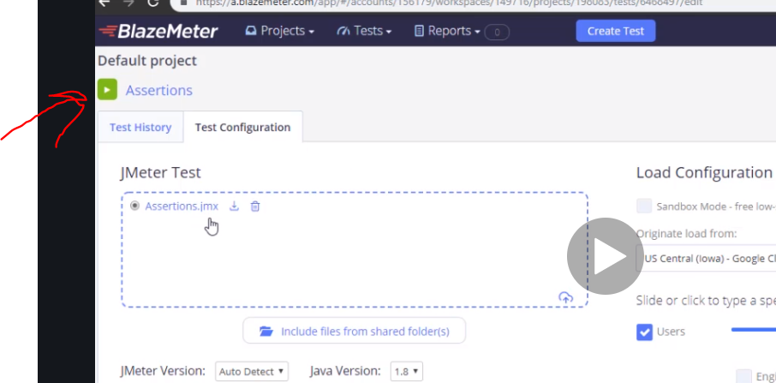

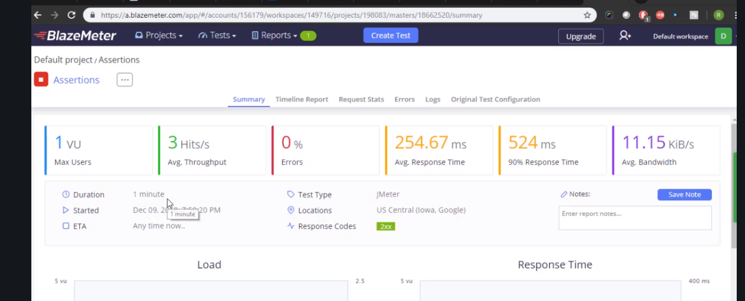

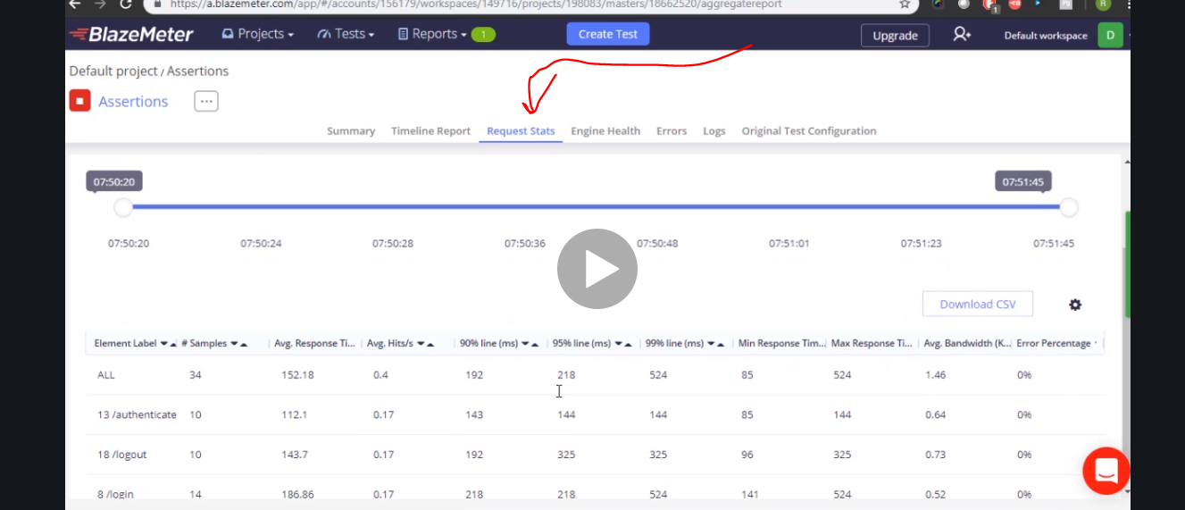

# Distribution mode in running test

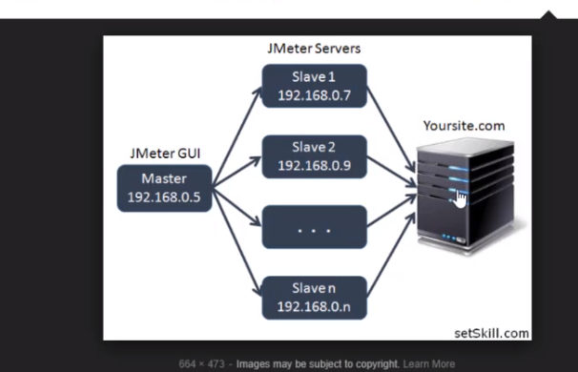

Now if you use only master with 5000 users to put load on…. The server will give u wrong info from the site u want to hit cos its too much hence you share it with other slave machine so all for plus master have 1000 users that gives better results and that is what is is all about.

U need to go jmeter property to set up slave and master but I will skip it for now.

# Bean script basics java

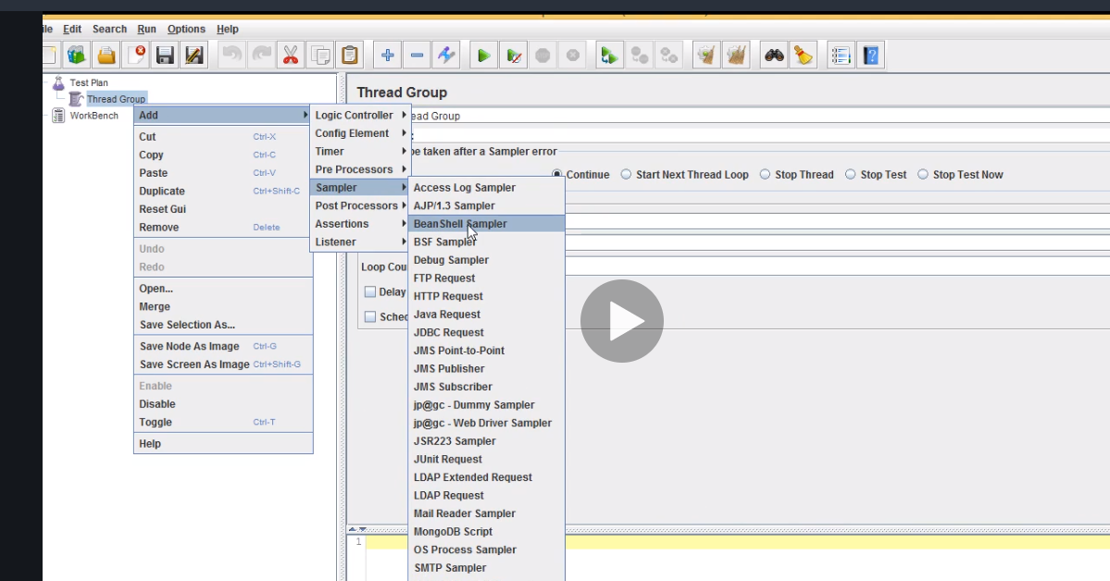

# More testing

If you have a **Performance testing interview** lined up, then don’t miss reading the top twenty **JMeter interview questions and answers**. We’ve covered all the essential elements of JMeter in this Q&A post. It is the most used Performance testing tool that every Web application tester, beginner or experienced should know how to use.

Consequently, it is built using Open Source technologies and is freely available for use. This quality eventually makes it the first choice of every tester doing load or performance testing. Also, its creator wrote it using Java and used XML as the input/output format. Both these technologies are industry standards and platform independent.

JMeter is a tool which can extend itself beyond your expectations. Like for performance testing, it lets you spawn as many numbers of tests as required by creating runtime threads. Also, it has a large plugin development community which delivers state-of-the-art JMeter extensions. These plugins are pretty useful in scaling up its functionality.

So, above was a brief overview of the JMeter features and functionality. Now, you can begin reading the twenty most frequently asked JMeter interview questions/answers for sure success.

Next, you would concede that no amount of automation or performance testings can decimate the need of real manual testing. So, here is a list of posts related to QA interview questions. Each one of them is super useful for QA Engineer.

Now, please start reading the top twenty questions for guaranteed success in a JMeter interview.

## JMeter Interview – Read Top Interview Questions.

**JMeter Interview Questions and Answers**

### Q-1. What is JMeter? What are the other applications that can be tested using JMeter?

**Ans.** Apache JMeter is an open source software. It is 100% pure Java desktop application designed to load test functional behavior and measure performance of the client/server applications.

**1.** It was originally designed for testing Web Applications only but has since then evolved to test other apps.  
**2.** It’s useful in testing the performance of both static and dynamic resources like files, Servlets, Perl scripts, Java Objects, Data Bases, Queries, FTP Servers and more.  
**3.** JMeter can also perform various other types of testing like Functional, Regression, and Unit testing.

### Q-2. Explain the basic workflow of JMeter?

**Ans.** JMeter acts like a group of users sending requests to a target server. It collects response from target server and other statistics which depict the performance of the application or server via graphs or tables.

### Q-3. Name the protocols supported by JMeter?

Ans. Following are some of the protocols supported by JMeter.

**1. Web Protocol:** To test the web applications, it supports both HTTP and HTTPS protocols.  
**2. Web Services:** To test web services applications, it supports both SOAP and REST.  
**3. FTP:** File Transfer Protocol provides the support for testing the FTP servers and applications.  
**4. Database via JDBC:** used for testing the database applications.  
**5. LDAP:** Lightweight Directory Access Protocol  
**6.** Message-oriented middleware (MOM) via JMS  
**7. Mail:** used for testing of mail servers such as SMTP(S), POP3(S) and IMAP(S)  
**8. MongoDB (NoSQL):** it is recently supported protocol by JMeter.  
**9.** Native commands or shell scripts  
**10.** TCP

### Q-4. List the important features that JMeter supports?

**Ans.** Following are some of the key features of JMeter.

**1.** It’s open-source software and is freely available.  
**2.** It has a very simple and intuitive GUI.  
**3.** JMeter can do load and performance test of many different server types like Web – HTTP, HTTPS, SOAP, Database via JDBC, LDAP, JMS, Mail via POP3.  
**4.** It is a platform independent tool. On Linux or Unix, the user can open the JMeter tool by clicking on the JMeter shell script. However, on Windows, it can be invoked by starting the jmeter.bat file.  
**5.** It has full Swing and lightweight component support (precompiled JAR uses packages java.swing.* ).  
**6.** JMeter prepares test plans in XML format.  
**7.** It’s a full multithreading framework allows concurrent sampling by many threads and simultaneous sampling of different functions by separate thread groups.  
**8.** It is highly extensible.  
**9.** Can also be used to perform automated and functional testing of your application.

### Q-5. What is seen on the screen when you open a JMeter?

**Ans.** By default, JMeter screen displays the Test Plan and Workbench tabs.

[**TOP**](https://www.techbeamers.com/jmeter-interview-questions-experienced/#top)

### Q-6. What is a Test Plan in JMeter? List some of the test plan elements available in JMeter.

**Ans.** A Test Plan defines and provides a layout of how and what to test. JMeter can be used to prepare a Test Plan for the web application as well as the client-server application. It behaves like a container for running tests.

A complete Test Plan comprises of one or more of the following elements.

**1.** ThreadGroup  
**2.** Controllers  
**3.** Listeners  
**4.** Timers  
**5.** Assertions  
**6.** Configuration Elements  
**7.** Pre-Processor Elements  
**8.** Post-Processor Elements

A Test Plan should have at least one thread group.

### Q-7. Explain the role of Workbench?

**Ans.** It is simply an area to store test elements while you are in the process of constructing a test. Once you’ve finished designing the test items in the Workbench, you can copy or move them into the Test Plan.

It also contains non-test elements like:

**1.** Http mirror server  
**2.** HttpProxy server

These items aren’t available in the thread group and Test plan.

### Q-8. What is a Thread Group? List down its main parts?

**Ans.** Thread group elements are the beginning points of any Test Plan. It is mandatory to have at least one thread group in the Test Plan.

One should know the following about the Thread Group.

**1.** All controllers and samplers must be under a thread group.  
**2.** Listeners may be placed directly under the test plan, in which case they will apply to all the thread groups.  
**3.** The controls for a thread group allows you to:  
**i.** set the number of threads.  
**ii.** Define the ramp-up period.  
**iii.** Sets the number of times to execute the test.

Following are the parts of a thread group.

**1. Sampler:** It sends various types of requests to the server.  
**2. Listeners:** It saves the results of the Run. It can be opened for viewing also.  
**3. Timer:** It makes the run more realistic by inserting delays between the requests.  
**4. Controller:** It is responsible for controlling the flow of the thread group. An example scenario is where the request definition includes if-then-else or loop structure.  
**5. Config Element:** information about the requests to be added to work with samplers.  
**6. Assertion:** To check if the response is generated within the given time and contain the expected data.

### Q-9. What are JMeter controllers? Explain their types?

**Ans.** JMeter provides two types of Controllers.

**1. Samplers Controllers:** It enables JMeter to post specific types of requests to a server. It simulates a user’s request for a page from the target server.

For example, you can add an HTTP Request sampler if you need to perform a POST, GET, or DELETE operation on an HTTP service.

**2. Logical Controllers:** It lets you control the order of processing of Samplers in a Thread. Logic Controllers can change the order of request coming from any of their child elements.

Some examples are ForEach Controller, While Controller, Loop Controller, IF Controller, Run Time Controller, Interleave Controller, Throughput Controller, and Run Once Controller.

[**TOP**](https://www.techbeamers.com/jmeter-interview-questions-experienced/#top)

### Q-10.What is a Configuration element? List down its elements.

**Ans.** Configuration Element allows you to create defaults and variables to be used by Samplers. It can be used to add or modify requests made by the Samplers. It will get executed at the beginning of the scope before any Samplers present in the same range. Thus, we can say that access to a configuration element is only allowed from inside the branch where it is present.

Following are the key features of Configuration Element.

**1. CSV Data Set Config:** It supports reading line by line from a file and splitting the line into variables.  
**2. HTTP Authorization Manager:** You can specify one or more user logins for web pages that are restricted using server authentication.  
**3. Java Request Defaults:** Using this you can set default values for Java testing.  
**4. HTTP Cookie Manager:** The Cookie Manager element has two functions:  
**i.** It stores and sends cookies just like a web browser.  
**ii.** Second, you can manually add a cookie to the Cookie Manager. However, if you do this, the cookie will be shared by all JMeter threads.  
**5. HTTP Request Defaults:** It lets you set default values to be used by your HTTP Request controllers.  
**6. HTTP Header Manager:** It enables you to add or override the HTTP request headers.

### Q-11. What are Listeners? List out a few JMeter Listeners.

**Ans.** It enables you to view the results of Samplers in the form of tables, graphs, trees or simple text in some log files. It provides visual access to the data gathered by JMeter for the test cases executed for the Sampler component of JMeter.  
JMeter supports the addition of Listeners anywhere in the tests that are included directly in the Test Plan. They will collect data only from elements at the same or lower level.

Some of the important JMeter Listeners are as follows.

**1.** Spline Visualizer  
**2.** Aggregate Report  
**3.** View Result Tree  
**4.** View Result in Table  
**5.** Monitor Results  
**6.** Distribution Graph(alpha)  
**7.** Bean Shell Listener  
**8.** Summary Report  
**9.** Aggregate Graph  
**10.** Assertion Results  
**11.** Backend Listener  
**12.** Comparison Assertion Visualizer  
**13.** Generate summary results  
**14.** Graph Results  
**15.** JSR223 Listener  
**16.** Mailer Visualizer  
**17.** Response Time Graph  
**18.** Save responses to a file  
**19.** Simple data writer

### Q-12. Explain what is Pre-processor Element? Name a few of them.

**Ans.** It enables configuring a sample request before executing it or to update those variables present in the response text that may not be extracted.

Some of the main pre-processor elements are as follows.

**1.** A modifier for HTTP URL.  
**2.** HTTP user parameter modifier.  
**3.** HTML link parser.  
**4.** BeanShell pre-processor.

### Q-13. Explain what is Post-processor?

**Ans.** Post-processors get used for calling an action after a request is made.

For example, suppose JMeter sends an HTTP request to the web server, and the user wants JMeter to stop sending the request. If the web server shows an error, in this case, the user can use post-processor to perform this action.

### Q-14. What is the execution order of Test Elements in Test Plan of JMeter?

**Ans.** Following is the order of execution of the Test Plan elements.

**1.** Configuration elements  
**2.** Pre-Processors  
**3.** Timers  
**4.** Sampler  
**5.** Post-Processors (unless SampleResult is null)  
**6.** Assertions (unless SampleResult is null)  
**7.** Listeners (unless SampleResult is null)

### Q-15. Is it required to prepare separate Test Plan using JMeter for the testing of the same application on different Operating System?

**Ans.** Following facts support that a JMeter Test Plan can run on any OS.

**1.** JMeter is itself a pure Java-based application which makes it platform independent.  
**2.** JMeter uses XML format while saving a Test Plan. Thus, they have nothing to do with any particular OS. You can run those Test Plans on any OS where JMeter can run.

### Q-16. How do you ensure re-usability in your JMeter scripts?

**Ans.** Taking the following points into consideration we can encourage re-usability in the test scripts:

**1.** Using config elements like “CSV Data Set Config” and “User Defined Variables” for supporting greater data reuse.  
**2.** Modularizing the shared tasks and invoking them via a “Module Controller”.  
**3.** Creating own Bean Shell functions and reusing them.

[**TOP**](https://www.techbeamers.com/jmeter-interview-questions-experienced/#top)

### Q-17. How can you reduce resource requirements in JMeter?

**Ans.** Following are the tricks that help in reducing resource usage.

**1.** Use a non-GUI mode.

jmeter -n -t test.jmx -l test.jtl

**2.** It is better to use as few Listeners as possible. Applying the “-l” flag as shown in above point may delete or disable all the Listeners.  
**3.** Disable the “View Result Tree” listener as it consumes a lot of memory and may result in JMeter tool running out of memory. It will freeze the console too. It is, however, safe to use the “View Result Tree” listener with only “Errors” kept checked.  
**4.** Instead of using a similar Sampler a large number of times, use the same Sampler in a loop and use variables (CSV Data Set) to vary the sample data. Or perhaps use the Access Log Sampler.  
**5.** Avoid using functional mode.  
**6.** Use CSV output rather than XML.

Also, you may like to read some of the common points.

**7.** Try to save the data that you need.  
**8.** Use as few Assertions as possible.  
**9.** Disable all JMeter graphs as they consume a lot of memory. All the real-time graphs can be viewed using the JTL tab in the web interface.  
**10.** Do not forget to erase the local path from CSV Data Set Config when used.  
**11.** Cleaning of the Files tab before every test run.

### Q-18. List the benefits that JMeter offers for performance testing?

**Ans.** JMeter provides the following advantages for performance testing.

**1.** It can be used to test performance for both, static resources as well as dynamic resources.  
**2.** It can generate and handle a large number of concurrent users as it happens on a live website.  
**3.** It provides a graphical analysis of performance reports.

### Q-19. Explain what is Assertion in JMeter? List its types.

**Ans.** Assertion helps to verify that the server under test returns the expected results.

Some commonly used Assertion in JMeter are as follows.

**1. Response Assertion:** It facilitates the user by comparing the server response against a string pattern to check that the result is as expected. For Example, while waiting for a response from the server the Response Assertion role is to verify that the server response has probable pattern string, “OK” or not.

**2. Duration Assertion:** You may need to test the response from the server reaches in user-defined time. If it takes longer than the defined time, server response fails.

**3. Size Assertion:** It is to test that each response coming from server holds the expected number of bytes. It facilitates the user to specify the size i.e. equal to, greater than, less than or not equal to a given number of bytes. For example, if the response packet from a server is less than expected 5000 bytes in size, then a test case pass, else a test case fails.

**4. XML Assertion:** It verifies that the response coming from the server holds the data in a correct XML format.

**5. HTML Assertion:** It is helpful for checking the syntax of the response data.

### Q-20. What is Spike testing and how can we perform it in JMeter?

**Ans.** Suddenly increasing the number of users at a certain point of application and then monitoring its behavior at that interval is Spike testing.

In JMeter, Spike testing can be performed using Synchronizing Timer. This timer keeps on blocking the threads until a particular number of threads get reserved. It then releases them at once thus creating large instantaneous load.

[**TOP**](https://www.techbeamers.com/jmeter-interview-questions-experienced/#top)

Important things to learn:

* How to record script.
* How to segregate script using different Controllers like Transaction\Simple controller.
* How to find out dynamic parameters in the script
* How to perform correlation and parameterization
* How to debug script
* How to divide user load amongst different User actions
* Usage of different Controllers, Samplers, Listeners, Pre and Post Processors, Timers and Assertions.
* GUI and Non GUI mode
* Remote executions

# Link to know more about Jmeter

<https://www.blazemeter.com/blog/getting-started-jmeter-basic-tutorial>

# Getting Started with JMeter - A Basic Tutorial

# What is Performance Testing?

[Performance testing](https://www.blazemeter.com/blog/performance-testing-vs-load-testing-vs-stress-testing?utm_source=BM&utm_medium=BM_blog&utm_campaign=getting-started-jmeter-basic-tutorial) and load testing are the practices of ensuring websites and apps perform under heavy loads, from different geo-locations and for different user scenarios. If you followed the latest [Pokemon Go](https://www.blazemeter.com/blog/gotta-test-em-all?utm_source=BM&utm_medium=BM_blog&utm_campaign=getting-started-jmeter-basic-tutorial) craze or heard about Macy’s crashing during the [last Black Friday](https://www.blazemeter.com/blog/load-testing-lessons-learn-black-friday-2016?utm_source=BM&utm_medium=BM_blog&utm_campaign=getting-started-jmeter-basic-tutorial), you know the importance of Performance Testing and how crucial it is for businesses. Poor performance, whether website crashes or slow page loading, equals an immediate and long-term loss of revenue, as it creates a bad reputation and immediate churn.

# An Introduction to JMeter

Therefore, it is important to carefully choose your [load testing tools](https://www.blazemeter.com/blog/open-source-load-testing-tools-which-one-should-you-use?utm_source=BM&utm_medium=BM_blog&utm_campaign=getting-started-jmeter-basic-tutorial). [JMeter](https://www.blazemeter.com/jmeter-load-testing?utm_source=BM&utm_medium=BM_blog&utm_campaign=getting-started-jmeter-basic-tutorial) is the most popular open-source load and performance testing tool. Open-source and JAVA-based, JMeter simulates browser behaviour (though it’s not a browser!) by sending requests to web or application servers for different loads. JMeter can also parse the responses. On your local machine, you can scale up to approximately 100 virtual users, but you can go up to more than 1,000,000 VUs with [CA BlazeMeter](https://a.blazemeter.com/app/sign-up?utm_source=BM&utm_medium=BM_blog&utm_campaign=getting-started-jmeter-basic-tutorial), which is kind of a JMeter in the cloud.

This blog post is a basic tutorial about how to get started with JMeter. We will create a few basic JMeter scripts and go over different JMeter features like assertions and dynamic data. In the end, we will briefly talk about analyzing your results in reports.

# Your First JMeter Script

First, [download](http://jmeter.apache.org/download_jmeter.cgi) JMeter.

This is the JMeter interface:

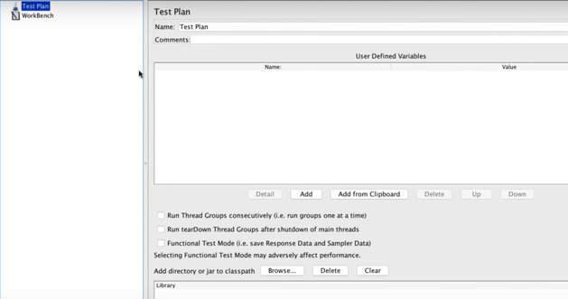

The Test Plan is your JMeter script, and it determines the flow of your load test.

In this post, we will load test the demo we always use at CA BlazeMeter, of a mock travel agency named Simple. The Simple Travel Agency lets us search and choose flights, and we will simulate these actions through JMeter.



## Thread Groups

To start building the test script, go back to JMeter and add a [Thread Group](https://www.blazemeter.com/blog/jmeter-test-results-why-actual-users-number-lower-expected?utm_source=BM&utm_medium=BM_blog&utm_campaign=getting-started-jmeter-basic-tutorial).

Thread groups determine the user flow and simulate how users behave on the app. Each thread represents a user.

Right click - Add->Threads(Users)->Thread Group

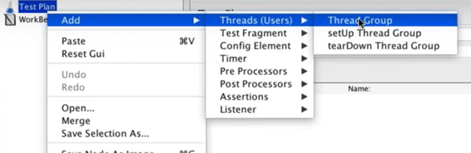

Configure the Thread Group -

- Its name (for your convenience)

- Number of threads - the number of users you are testing. Let’s say 3.

- Ramp-up time - how much time you want to allow the Thread Group to go from 0 to 3 users. Let’s say 5 seconds.

- Loop count - How many times the test should be looped. Let’s say 1 time.

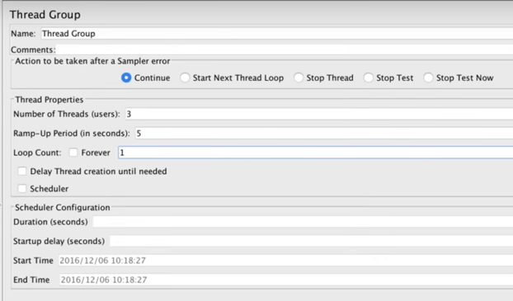

## Samplers

We want to send a HTTP request to our site, in this case to our demo, so we add a HTTP Requests Sampler.

Right click - Add->Sampler->HTTP Request

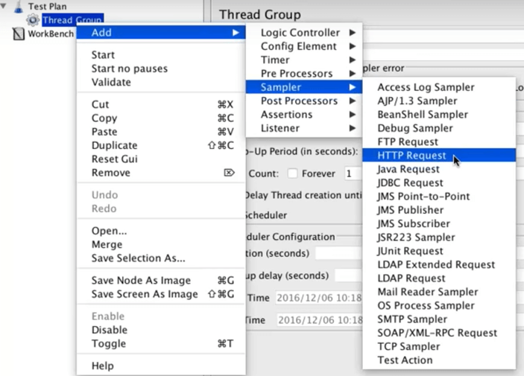

Configure the Sampler -

- Its name (for your convenience)

- The server or IP you’re testing. In this case - blazedemo.com

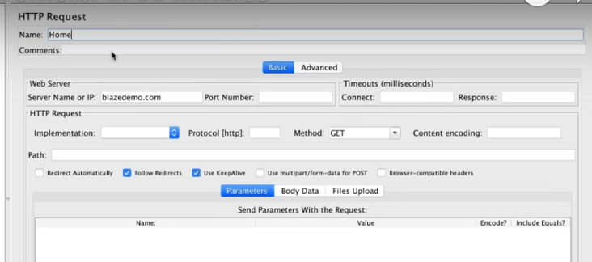

## Timers

When users click on your website or app, they naturally have pauses and delays. These can  be simulated with [Timers](https://www.blazemeter.com/blog/comprehensive-guide-using-jmeter-timers?utm_source=BM&utm_medium=BM_blog&utm_campaign=getting-started-jmeter-basic-tutorial).

Constant timers are the most common, and they determine how many milliseconds to wait before between requests.

Right click - Add->Timer->Constant Timer

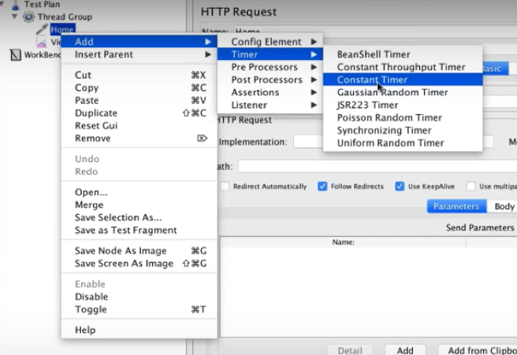

In this case, we will wait for 300 milliseconds.

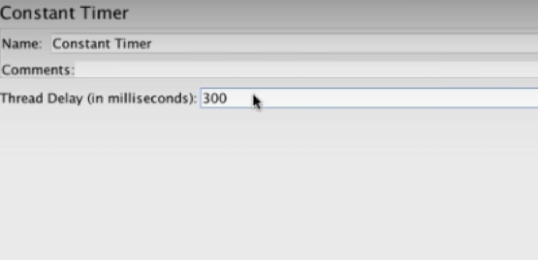

## Listeners

After running our test, we want to see its results (obviously). This is done through Listeners, a recording mechanism that shows results, including logging and debugging.

The View Results Tree is the most common Listener.

Right click - Add->Listener->View Results Tree

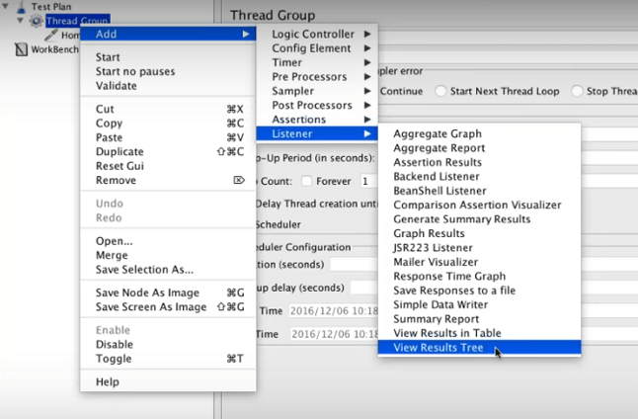

We’re done! This is the basic script we created for hitting the BlazeDemo page:

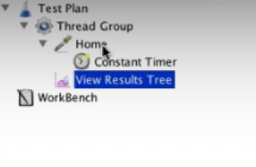

Now click ‘Save’. Your test will be saved as a .jmx file.

To run the test, click the green arrow on top. After the test completes running, you can view the results on the Listener.

In this example you can see the tests were successful, because they’re green. On the right you can see more detailed results, like load time, connect time, errors, the request data, the response data, etc. You can also save the results if you want to.

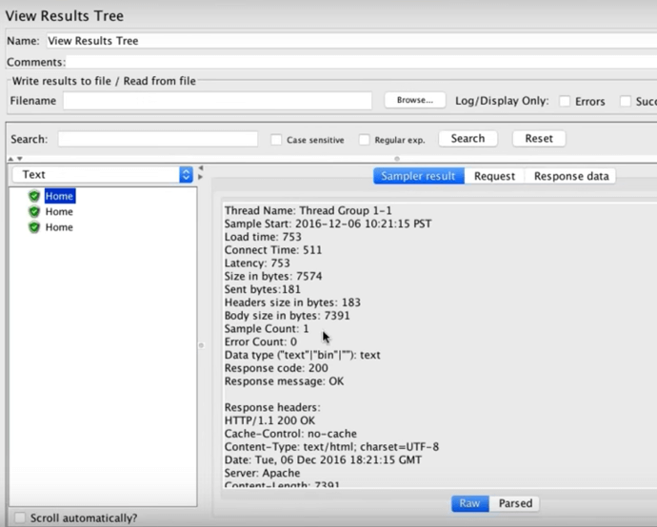

# Your Second JMeter Script

Congratulations! That was your first script. Now let’s create a second one, and add parameters to it. In our example, we want to also choose the flights.

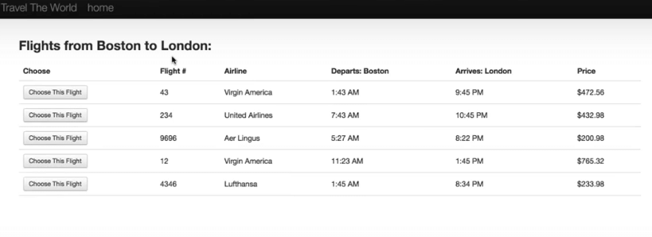

How do you simulate that?

Go back to JMeter, add another HTTP Sampler, and this time, add the website path after the server. In our example - reserve.php.

Afterwards, add the relevant parameters from your website or app. In this case: fromPort, Boston; toPort, London.

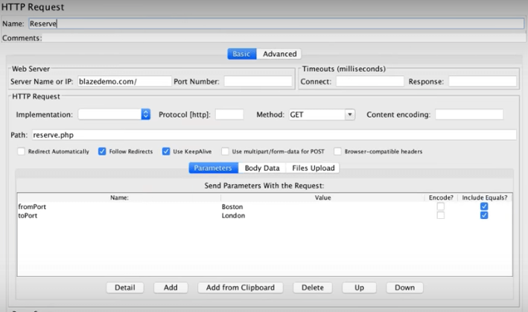

We’ll also add a “View Results in Table” Listener, just to spice things up.

This is the second test plan, which includes hitting the Home page and then sending two parameters to the Reserve page.

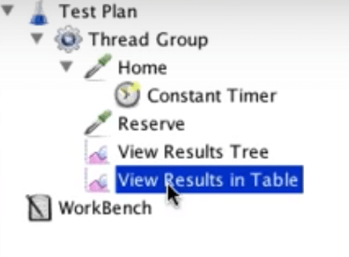

Save and run the test.

In the results, you can see that each page is hit 3 times:

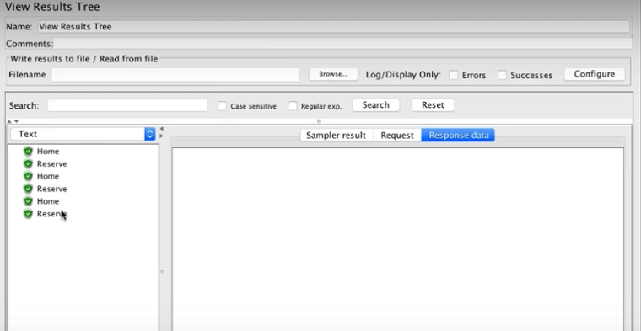

The View Results Table shows us additional data: start time, sent bytes, connect time, latency, etc.

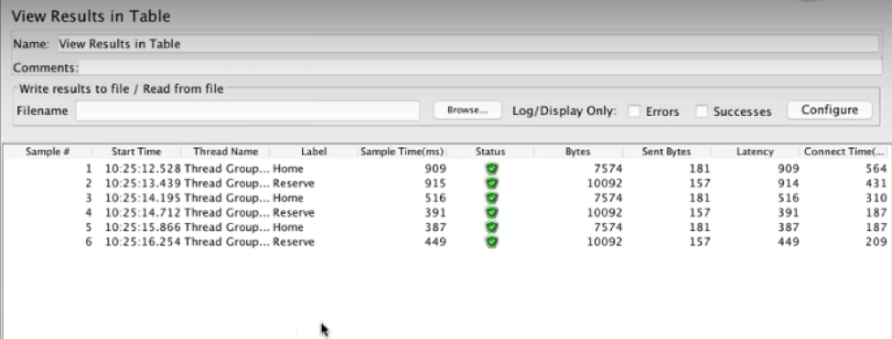

# Recording Scripts - Your Third JMeter Script

Congratulations! You can now create your own basic JMeter scripts. But as you might have understood, if you need to create a long user flow, it could take you a long time.

Therefore, a better way to create scripts is by recording them. To record, you can either use the JMeter recorder, or the [BlazeMeter Chrome Extension](https://guide.blazemeter.com/hc/en-us/articles/206732579-Chrome-Extension?utm_source=BM&utm_medium=BM_blog&utm_campaign=getting-started-jmeter-basic-tutorial). The BlazeMeter extension, free to use from the Chrome store, is more user friendly than the JMeter one, which requires you to set a proxy to redirect the traffic.

Through your Chrome, start recording and simulate the user scenario you want to test by clicking away. When you’re done, stop the recording, and edit as necessary.

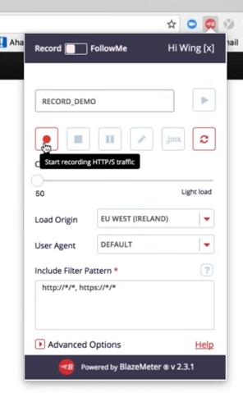

Export your recording to JMX. Don’t forget to move the downloaded script to your preferred folder.

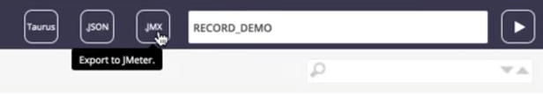

Open the .jmx file file in JMeter. You will be able to see your test plan, which was created from the recording and the .jmx file.

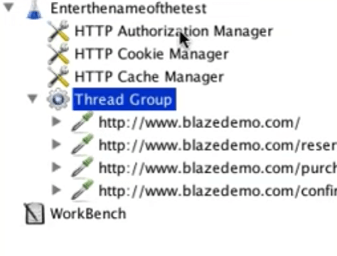

Note that this plan has new elements, like Cookie Manager and Cache Manager. They are here because browsers keep cookies and cache and they were captured in the recording. You can clear them up if you need to, and sometimes it’s even necessary to ensure you are really simulating new users.

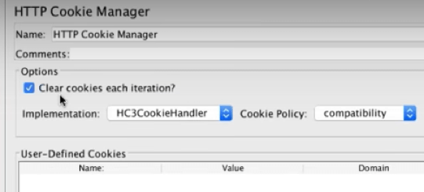

Now add a listener and run the test.

## Assertions

[Assertions](https://www.blazemeter.com/blog/how-use-jmeter-assertions-3-easy-steps?utm_source=BM&utm_medium=BM_blog&utm_campaign=getting-started-jmeter-basic-tutorial) are elements that let you check for errors, or in other words - determine if your test passes or fails.

Let’s say we want to make sure a webpage returns the information we’re looking for. In our example, we want to make sure users who purchase flights receive a message on the confirmation page saying - Thank you for your purchase today!

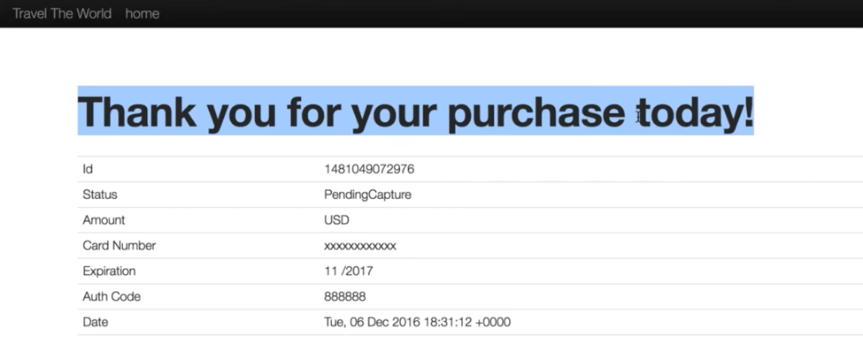

Go to JMeter.

Add a Response Assertion (you know how to do it).

Add the exact characters you want users to see.

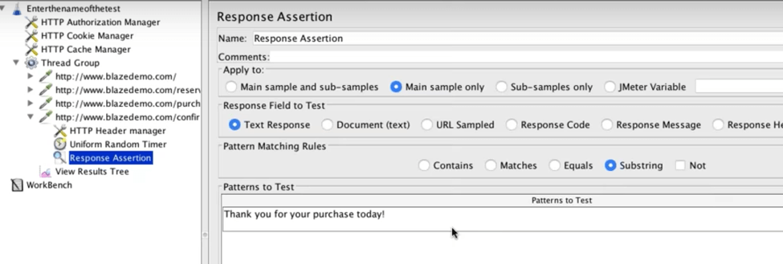

Save and run the test.

If the response contains the string, the test will pass. If not, the test will fail, and it will also detail why.

## Dynamic Data

What happens when you want to create a [dynamic](https://www.blazemeter.com/blog/advanced-load-testing-scenarios-jmeter-part-1-correlations?utm_source=BM&utm_medium=BM_blog&utm_campaign=getting-started-jmeter-basic-tutorial) script, which chooses different parameters each time you test, like passwords, login information or search criteria? This is what Dynamic Data through CSV files is for.

Create a CSV file on your computer, with the different variables you are testing. Put the file in the JMeter folder. In our case, we created a basic one, with departure and destination cities.

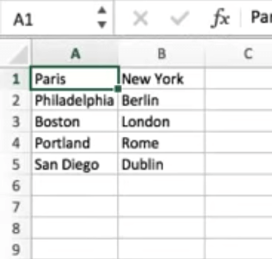

Got to JMeter. Right click - Add->Config Element ->CSV Data Set Config

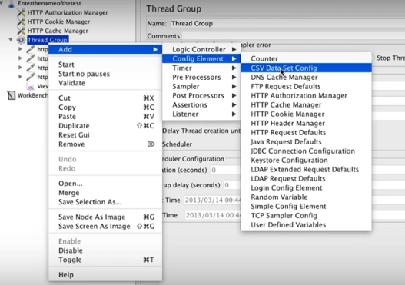

Configure by adding the variable names. In our case, fromPort and toPort.

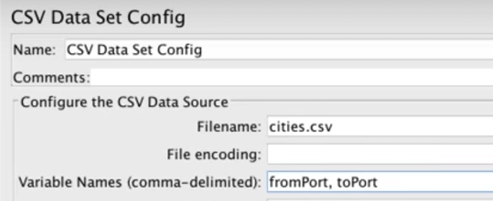

Go back to the HTTP Request (from our second script) and change the variable from the specific name (of the cities) to the general name.

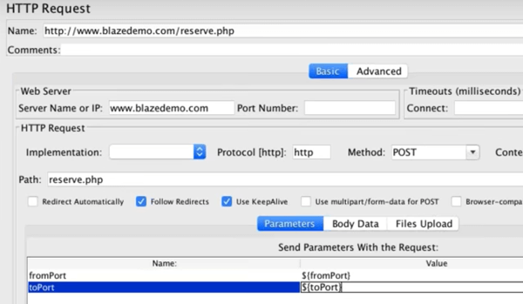

The data tested will now come from the CSV file, and you will be able to see the dynamic results in the View Results Tree. In our example, it’s no longer Boston and London, but Philadelphia and Berlin, Portland and Rome, etc.

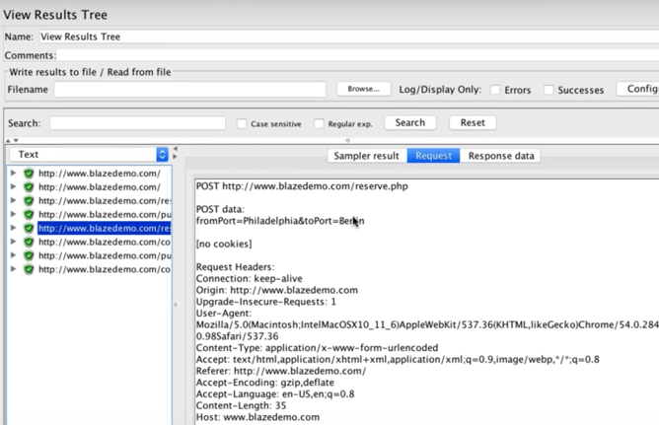

## Scalability

After you built your test and checked it for a low number of users, it’s time to scale it up and check a large number of VUs. How many? That depends on your business goals.

In general, we recommend that in addition to your expected number of users, you bring your test to the limit. This lets you characterize your system’s strengths and weaknesses, enabling you to plan better and also react in real-time to unexpected bottlenecks and errors.

The best way to scale is through CA BlazeMeter, which lets you run heavier loads than JMeter. CA BlazeMeter lets you upload your JMeter scripts, scale your number of users, choose your region, set ramp-up time and determine how long the test will run.

# Analyzing Results

After running your test on CA BlazeMeter, you will get rich and in-depth [reports](https://www.blazemeter.com/blog/understanding-your-reports-part-4-how-read-your-load-testing-reports-blazemeter?utm_source=BM&utm_medium=BM_blog&utm_campaign=getting-started-jmeter-basic-tutorial), with [KPIs](https://www.blazemeter.com/blog/load-testing-kpis-part-1-what-are-kpis?utm_source=BM&utm_medium=BM_blog&utm_campaign=getting-started-jmeter-basic-tutorial) like throughput, error rate and connection time. Reports let you analyze trends and statistics, determine the health of your system and decide how you want to keep developing your product.

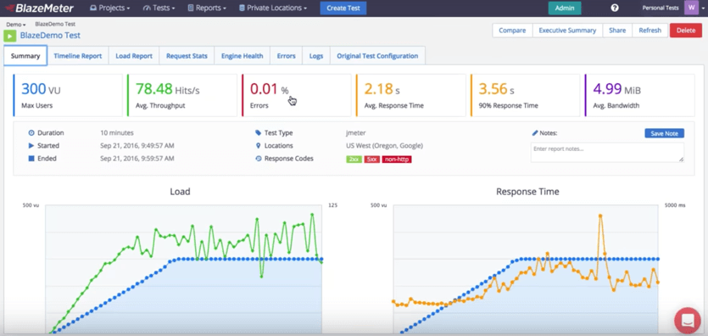

Congratulations! You just finished your basic JMeter tutorial. If you prefer viewing the content this blog post covered through our Get Started with JMeter  in 60 Minutes webinar, [click here](http://info.blazemeter.com/get-started-jmeter-60-minutes-webinar?utm_source=BM&utm_medium=BM_blog&utm_campaign=getting-started-jmeter-basic-tutorial).

Want more basic training? Try out our free [5-day basic JMeter course](http://info.blazemeter.com/jmeter-training-course?utm_source=BM&utm_medium=BM_blog&utm_campaign=getting-started-jmeter-basic-tutorial).

Feeling ready to move forward? Check out our [advanced load testing webinar](http://info.blazemeter.com/loadtesting_advancedjmeter?utm_source=BM&utm_medium=BM_blog&utm_campaign=getting-started-jmeter-basic-tutorial).

Want to learn more about CA BlazeMeter? [Request a demo here](http://info.blazemeter.com/request-a-demo2?utm_source=BM&utm_medium=BM_blog&utm_campaign=getting-started-jmeter-basic-tutorial).

# Bean shell scripting

First you have to create thread so right click test plan and add thread group. Now go to thread group and right click and select sampler and then select beanshell sampler.

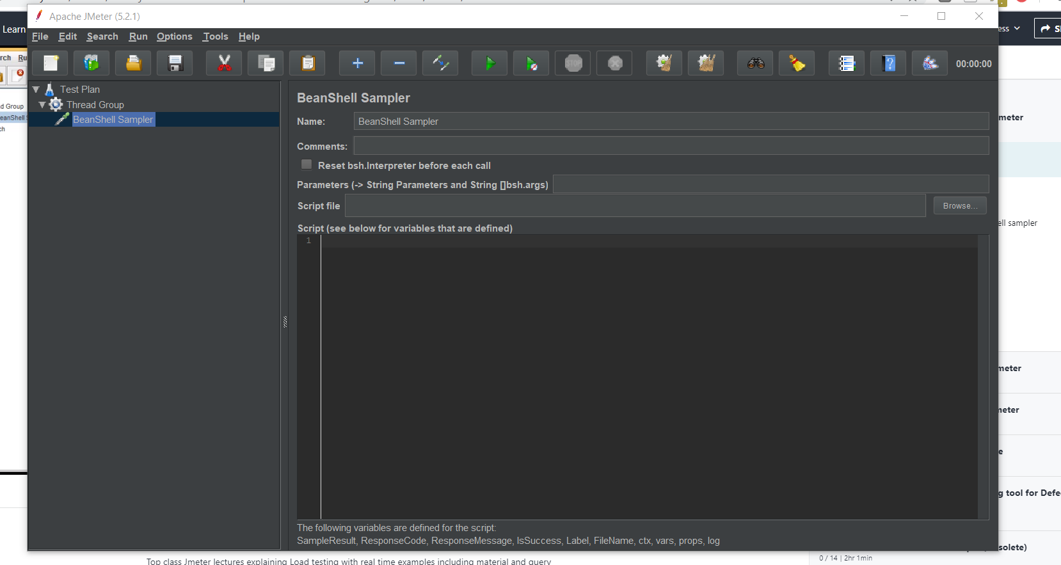

Next go to option and click log viewer to give you a console area

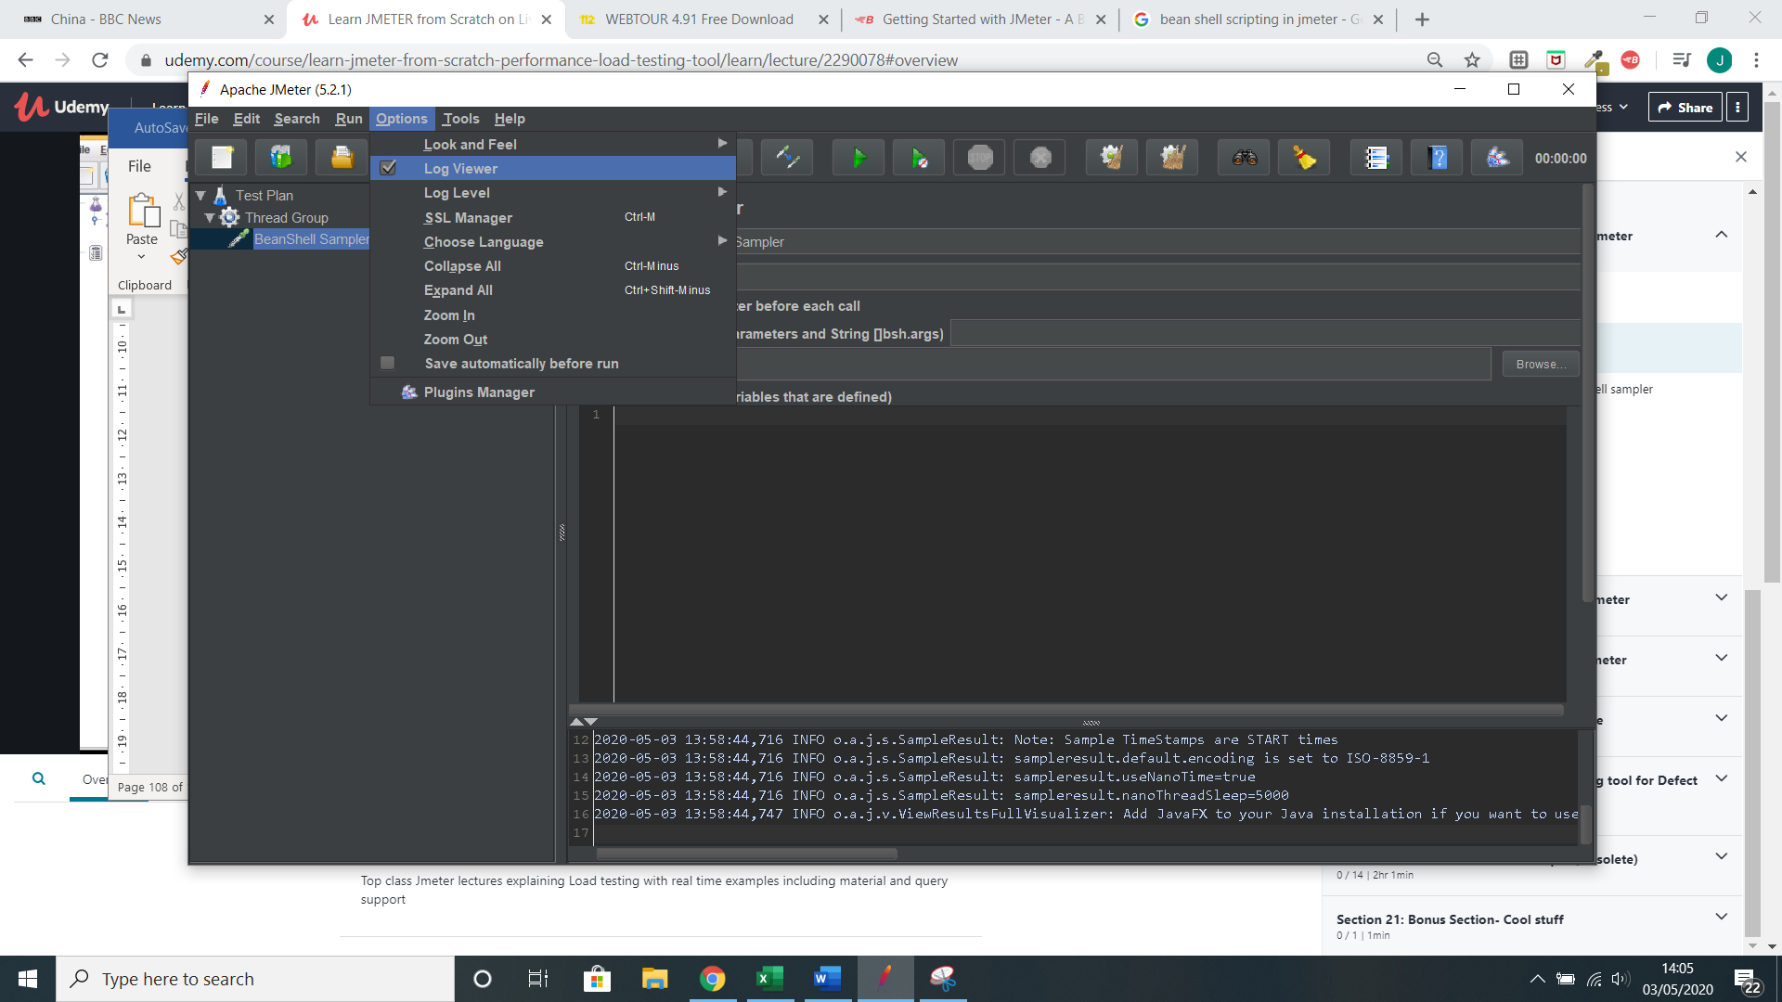

t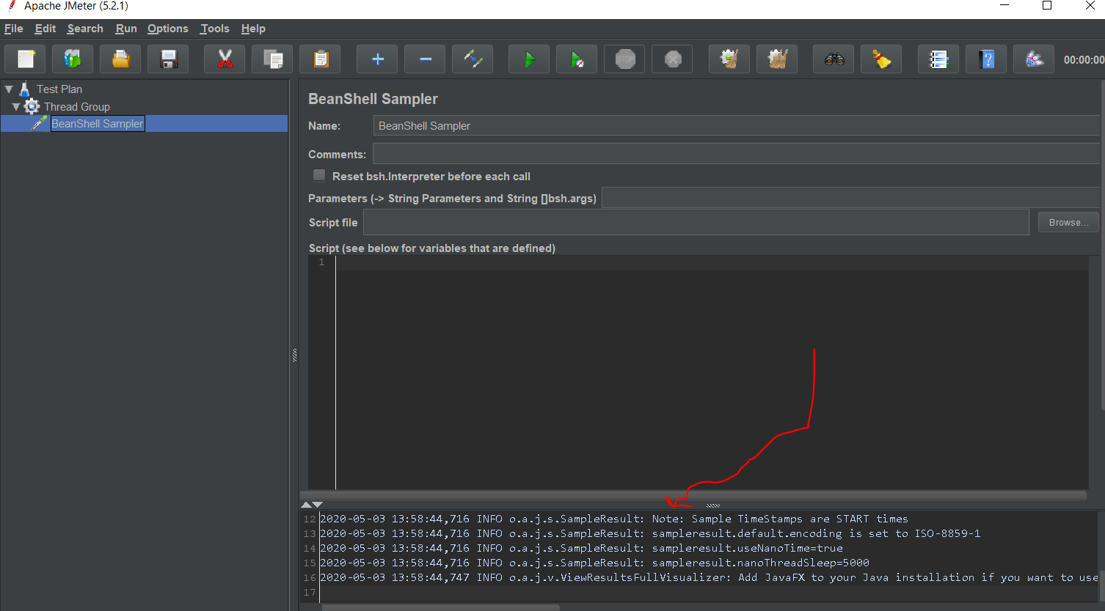

now lets look t the code so far we have added and we use put to replace the value of a

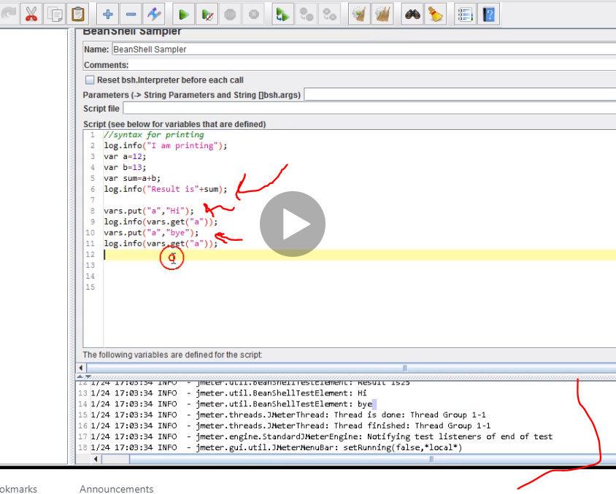

Log.info is used to print so as you can see our result has hi and bye because we printed it when we put those strings in a

Now we are using something called the ctx variable in bean shell

We use it to access a method get thread number but it has to be integer so we saved as interger.

This is a cool way to access jmeter api with ctx

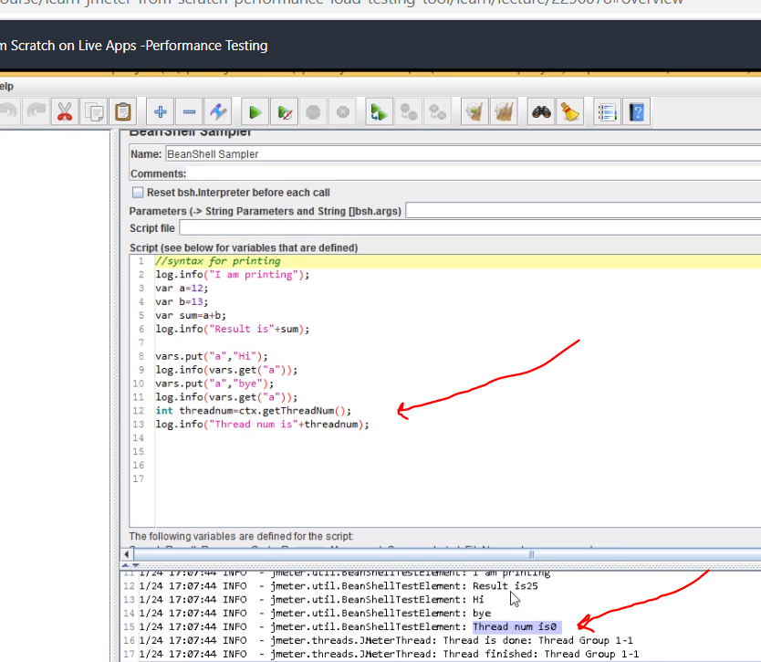

The document below consists of a list of jmeter methods

Now lets test this we start recording always remember the port should be same or it wnt record

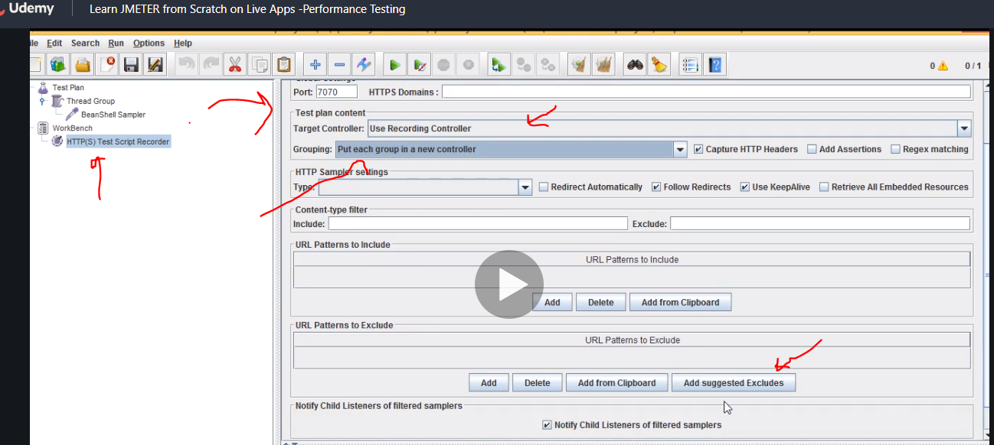

Remember to click at the bottom add suggested excludes.

Now we just recorded this but if we run it again it will fail because it is dynamic and does not change

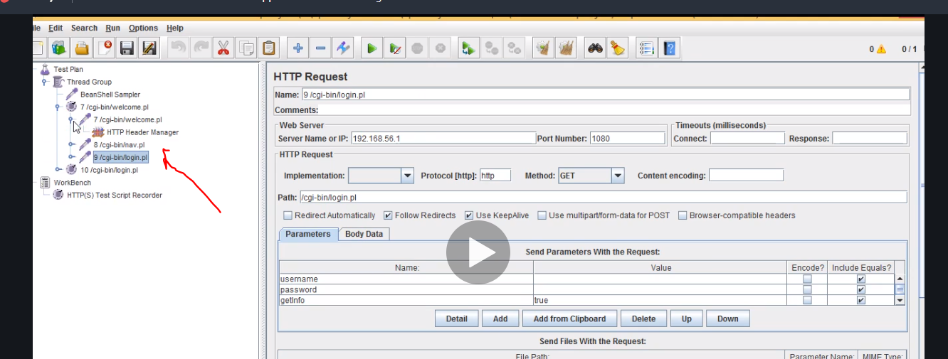

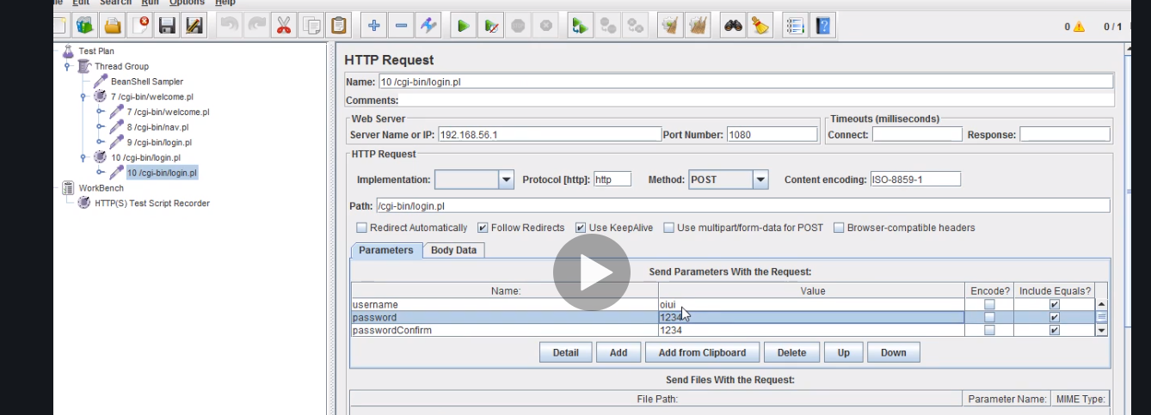

If we run it again it will fail saying user already exist so this is what we do

We create variables

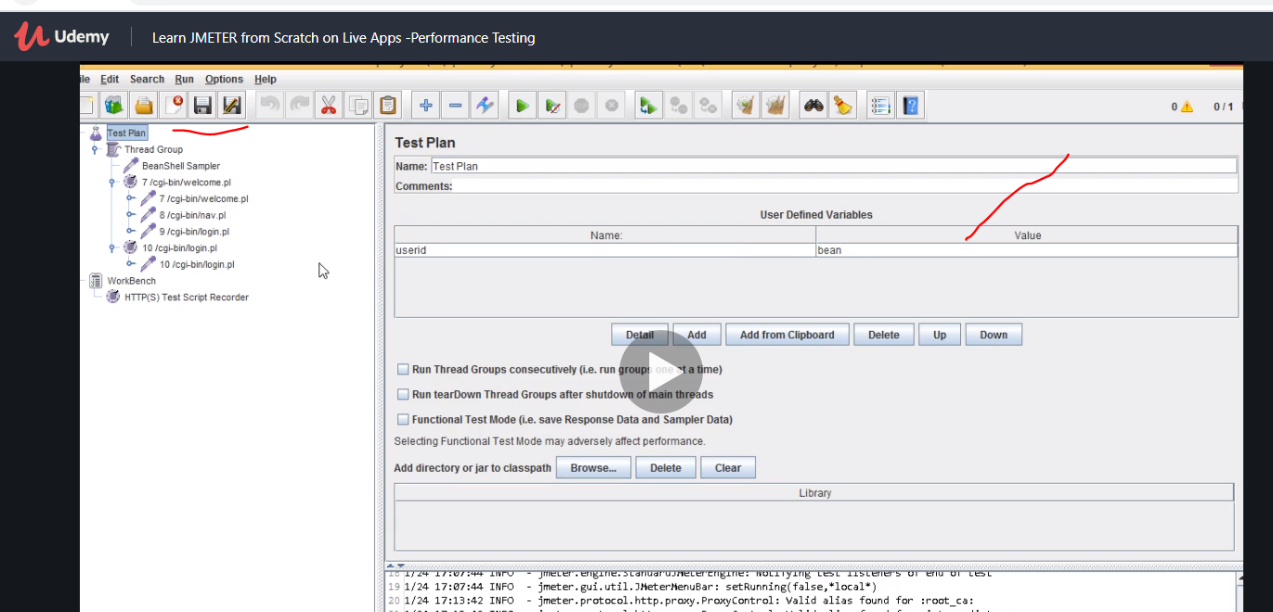

Next we use the dollar sign to call it

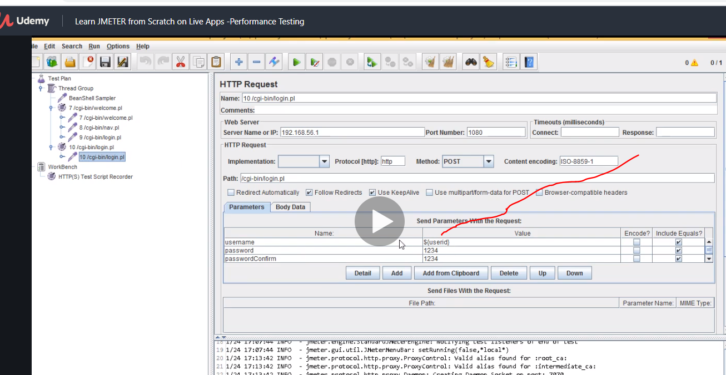

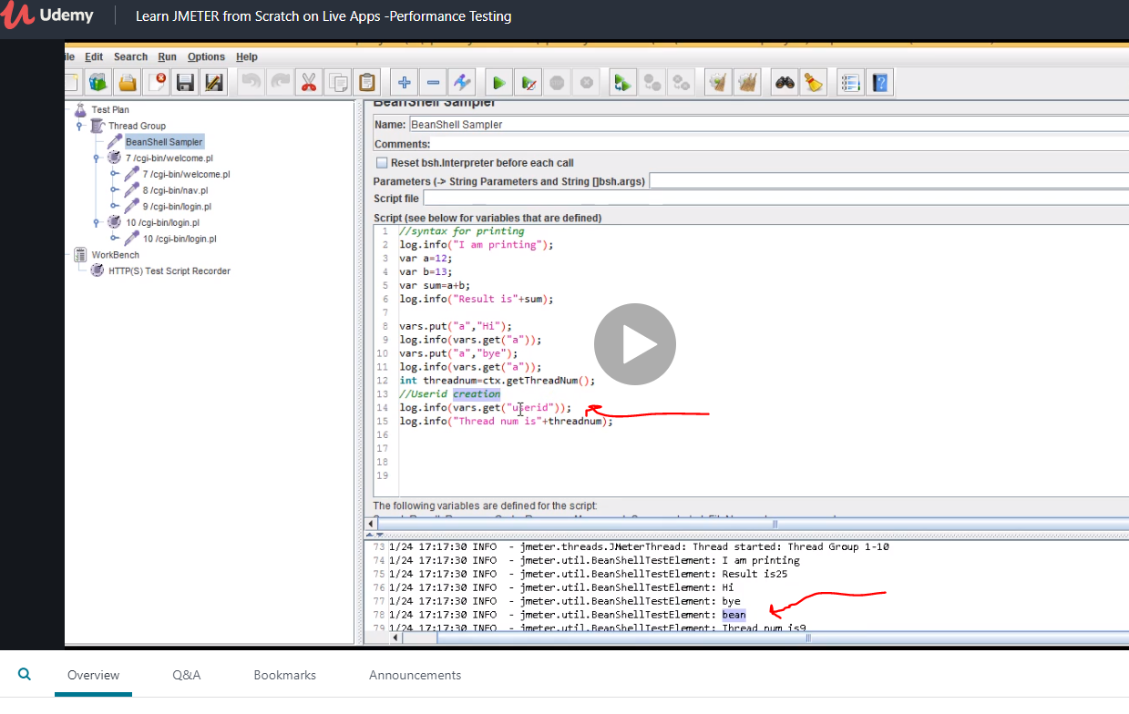

Now we use bean shell to call the userid and we can see the answer is bean.

Now remember that thread is like number of people or the number of time people run it so if u log in as mr Jackson and mr will that 2 threads…. If you make the thread 10, it means those two names will run 5 times to meet the thread.

If you use 1 user denisa…log in detail. That’s one thread. If you then change it to 5 times. Means same user will run but 5 times.

If you have 7 users, then initial thread is 7 …so run 7 times if you wan times then the 7 will run plus the very first user who ran making it 8 and if you want 14 then they will run twice.

So now with bean script we have one user with log in details, wehave concantinated it to get the thread number and add it to the userid.

Remember even though in the process we have only one user…because the thread is 5, it will run it 5 times.

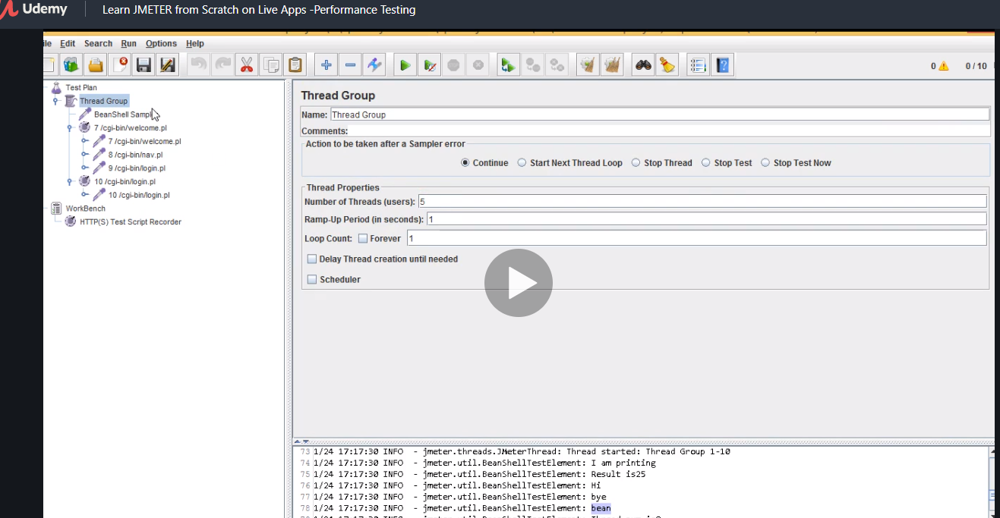

By doing this our user is unique

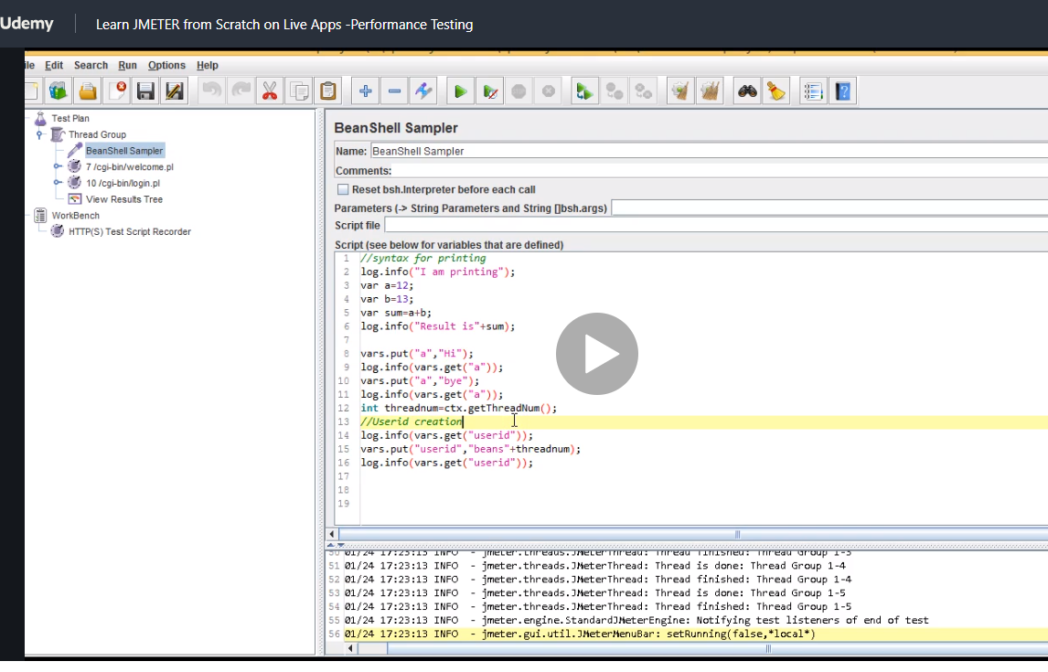

The advantage here is instead of running wth csv file and many users you use bean shell and u can simulate the process.

Also this is what it is first record….then manipulate the recording so

If u record a user bean 1 and he click dropdown say Nigeria and then when u do the script you can change the dropdown to ghana but the trick is to first record then next manipulate it that’s all this is all about.

So basically for every thread you can pass unique values.

Now lets look at bean shell post processing

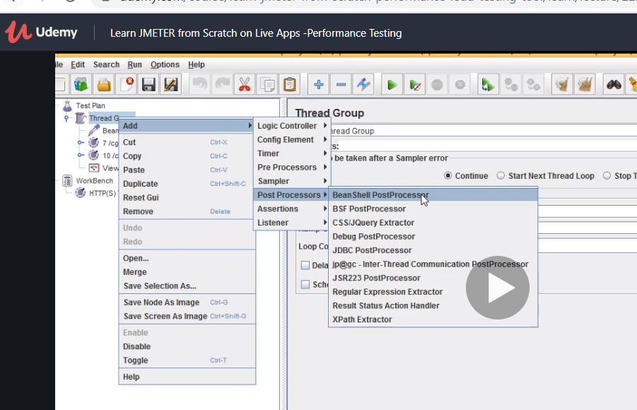

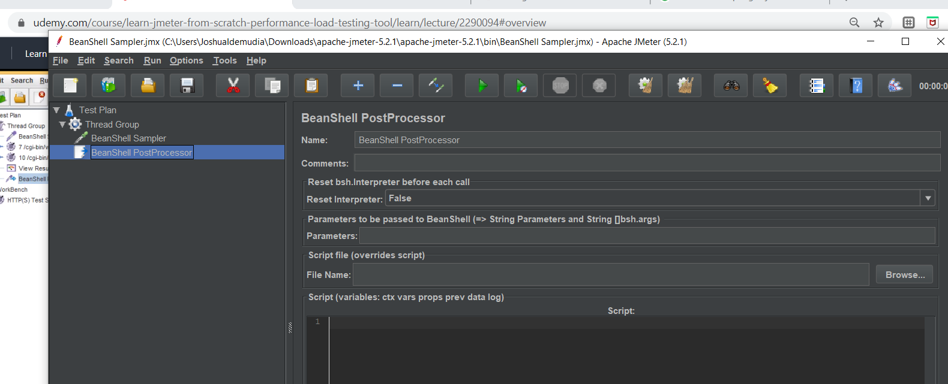

Note variables here are unique to each thread group while property is available to all group and can be accessed by all group.

So properties are defined in test plan level and variables are defined in thread group level and the syntax as we used above instead of using vars we use props.

Now using this command we can get the response for the previous simulation so basically the last simulation you made

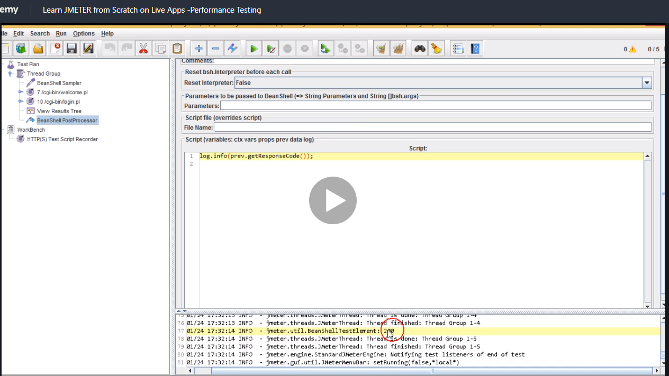

Now you can do the same thing with get message response and then do an if condition but also now we will create another variable result.

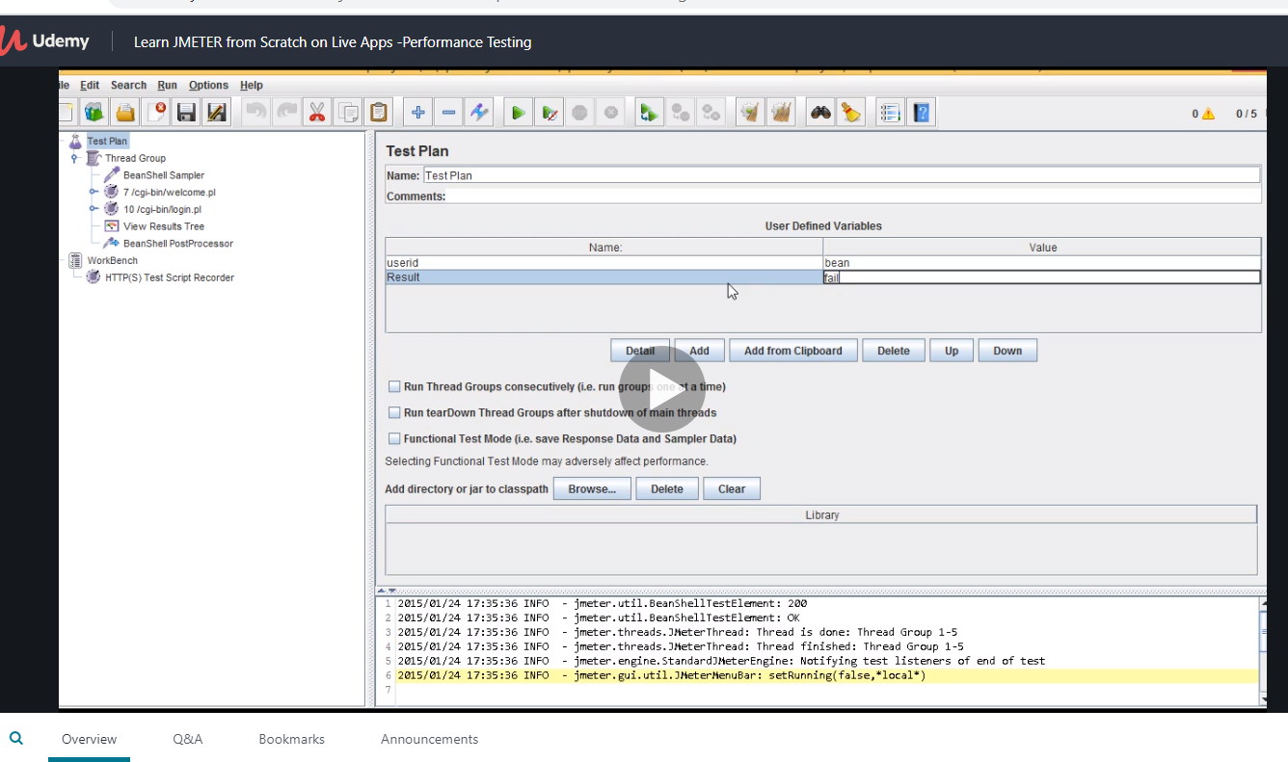

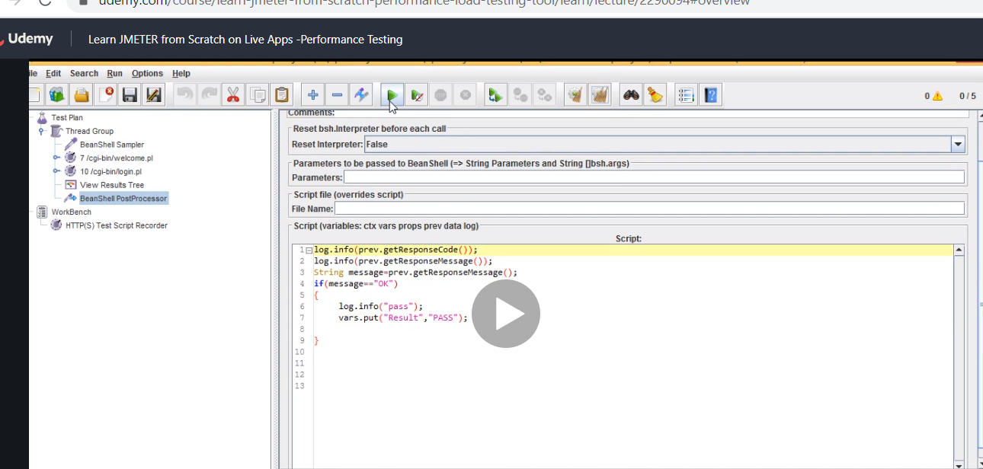

Basically we changed results to fail but when we run this script, its almost like assertion if it is passed then print pass and go into the variable table and change the fail to pass and if it fails just fail haha

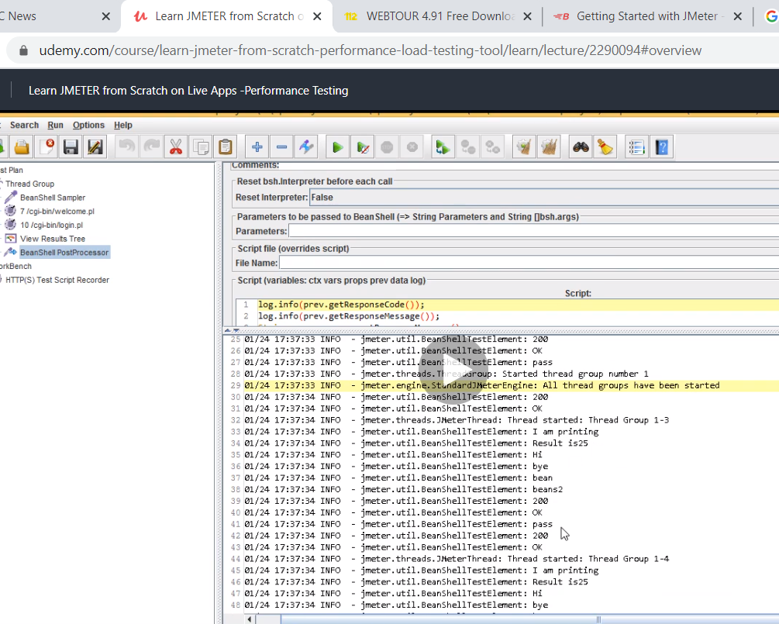

If message is not ok then the control will never go into the loop and will not show pass and it wnt show any result.

But if we just add it to the script below, it doesn’t go into the loop but it will still execute the result which is a fail

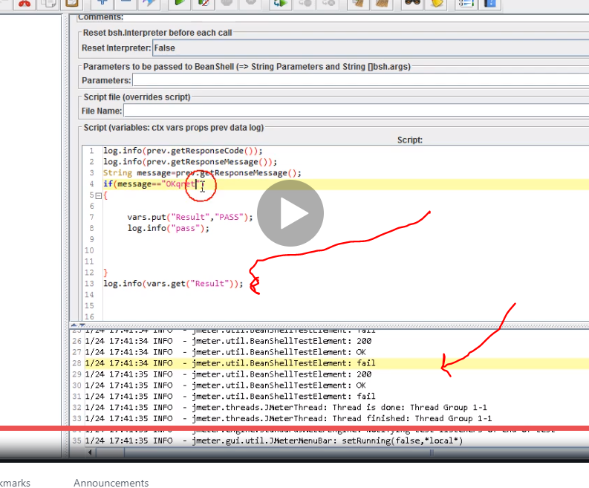

Now let add listeners to see the behaviour. Its outside the loop and just show the initial condition

# Selenium with jmeter for putting load

So far we have used jmeter now we want to use selenium to do shit

We created a java project in selenium seleniumjmeter

Now create a class. Put shit on it and export it

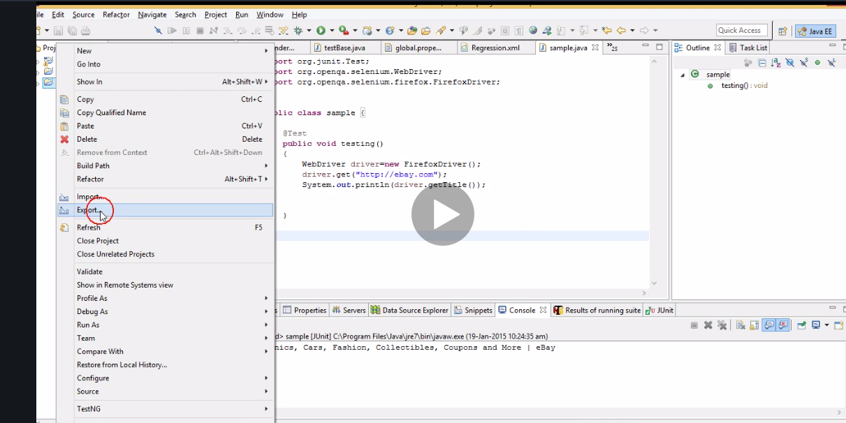

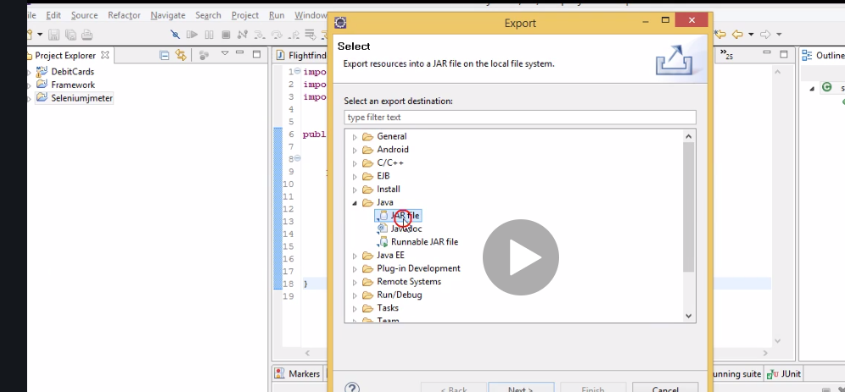

Save it in c drive.

Now go to your c folder and copy it

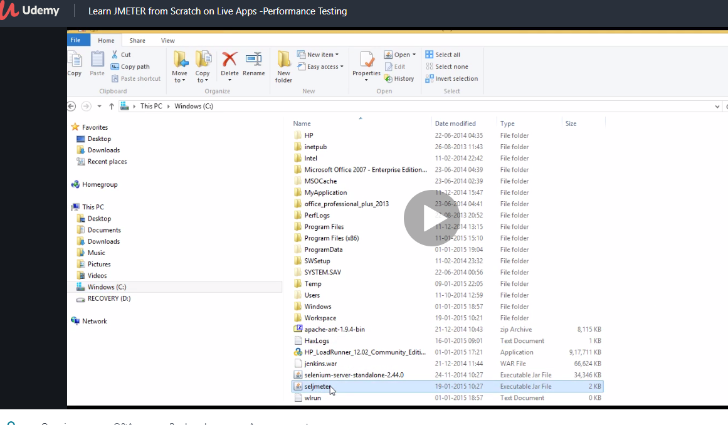

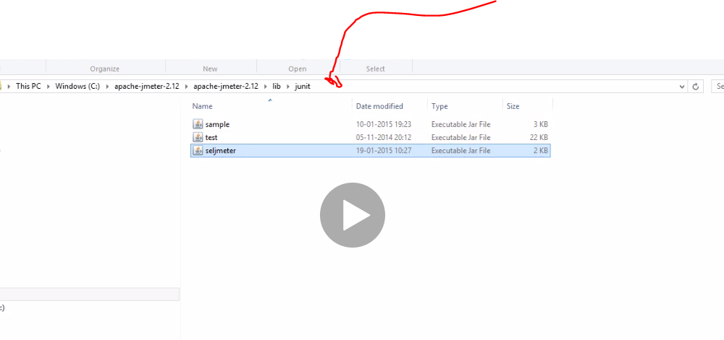

Paste it here.

Now jmeter can access this file.

Just restart jmeter

Then u can run it from here

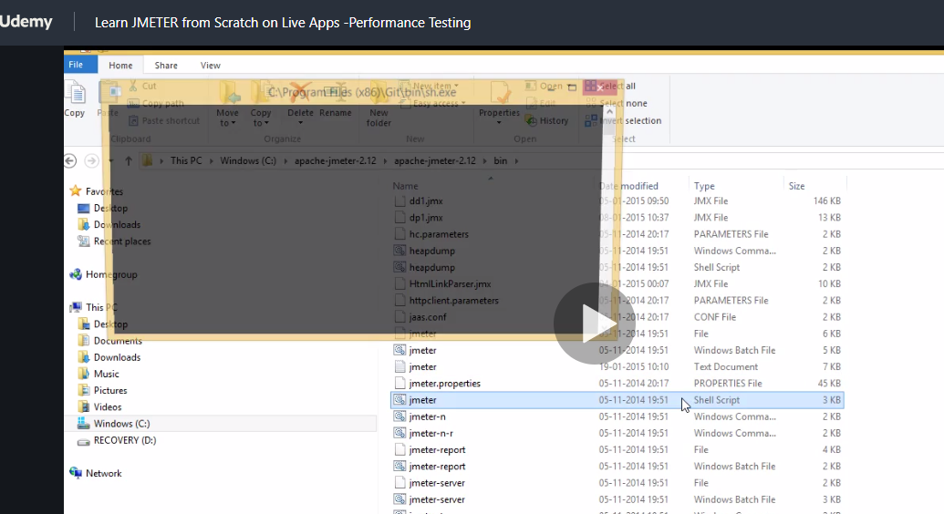

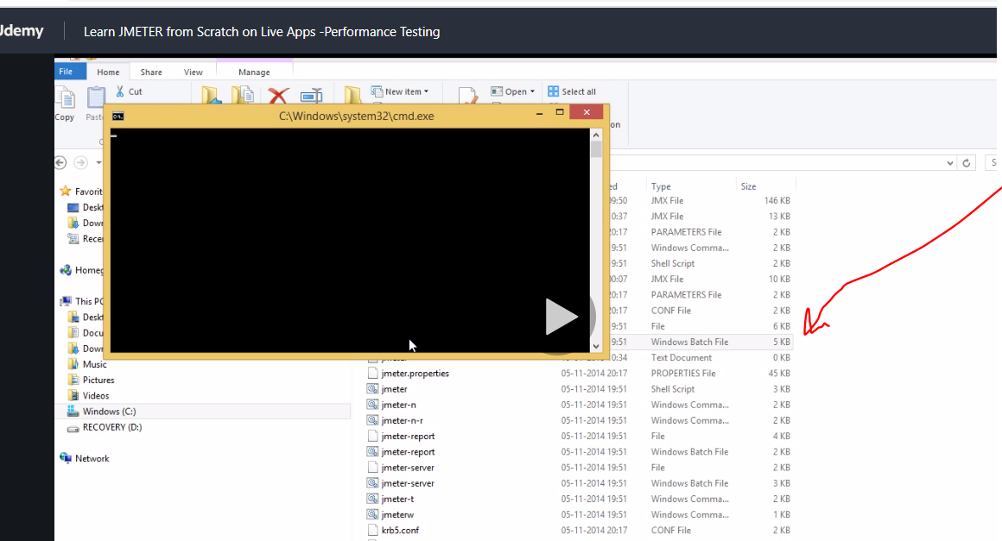

Follow the directory and click jmeter windows batch file

Or

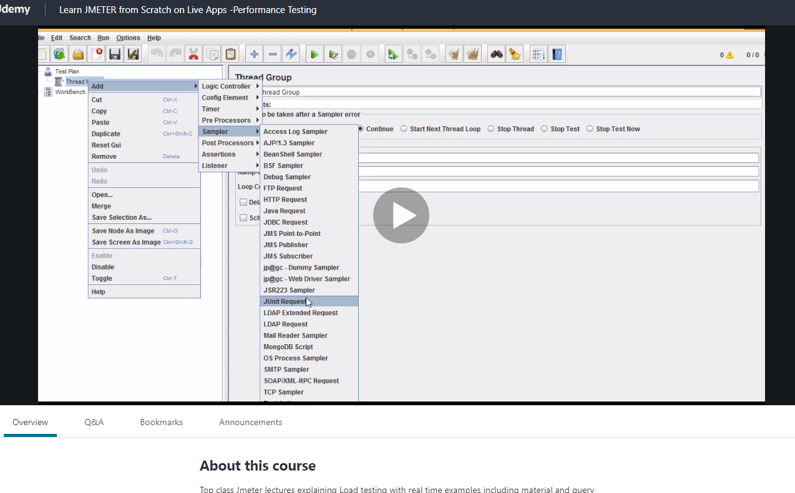

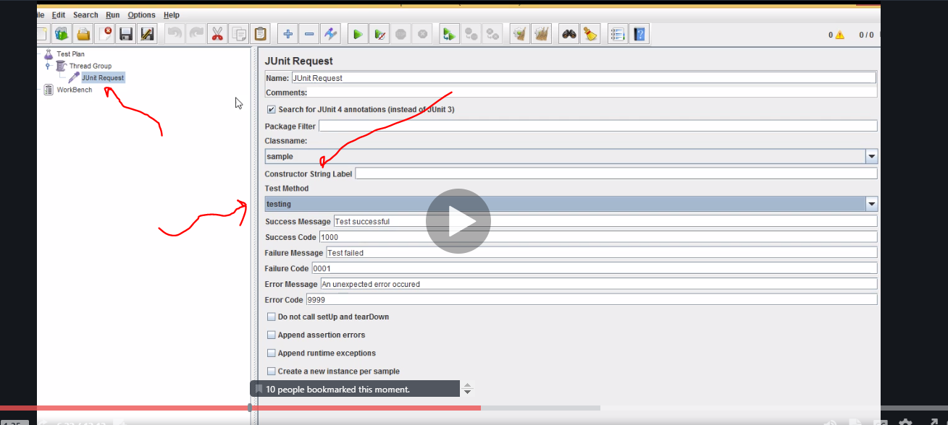

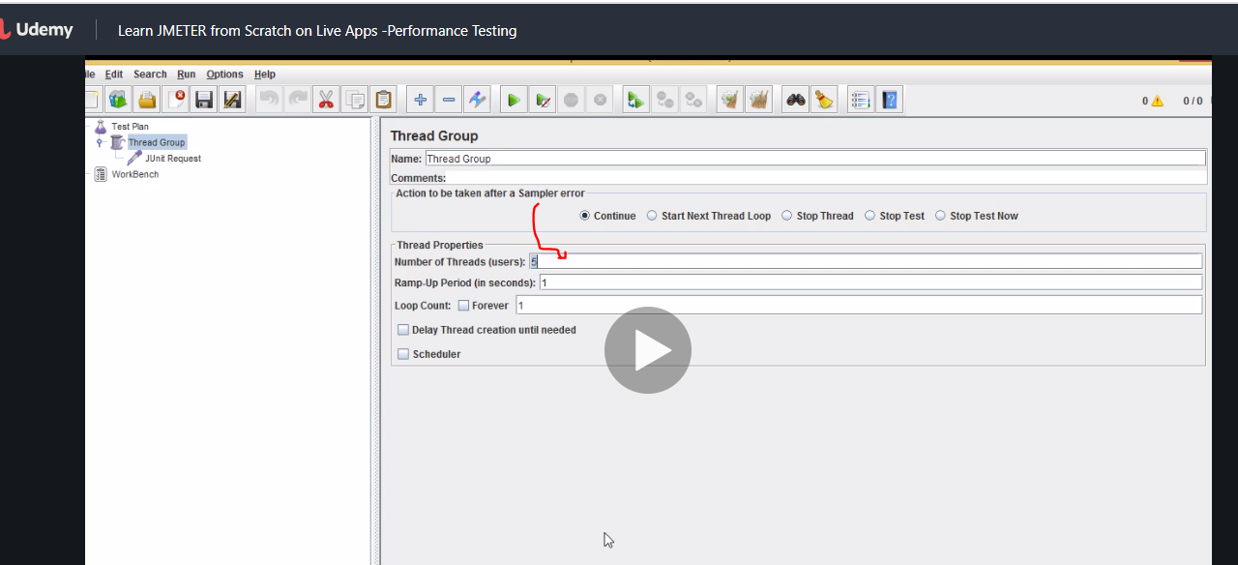

Problem is it will open 5 times and slow performance so this will be the benefit of headless browser

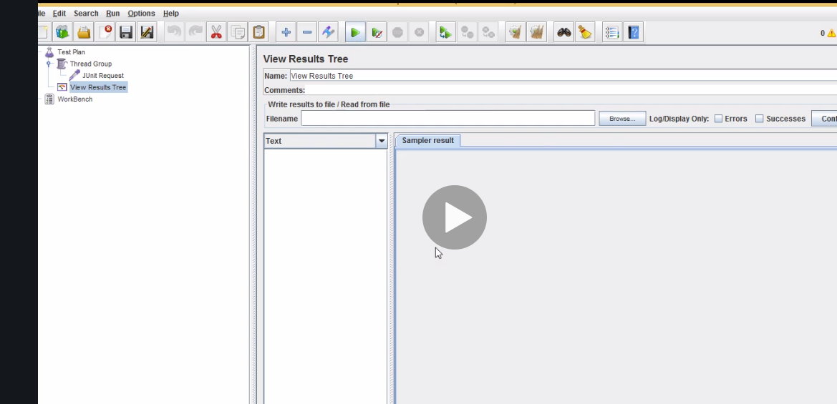

Save it and click log viewer to see whats running

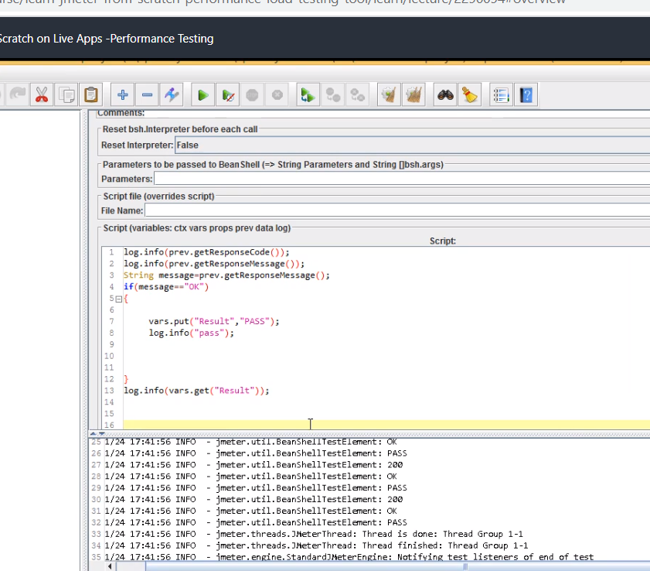

Here it goes and comes out to meet the command so bean shell is so gooood. Does assertion like and all amazing.

-

Now so we dnt see the browser

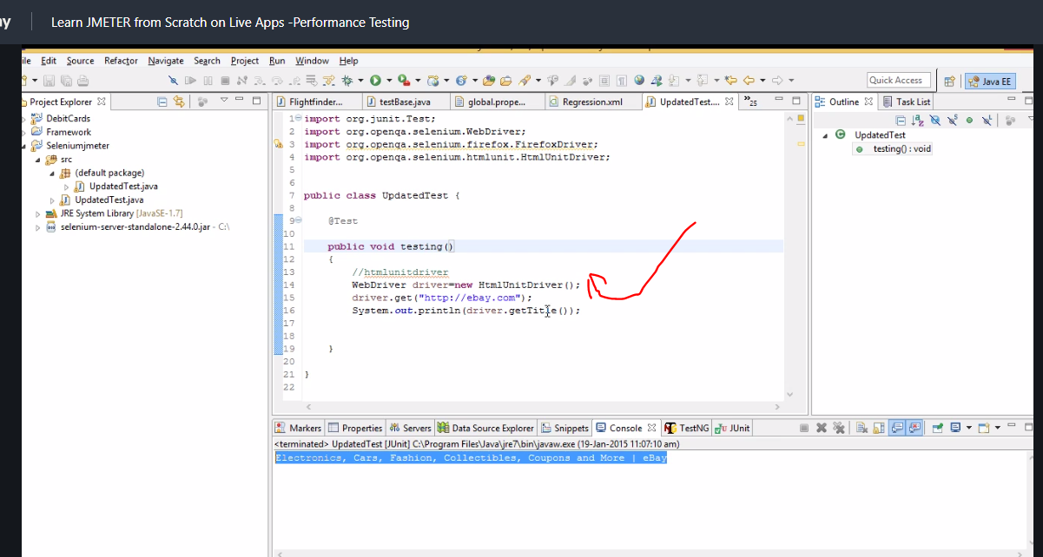

Save like before and call from here.

# Api load testing using jmeter so putting load on api

If u rest its not as heavy as soap but may not be as secure but people using rest. So soso

Rest is not a protocol it’s an architecture.

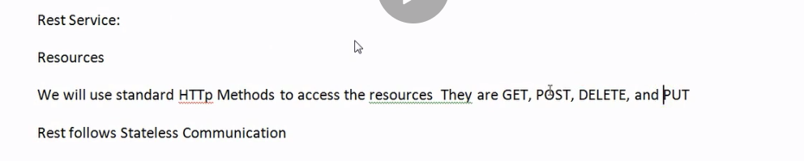

Note when u use get, the url changes but when you use post the url is the same

# Now we will start this request google nearby search api

Just google google sea

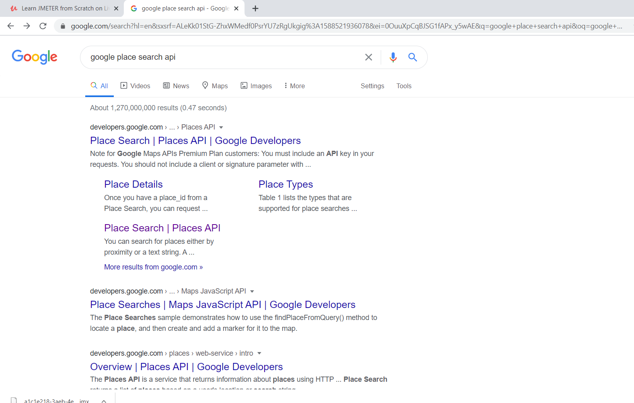

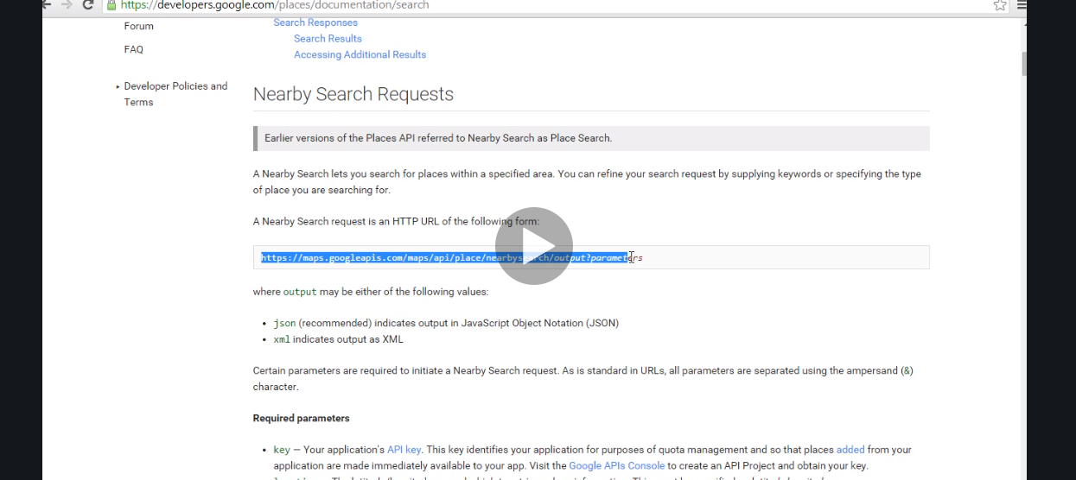

Now this is the http request you need to send to the server.

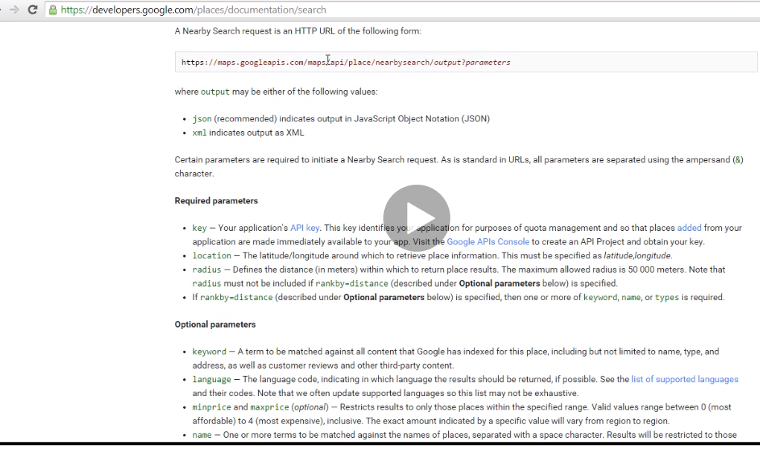

These are the required parameter to send http

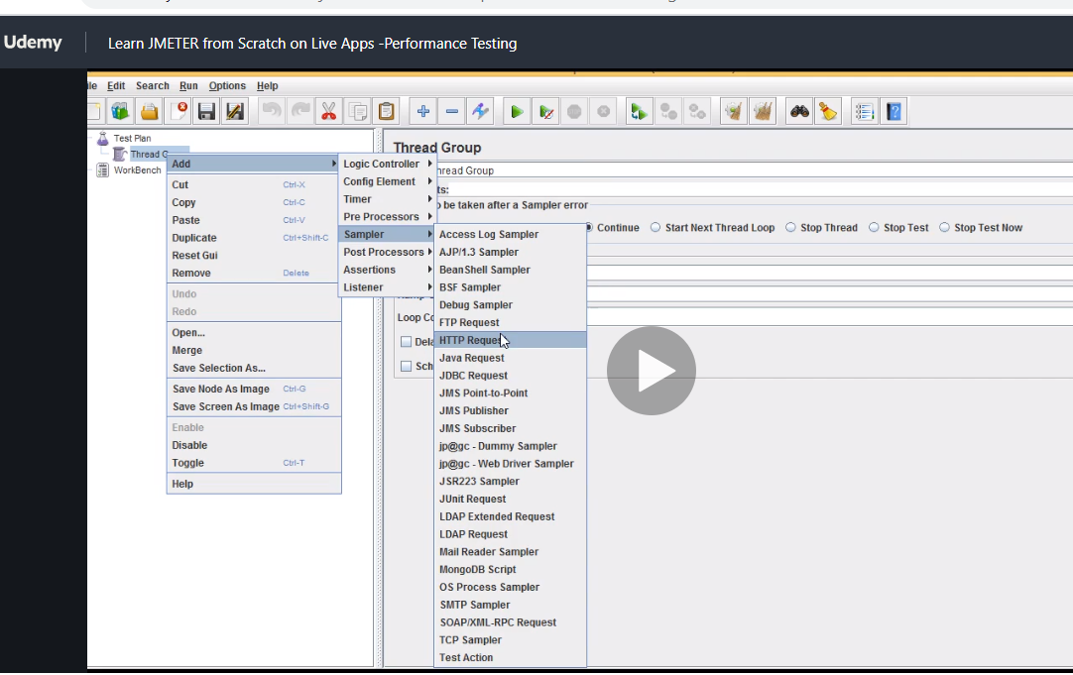

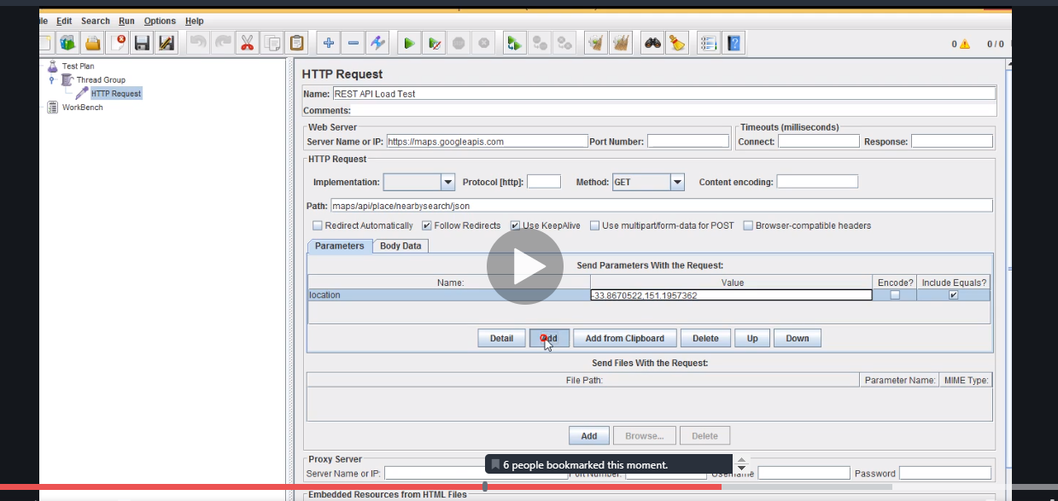

Click add and add radius , type , name and key. Now to generate your own key u need to do some shit…but basically when u get all of them put them in this table

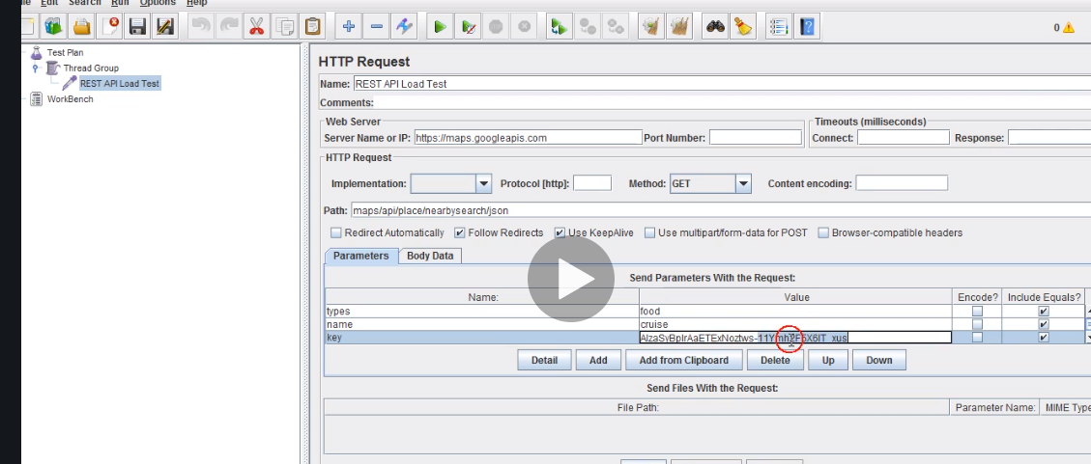

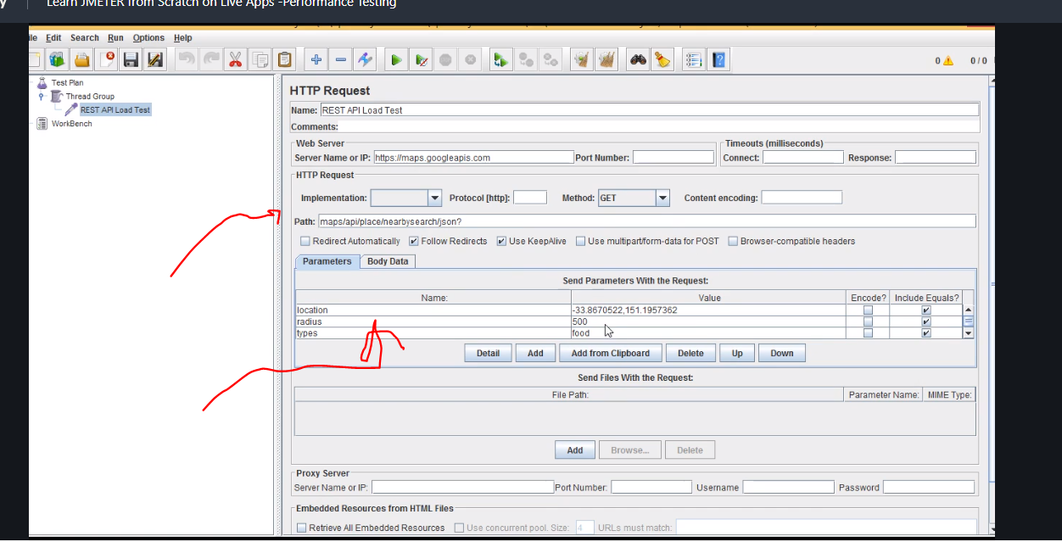

This is manually so no need for recording how cool it is.

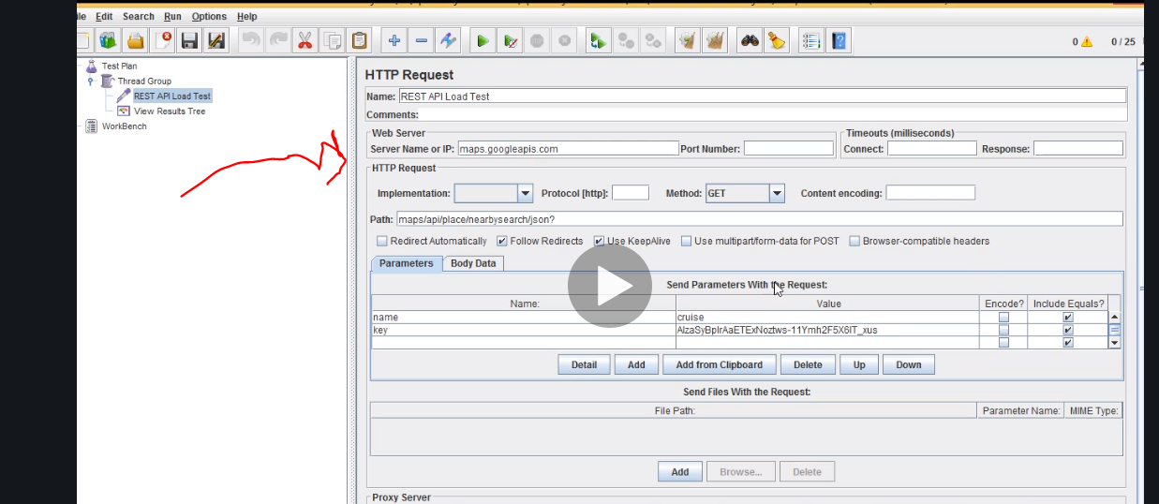

Note here remove the http u dnt need it twice

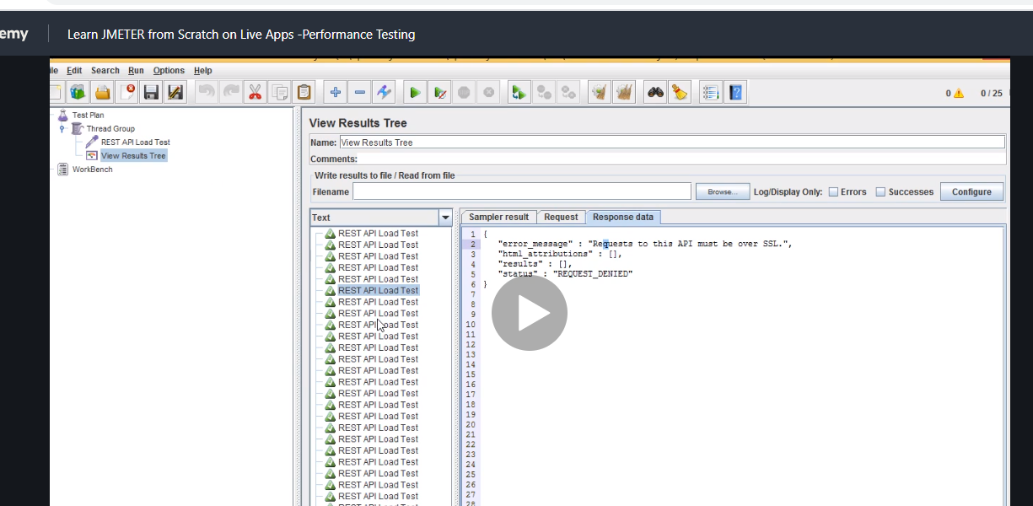

Something is wrong here

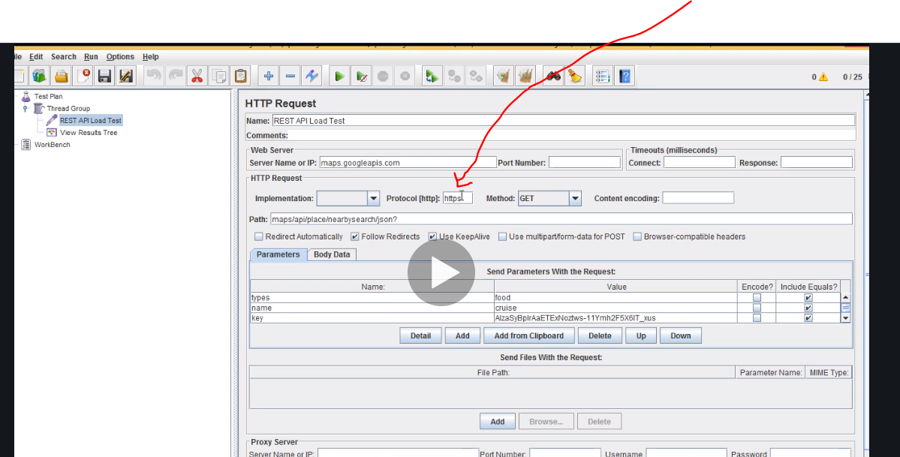

There add http

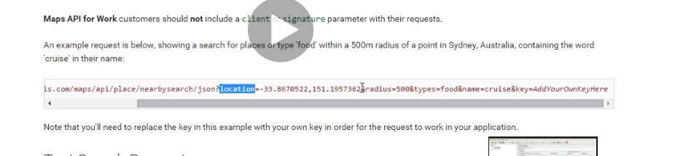

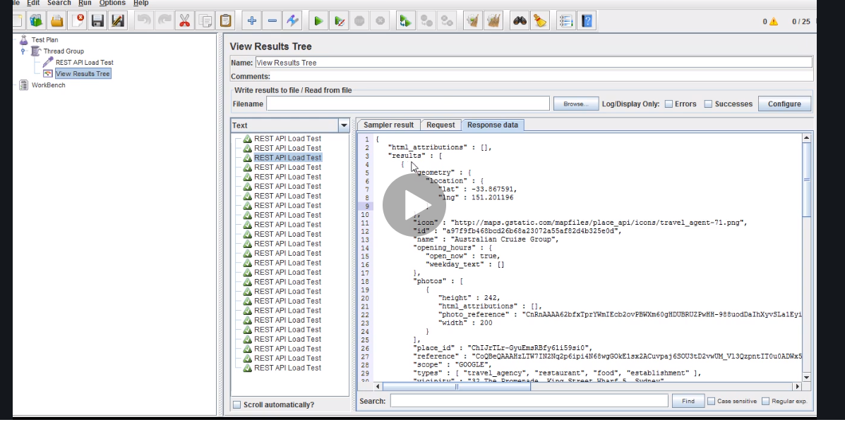

That result is correct

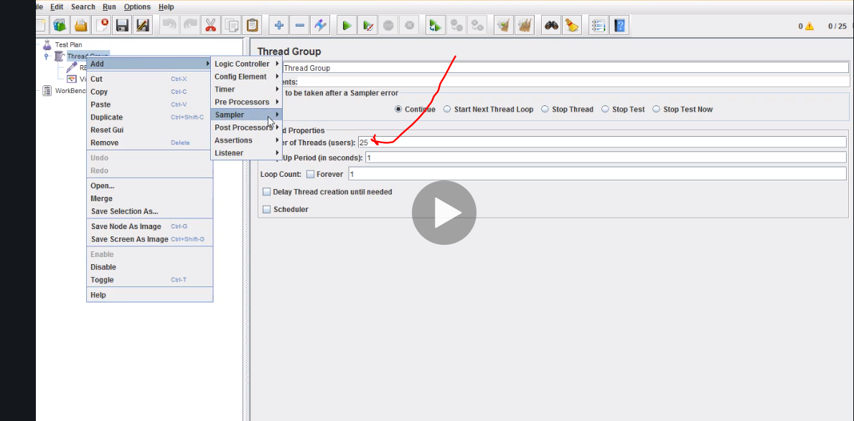

Remember to add load above as we did to show the result.

# Managing server

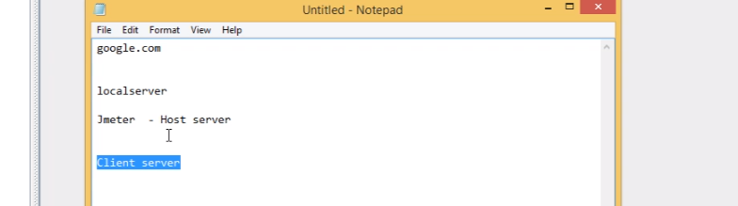

Managing client or host servers

# Download yourkit to manage server parameters

So download it go to the directory go to bin and execute profiler.exe file

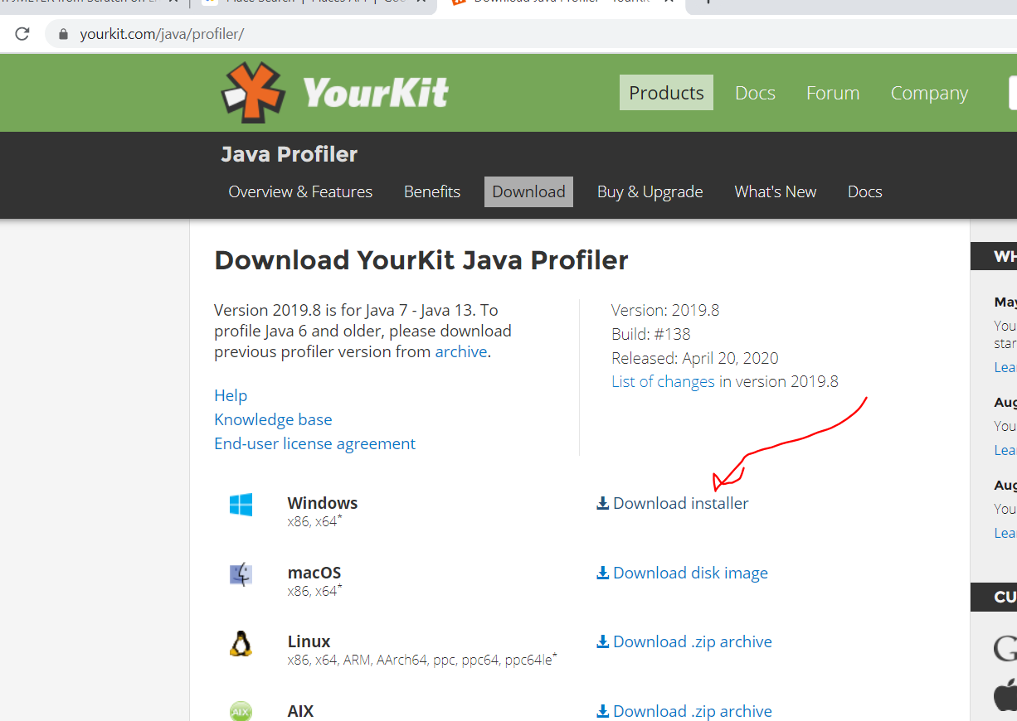

Or just download it , request evaluation key open email and go

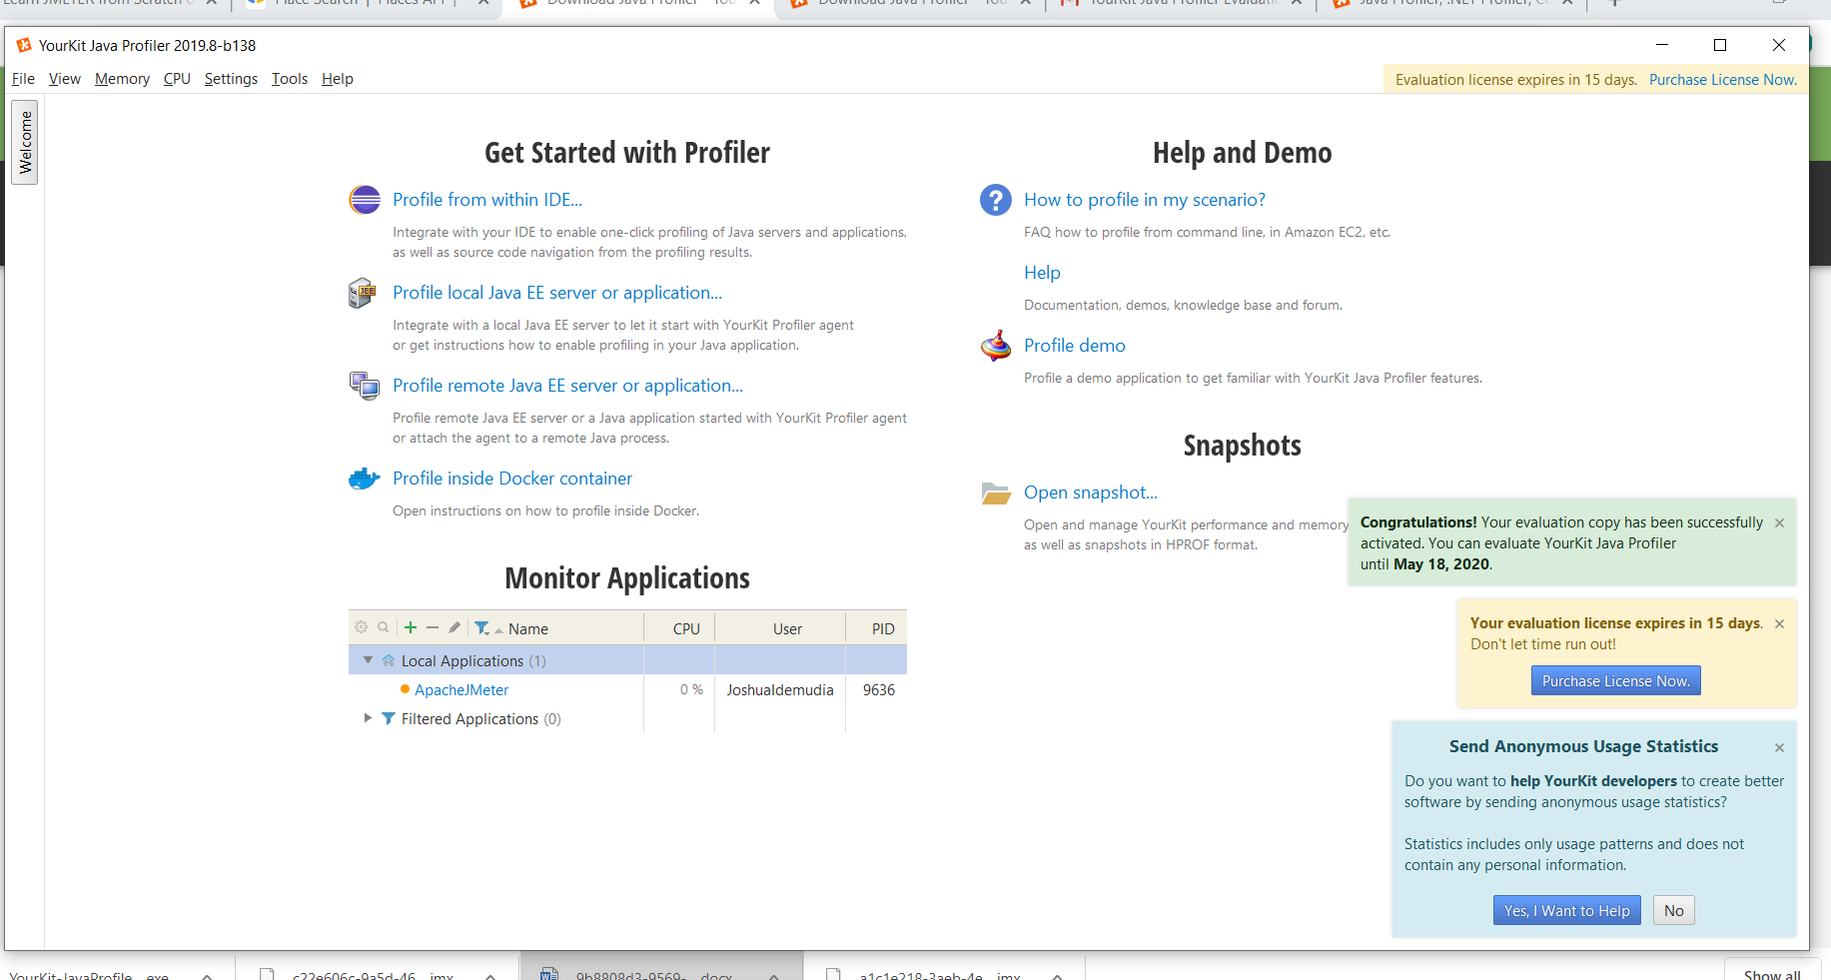

You can even monitor eclipse memory … if you have huge code and jmeter so it will show you how cpu is behaving when playing with loads.

You have to right click and choose

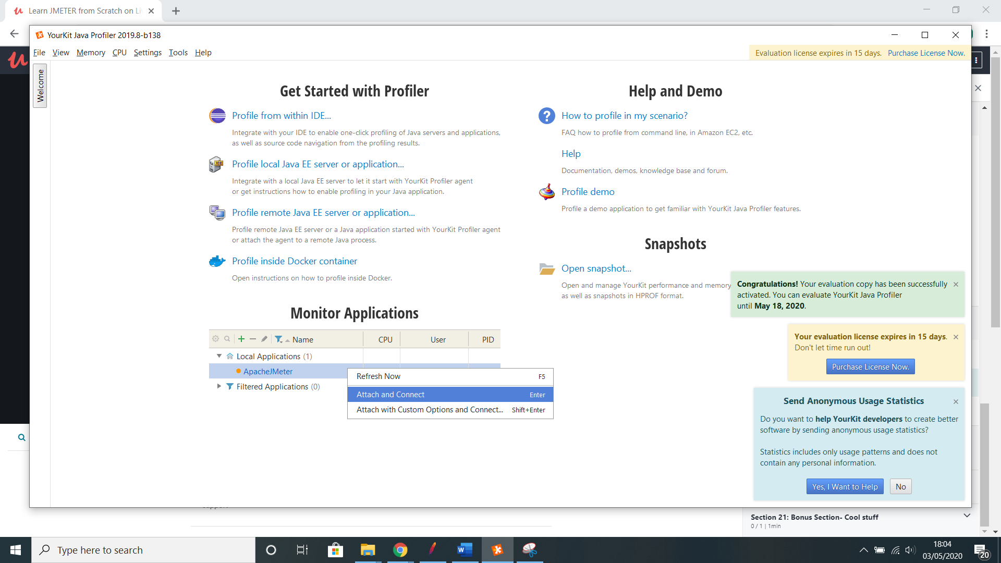

Attach and connect.

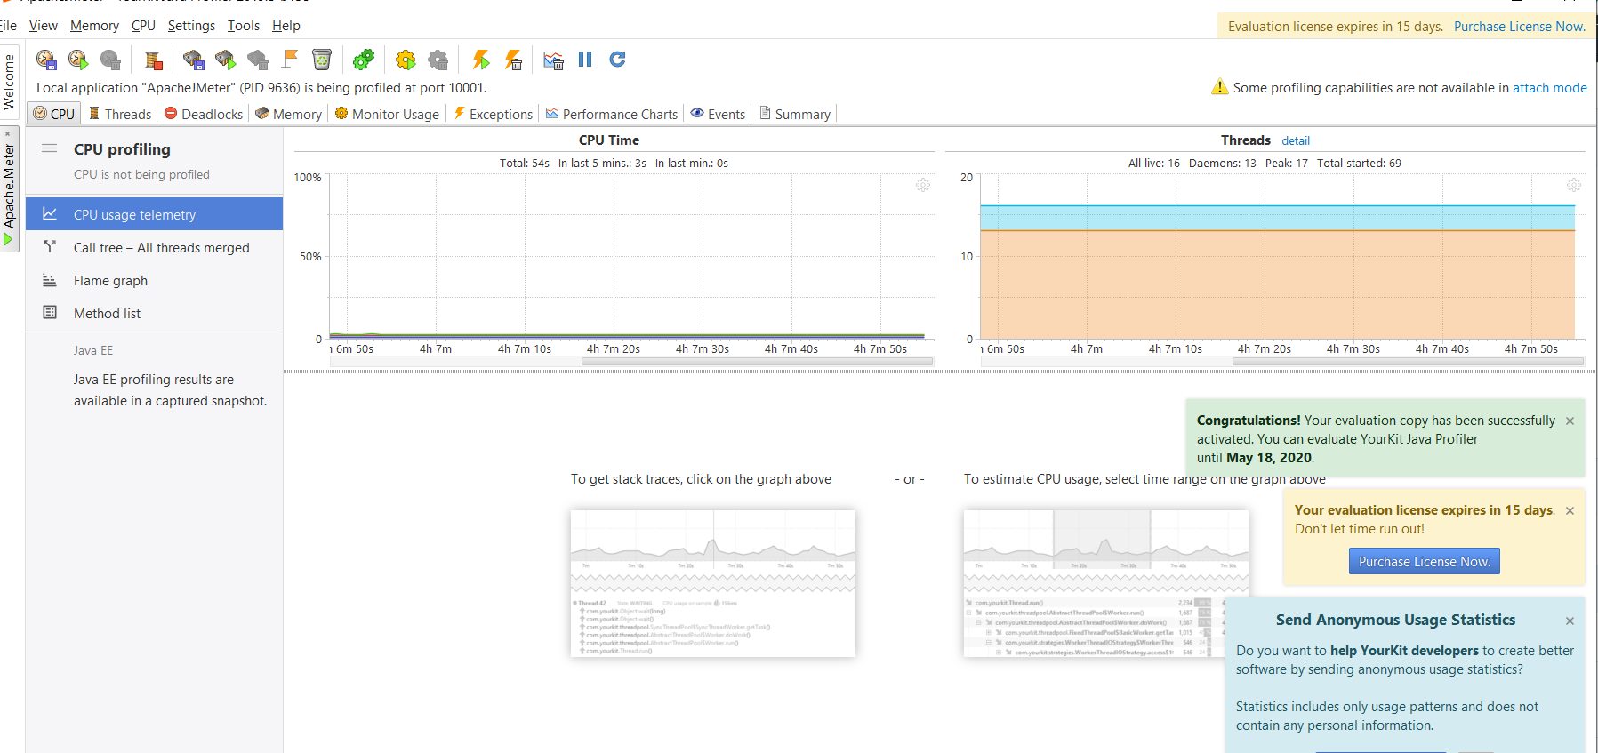

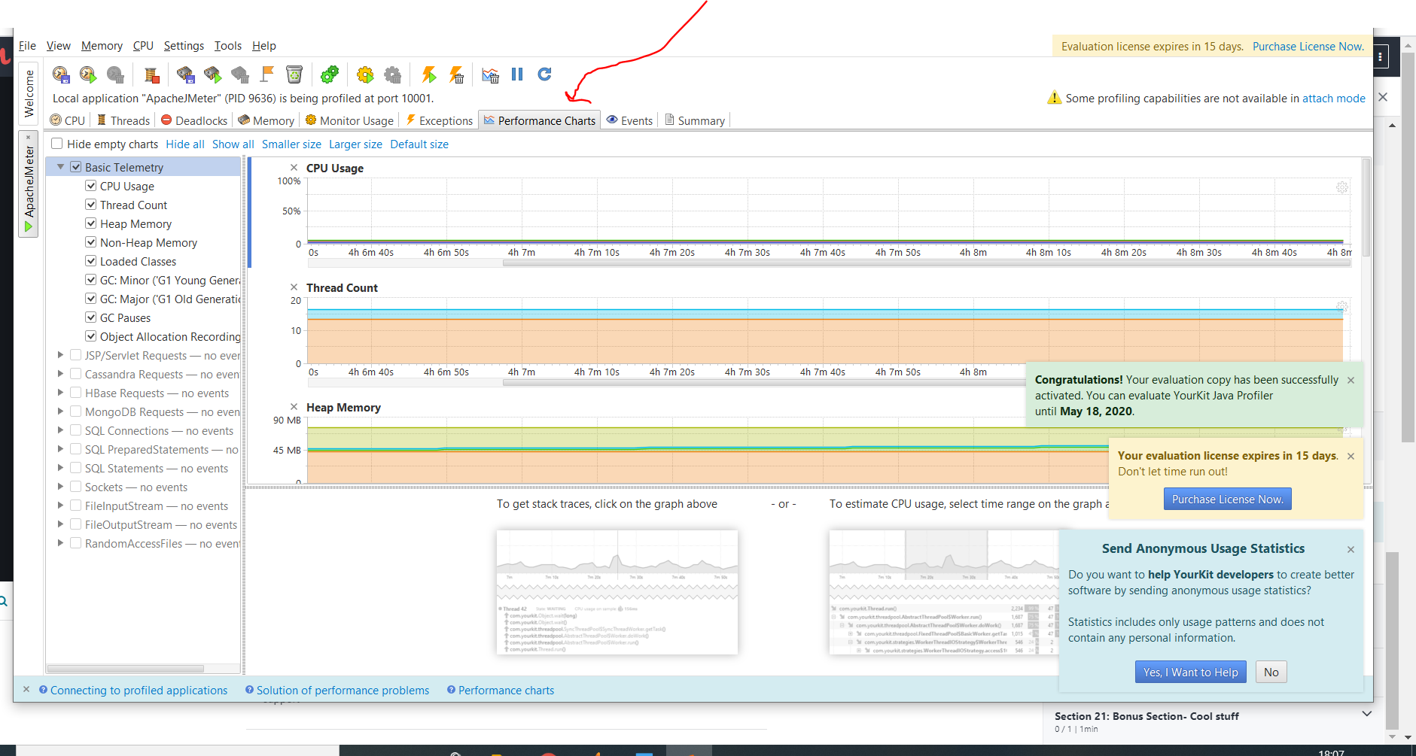

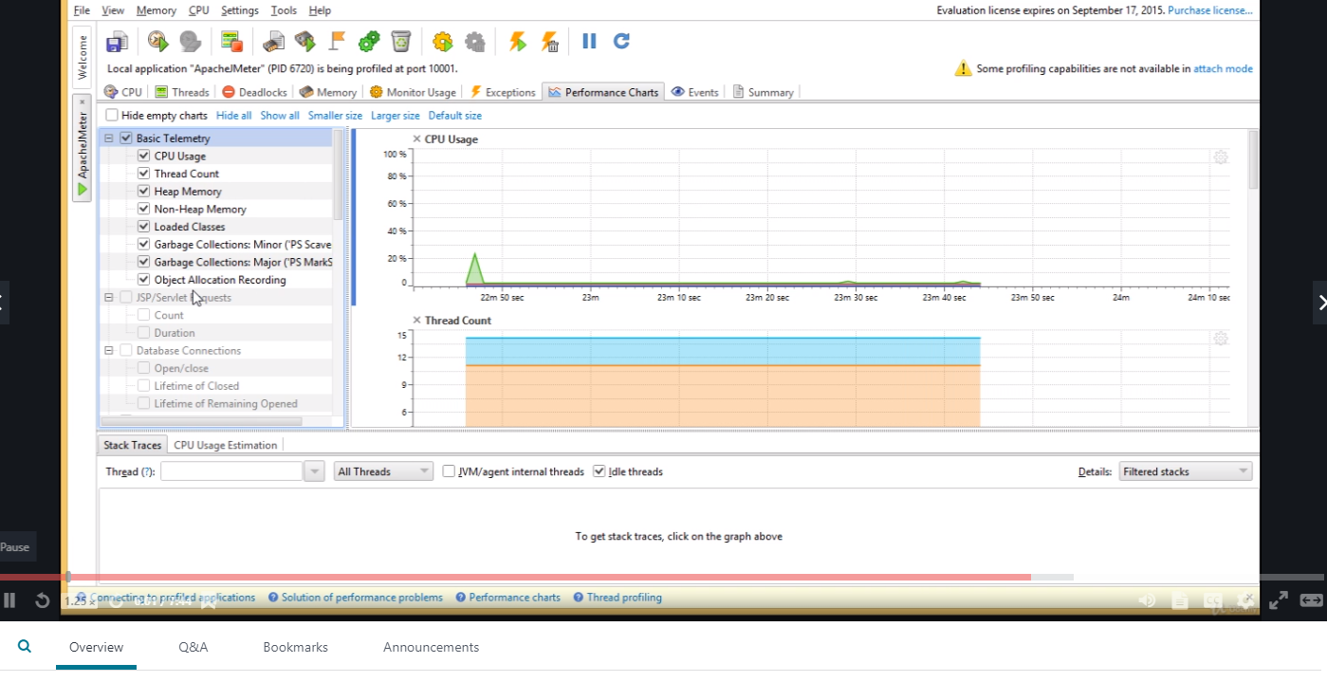

Heap memory is dynamic will be created and destroyed. If it is full system starts acting slow.

When cpu starts getting to 80 it starts to get very slow meaning something is fishy so report it

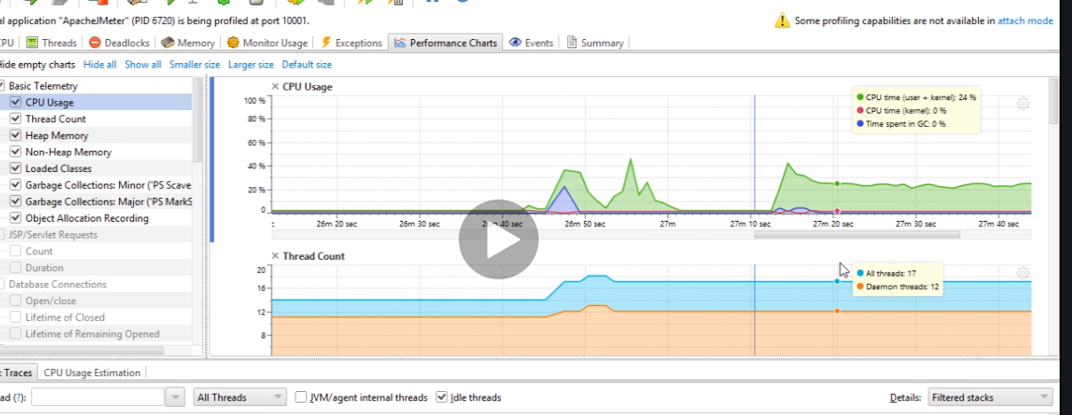

Could be a bug so run the program and then check. In our work what to we use to monitor cpu usage?

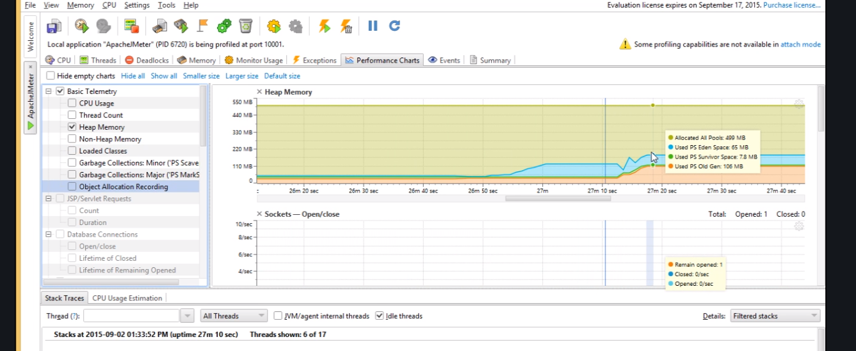uncheck the res and check heap memory if more than 1gb problem